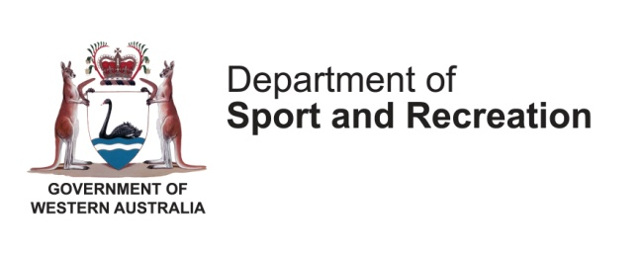
Equality
2015 Human Resources Tool Kit
developed by apex human resources for the department of sport and recreation

Equality Policy

Policy Statement
<Organisation> recognises that discrimination and victimisation is unacceptable and that it is in the interests of the Organisation and its employees to utilise the skills of the total workforce. It is the aim of the organisation to ensure that no employee or job applicant receives less favourable facilities or treatment (either directly or indirectly) in recruitment or employment on grounds of age, disability, gender / gender reassignment, marriage / civil partnership, pregnancy / maternity, race, religion or belief, sex, or sexual orientation (the protected characteristics).
- Our aim is that our workforce will be truly representative of all sections of society and each employee feels respected and able to give of their best.
- We oppose all forms of unlawful and unfair discrimination or victimisation. To that end the purpose of this policy is to provide equality and fairness for all in our employment.
- All employees, whether part-time, full-time or temporary, will be treated fairly and with respect. Selection for employment, promotion, training or any other benefit will be on the basis of aptitude and ability. All employees will be helped and encouraged to develop their full potential and the talents and resources of the workforce will be fully utilised to maximise the efficiency of the organisation.
- Our staff will not discriminate directly or indirectly, or harass customers or clients because of age, disability, gender reassignment, pregnancy and maternity, race, religion or belief, sex, and sexual orientation in the provision of the Organisation’s goods and services.
- This policy and the associated arrangements shall operate in accordance with statutory requirements. In addition, full account will be taken of any guidance or Codes of Practice issued by the Equality and Human Rights Commission, any Government Departments, and any other statutory bodies.

Our Commitment
- To create an environment in which individual differences and the contributions of all our staff are recognised and valued.
- Every employee is entitled to a working environment that promotes dignity and respect to all. No form of intimidation, bullying or harassment will be tolerated.
- Training, development and progression opportunities are available to all staff.
- To promote equality in the workplace which we believe is good management practice and makes sound business sense.
- We will review all our employment practices and procedures to ensure fairness.
- Breaches of our equality policy will be regarded as misconduct and could lead to disciplinary proceedings.
- This policy is fully supported by senior management and has been agreed with trade unions and/or employee representatives.
- The policy will be monitored and reviewed annually

Responsibilities of Management
Responsibility for ensuring the effective implementation and operation of the arrangements will rest with the Chief Executive. Directors / Managers will ensure that they and their staff operate within this policy and arrangements, and that all reasonable and practical steps are taken to avoid discrimination. Each manager will ensure that:
- all their staff are aware of the policy and the arrangements, and the reasons for the policy;
- grievances concerning discrimination are dealt with properly, fairly and as quickly as possible;
- proper records are maintained.
Senior Management will be responsible for monitoring the operation of the policy in respect of employees and job applicants.

Responsibilities of Staff
Responsibility for ensuring that there is no unlawful discrimination rests with all staff and the attitudes of staff are crucial to the successful operation of fair employment practices. In particular, all members of staff should:
- comply with the policy and arrangements;
- not discriminate in their day to day activities or induce others to do so;
- not victimise, harass or intimidate other staff or groups who have, or are perceived to have one of the protected characteristics.
- ensure no individual is discriminated against or harassed because of their association with another individual who has a protected characteristic.
- inform their manager if they become aware of any discriminatory practice.

Third Parties
Third-party harassment occurs where an Organisation employee is harassed, and the harassment is related to a protected characteristic, by third parties such as clients or customers. <Organisation> will not tolerate such actions against its staff, and the employee concerned should inform their manager / supervisor at once that this has occurred. <Organisation> will fully investigate and take all reasonable steps to ensure such harassment does not happen again.

Grievances/Discipline
Employees have a right to pursue a complaint concerning discrimination or victimisation via the Grievance or Harassment Procedures.
Discrimination and victimisation will be treated as disciplinary offences and they will be dealt with under the organisation Disciplinary Procedure.

Review
The effectiveness of this policy and associated arrangements will be reviewed annually under the direct supervision of the Organisation Chief Executive.

