Great Southern Regional Sport and Recreation Plan

Supporting Documentation

Dave Lanfear Consulting | Department of Local Government, Sport and Cultural Industries | January 23, 2018
Contents
Appendix A: Document Review 3
Appendix B: Demographic Analysis 46
Appendix C: Consultation Outputs 53
Appendix D: Participation Rates 116
Appendix E: Industry Trends 124
Appendix F: Development Principles 131

Appendix A: Document Review
Table 1 below summarises the outputs from key local government, state government and national research documents.
Table 1: Local Government Strategies, Plans and Supporting Documentation
Document | Precis of Main Considerations | Implications
City of Albany
Albany 2030 Community Strategic Plan | The stated vision: is “To be Western Australia’s most sought-after and unique regional City to work, live and visit”  The key themes and relevant aspects of those key themes include:  - Theme 3: Clean, Green & Sustainable  - Objective 3.2: To build, maintain and renew city assets sustainably.  - 3.2.1: Deliver environmentally & financial sustainable long-term planning for infrastructure via a forward capital works program that meets the needs of our community.  The maintenance, servicing and renewal of City’s assets are environmentally and financially sustainable.  - 3.2.2: Design, construct and maintain infrastructure cost effectively in a manner that maximises its life, capacity and function.  City assets continue to function effectively as they age.  - Theme 4: Community Health & Participation  - Objective 4.1: To build resilient and cohesive communities with a strong sense of community spirit.  Increasing numbers actively participating in community and civic life.  - Objective 4.3: To develop and support a healthy inclusive and accessible community.  - 4.3.1: Develop a range of activities and facilities that connect people, promote a healthy community and are appropriate for all ages.  Our community increasingly uses community spaces to meet and participate in healthy activities.  - 4.3.2: Encourage and support volunteers and community groups to grow an active volunteer base that is supported and valued.  Volunteering and participation in community organisations increases. | The key implications in respect to the GSR Sport and Recreation Plan are:  - Astute asset management is critical in maintaining, servicing and renewing the City’s assets in an environmentally and financially sustainable way.  - Future investment should have regard to functionality and lifecycle costing.  - The City is committed to increasing participation and health and wellbeing of the community together with supporting volunteers. This is firmly embedded within their current approach to the development of Centennial Park.
City of Albany Corporate Business Plan 2014-2018 | The Corporate Business Plan aligns the services, programs and projects delivered with the Community Strategic Plan “Albany 2023”.  Of the strategic projects identified the following are pertinent:  - Recreation Strategic Planning  - Trails Hub Strategy & Projects  - Kite Boarding Facilities Planning  - Regional Tennis Feasibility Study  - Surf Reef Feasibility  Albany Leisure & Aquatic Centre is identified for renewal.  Centennial Park Sporting Precinct is identified for renewal, upgrade and expansion. | Of the key projects, the completion of the recreation plan is important to establish baseline standards as a reference point for future investment. This will determine the timescale and phasing of any potential future investment (subject to achieving necessary funding).
Albany Local Planning Strategy (August 2010) | Under 4.5.1.4 major sporting venues are referenced. Key considerations include:  - Noise at the Atwell Park Speedway in Reddale Road and the establishment of a noise buffer (resulting in the Speedway Noise Buffer Area Town Planning Scheme Policy in 2004). No retrospective noise controls will be applied.  - Albany Harness Racing Club’s trotting complex in Lancaster Road, as urban development continues around the complex may require a buffer which will be modelled on the speedway policy.  One of the most significant aspects of future development of Albany’s urban areas is staged and co-ordinated access to primary infrastructure services such as sewerage, water, power and telecommunications and important community needs such as schools, health services, churches and venues for sport and recreation and cultural activities (section 6.4).  Under 6.4.7 Recreation, the following is relevant:  - The City owns most sporting facilities and fields in Albany with major facilities, including the North Road sporting precinct and the Albany Leisure and Aquatic Centre.  - Reference is made to the Albany Recreation Needs Study of 2000, Albany Recreation Study of 2000 and Centennial Park Recreation Precinct Plan.  - The City has developed this priority ranking for planning and establishing reserves:  - Recreation (reserves and parks varying in size from being able to service a regional community to small urban enclaves).  - Preservation (examples of purpose are wetlands and foreshore conservation, vegetation retention, regional significance).  - Public use reserve (drainage and gravel extraction).  - Some bigger projects being considered are a motor sports complex incorporating a speedway, an adventure sports centre and a venue for horse riding and other equine activities.  - At a regional level the LG’s recommends:  - Protecting existing regional facilities.  - Identifying and set aside land for facilities such as the horse activities centre and the motor sports complex in Albany. The impact of recreation facilities on existing adjacent land uses should be considered.  - Undertaking a co-ordinated review of coastal and estuarine areas popular with recreational boaters around Albany and Denmark to identify development or upgrading of facilities that may be needed as the population grows.  Of the strategic objectives: “Recreation facilities to be provided by the public and private sectors as part of Albany’s urban growth areas.” Local open space, protection of conservation areas and places for recreation activities and facilities will be provided in the form of either land for reserves or monetary contributions by the private sector as part of the development process, along with a contribution towards regional facilities to be provided in partnership with the City and State Government agencies. | The local planning strategy is subject to review and therefore this document merely provides an indication of future potential direction. It is to be noted that the population figures on which the document is based have been downgraded following the recent 2016 census data publication. The demand therefore for new investment is likely to be modified and reviewed.  In the absence of a Developer Contributions Plan however the key principles of securing funding for future investment through either land for future reserves or monetary contributions is still relevant.
Motor-Sport Complex Feasibility Study | This study investigates the feasibility of co-locating motor-sport and driver training facilities to a suitably identified site, estimates capital costs; and makes recommendations. The feasibility study supports the concept of the development of a Motor-Sport Complex on Parker Brook Reserve (reserve 1947) subject to undertaking an Environmental Noise Impact Assessment; Site Design and approval of a Full Environmental Management Plan; A facility/operational management plan; securing funding and a new/amended lease over the site.  The feasibility study was handed over to the ‘Great Southern Motorplex Management Group’ to lead and undertake responsibility for the development of the project and undertake responsibility for the lease and management of the site. | The motorsport project has been held in abeyance following the development of the study and is unlikely to progress in the short term. It is however important to recognise the outcome of the study as a project which could be developed in a medium to long term to satisfy the motorsport requirements of an expanding population base in and around Albany. It should however be complimentary to the development of the motocross facility at Cranbrook.
Asset Management Strategy (Synergy 2013) | Current asset estimated value is $401,621,100 of which $11,273,302 is reserves and $111,266,753 is buildings.  The City currently owns and maintains approximately 486 Natural reserves and 80 Developed reserves with infrastructure including playground equipment, reticulation, park furniture, sporting infrastructure, lighting and fencing.  A condition audit is recommended every 4 years (next in 2021).  Two levels of Service are specified: The Operational or Functional Level and The Community Expectation Level.  The renewal demand identifies an investment range of between $6.4M to $9.1 annually up to 2021. | The asset management process has evolved significantly from this report and tracked on a regular basis and reported annually. The learnings from this process would benefit all LG’s within the Great Southern and should be used as a mechanism to benchmark and educate partner LG’s.
Carbon Footprint Reduction Strategy – Clear Green and Sustainable (2013) | The challenge for the City is to focus on its own operations (which include a wide variety of facilities - heritage, community facilities, administration, waste and depot) with the key themes being:  - Energy efficiency.  - Water management.  - Fleet and plant management.  - Carbon offset. Including the development of a tree strategy and tree register.  - Waste management. In particular to review water management practices. | Water management and water re-use will continue to be a significant influencing factor on the provision and maintenance of public open space and reserves. Opportunities to reduce environmental impact should always be sought and is consistent with obligations referenced within the Strategic Community Plan.
City of Albany Sport and Recreation Futures Plan (Draft and not presented to council for endorsement) | The plan aims to provide a strategic framework for the City to achieve its vision of contributing to the health and wellbeing of the community by encouraging and providing opportunities for Active People and Active Places.  The well planned and designed infrastructure and environments and the maintenance and enhancement of sport and recreation facilities falls underneath the Active Places aims whilst Active People seeks to get people more active and seeks to encourage those that are active, to stay active.  Priority projects referenced in the document include:  - Centennial Park Sporting Precinct.  - Attracting more indigenous participation, particularly associated with football.  - Collingwood Park .  - Upgrade indoor court lighting to ALAC to 500lux.  - Emu Point Sporting Club and Albany Bowling Club upgrade of synthetic greens and lighting by the club.  - Investigation of the relocation of the cricket high performance program in consultation with the GSRCA.  - Joint use/shared use of new school facilities and ongoing opportunities for after-school use of facilities for community sport.  - Upgrade of outdoor lighting to the hockey turf of 500lux.  - The development of a regional shooting hub for co-located disciplines.  - Assist with the ongoing co-location model for the new football (soccer)/cricket pavilion.  - Improvements to the Albany Surf Life Saving Club.  - Undertaking a feasibility study to determine whether the construction of a new 50m pool at ALAC is viable.  - Undertake a needs and feasibility study for the development of a regional tennis centre and consequential co-location and rationalisation of existing Albany tennis clubs.  - Improved lighting at Middleton Beach to facilitate triathlon competition and event hosting and in addition the provision of Beach Volleyball and Surf Life Saving activities.  - The master planning of the Albany Water Sports Clubs and potential co-location of Kalgan Progress Association, Albany Rowing Club and Albany Waterski Club. | The plan whilst currently only in draft and the absence of it being reported for formal endorsement by elected members has limited weight in the decision-making process at present. Nevertheless, there are a number of key facility development priorities that have been identified through the consultation process and are consistent with priorities identified in adopted plans. The two main strategic facility projects of Centennial Park and Collingwood Park will be the focus for City investment whilst other projects require budgets to be set aside within the 10-year financial plan and through the ongoing support and facilitation of grant funding options for clubs where the City have no or limited control over the land and buildings.
City of Albany ICT Strategic Plan 2012-2017 | The document specifies the Information and Communication Technology (ICT) Strategic Plan for the City of Albany covering 2012 through to 2017. Online business systems and services for staff and external service customers will be improved through the provision of more contemporary structures. | The importance of updated technology to improve reporting systems and communication both within and external to the City should underpin future services, programs and development options. This has the benefit of improving economic performance, responding to customer needs and marketing the city and broader region.
City of Albany Communications Strategy | Under 1.1 To develop a City of Albany brand that is consistent with our vision, strategic direction and values. Under 1.2 it specifies that the City wish to engage effectively with our community on issues and decisions which affect their lives.
City of Albany Sporting Precincts Ground User Guide | The guide establishes the ongoing responsibilities of the City and sporting clubs who utilise City controlled reserves. The document references two types of permits for community level sport (seasonal permit and casual permit). The document clearly articulates responsibilities and introduces the obligations of clubs in respect of replacement costs.  The 27 sports fields managed by the City of Albany are assessed on a regular basis to ensure effective maintenance and restoration is undertaken and to avoid over-play. | The user guide clearly articulates roles and responsibilities of clubs and the City in the ongoing management and maintenance of reserves. A variation of this guide could be adopted for all LG’s across the region to ensure consistent standards and maintenance programs are adopted where possible.
City of Albany Major Regional Events Strategy 2014-17 | The aspiration of the City is to be Western Australia’s most sought after and unique regional City to live, work and visit. The focal point is to deliver major events (of a national and international interest) and regional events (which attract regional participation). The council’s central role in tourism is re-enforced by the Albany Visitor Centre, Albany Heritage Park and Albany Regional Airport. It also acts as a consenting authority and as a leading economic development advocate. The plan provides 4 focus areas:  - Focus Area 1 - Event friendly host destination.  - Focus Area 2 – Resourcing.  - Focus Area 3 - Event Evaluation Tool.  - Focus Area 4 - Portfolio of Major and Regional Events.  Each focus area has a set of objectives and key actions. The evaluation tool is to be used as the mechanism to instruct major event selection which is also to be aligned to the Amazing Albany brand. | The option to utilise infrastructure for a variety of national, international and regional events and coordinate across departments will need to be undertaken if it is to deliver effective results. This also needs to be delivered in partnership with neighbouring LG’s who are likely to benefit from an integrated approach.
Tourism Development Strategy for the Lower Great Southern | This document has been undertaken in partnership with Tourism WA, the Shire of Plantagenet, Shire of Denmark, Great Southern Naturally and the City of Albany. The document provides a current state assessment. It emphasises the importance of a coordinated events strategy to attract interstate travellers and a unified brand and service model. In addition, the building of capacity within the region and sustainable business models are highlighted as key considerations. Benchmarking with other successful destination marketing organisations within WA and abroad is similarly referenced. | The key themes identified within the strategy are directly aligned to the themes emerging from the review of sport and recreation infrastructure, in particular:  - Coordination of events  - Building capacity  - The importance of benchmarking  - Alignment across boundaries of strategic alliances for the greater benefit of the region.
City of Albany Economic Development Strategy 2013-2017 | Three key strategic objectives are identified as:  - Strategic Objective 1 - To strengthen and diversify our economic base.  - Strategic Objective 2 - To foster links between education training and employment that support our economic growth and development. Under this objective the following is relevant:  - 1.1: Assist the Department of Sport and Recreation to establish the Outdoor Centre for Excellence in Albany.  - 1.2: Partner with the Princess Royal Sailing Club and Department of Sport and Recreation to establish links with Singapore with a view to establishing a Sailing Centre of Excellence.  - Strategic Objective 3 To develop and promote Albany as a unique and sought-after visitor destination. | The commitment to the Outdoor Centre for Excellence is important and should incorporate potential alignment of the Active Albany initiative. This would align strongly with Albany as a visitor destination.
Connected Communities 2014-2018 | The plan identifies a structure for the facilitation of community development activity.  As part of this strategy the following objectives are relevant:  - 1.2: To engage youth in positive activities.  - 3.1: To create inclusive and dynamic community spaces for linking people, activities and events.  - 3.1.3: Develop, implement and review the establishment of neighbourhood ‘hubs’ activities to link residents to their local community.  - 3.2: To improve connection between people and places within the City.  - 3.2.1: Work with relevant stakeholders to increase opportunities for active transport across the City - People have greater opportunities to walk and cycle to their destinations. | The integration of paths, trails and tracks with recreation and sporting infrastructure should underpin active transport strategies. This alignment is critical to neighbouring LG areas and will add value to the unique service offer associated with trail development within the Great Southern.
City of Albany Access and Inclusion Plan 2018-2022 (adopted Nov 2017) | Outcome 1: People with disability have the same opportunities as other people to access the services and events organised by the City of Albany. In particular:  - 1.6: Provide opportunities for people with disability to participate in mainstream recreation activity organised by a range of agencies.  1.6.1: Investigate partnerships with key agencies to provide access for all abilities to mainstream leisure activities.  - 2.2: Incorporate provision for disability access into all future asset and facility development for the City.  2.2.1: Ensure people with disability in the City’s outlying communities are included in consultation about improvements to parks and recreational facilities in their community.  - 2.4: Continue to review and improve access to public open spaces and public areas including:  - Parks and reserves  - Beaches  - Facilities (including footpaths)  2.4.7: Public Open Space policy developed to improve the accessibility of facilities in public open spaces and other recreation facilities. | The ongoing commitment to upgrading and improving both Centennial Park and future investment in Collingwood Park will ensure that DDA compliance is addressed. This will need to be expanded to the gradual renewal and refurbishment on non-City controlled sporting infrastructure.
Cycle City Albany – 2014-2019 Strategy | The document aims to provide strategic guidance to enable the City of Albany to become one of Australia’s primary cycling destinations. The strategy is aimed at improving commuting and recreational cycling facilities; providing infrastructure and programs which will encourage cycle tourism and support the community to become more active by linking to key community hubs. Of the sport and recreational facilities, the following are a focus:  - Centennial Park - a major destination in itself with several sporting fields, the Albany Leisure and Aquatic Centre (ALAC) and Showground.  - Recreational cycling along many of the connector routes. | The desired outputs link to the integration of sporting infrastructure with a connected cycling and trails network. This will assist in reducing the carbon footprint and align to health and wellbeing objectives.
City of Albany Trails Hub Strategy | The strategy provides strategic guidance to assist the City to become one of Australia’s primary trails destination: A World Class Trail Tourism Hub (TTH) situated around a high quality trail system, supported by a complete package of hospitality and visitor services. It aims to:  - Improve the quality, type and number of trails in iconic locations.  - Improve trails maintenance and upkeep through sustainable models of governance.  - Focus strategic investment and support in facilities and services to optimise access to and use of Albany’s trails.  - Maximise the promotion of Albany’s unique trails and outdoor adventure experiences to a broad visitor market.  The report is structured into 5 discrete volumes of work related to tourism and trail trends; priority projects associated with the trails network identifying those projects to be developed over the next 10 years; background review and research findings; outputs of community consultation and a trails toolkit. Trail Hubs incorporate more than just the hard infrastructure (built trails) but a comprehensive trail offering that ensures the town or destination is highly recognised as a place that is synonymous with great outdoor trail experiences.
Albany Heritage Park Trail Network Concept Plan | The trails system comprises a number of trail heads and a combination of trail styles, difficulty levels and designs. The main trails and trail heads include:  - The Ridge Link Trail  - The Green Dual Use Ridge Link Trail  - The Blue Dual Use Coastal Trail  - City Trail Head  - Saddle Trail Head  - Middleton Beach Trail Head  - Mount Clarence Car Park Trail Head  - Mount Adelaide Trail Head  - National ANZAC Centre Trail Head  These trails provide significant local community member and visitor attractors. They also link in to the broader regional trails plan and connectivity objectives. | The trail network is a critical component of the Active Albany brand and programming and aligns strongly to the regional network objectives.
Shire of Broomehill-Tambellup
Strategic Community Plan 2012-2022 | The main considerations are:  - Strengthening community spirit.  - Maintaining a country lifestyle.  - Living in a safe community.  - Staying active & being entertained: Sporting and recreation facilities are important gathering points for community activities. Ensuring these venues are well maintained encourages community use and greater community interaction. Expanded skate park facilities for the youth at Broomehill is identified as a priority. Future recreation and entertainment options might include Fitness centre, Canoeing, Walk trails, BMX track, Cycleway along disused railway tracks, Swimming pool and School holiday sporting carnivals. Undertake a feasibility study to upgrade the sporting pavilion in Tambellup as a multipurpose building with private function and meeting facilities (short term).  - Being healthy.  - Building prosperity. | The key implications in respect to the GSR Sport and Recreation Plan are:  - Ensuring sport and recreation venues continue to be invested in and the asset managed to provide social meeting hubs.  - The sporting pavilion upgrade is almost complete and the main focus for future investment and resourcing is to ensure the governance and management framework is viable and sustainable.  - The commitment to tracks and trails needs to be developed in partnership with neighbouring LG’s.
Annual Report 2014-15 | The Shire has two towns, Broomehill Village and the Tambellup townsite that offer advantages of rural lifestyle with the convenience of most essential services including recreation and leisure facilities plus government, health and education services.  Projects referenced include:  - The upgrade of the Tambellup Sporting Pavilion which will achieve a major outcome of the Strategic Community Plan.  - Broomehill Recreational Complex store room construction. | The Tambellup Sporting Pavilion is now almost complete and the future focus will therefore need to be on securing its ongoing viability.
Corporate Business Plan 2013 | The Corporate Business Plan, provides the internal business planning tool that translates Council priorities into operations within the resources available. It supports the delivery of the Strategic Community Plan. | As above.
DAIP Broomehill Tambellup 2015-2020 | The plan identifies key Accessibility priorities for the shire including:  - Outcome 2: People with disability have the same opportunities as other people to access the buildings and other facilities of a public authority. Ensure that all recreational areas are accessible. Conduct an audit of Community Hall, sports pavilion and playgrounds, and develop and implement a program of progressive upgrade. | The commitment to the DAIP will require an ongoing commitment through asset management planning and implementation.
Shire of Broomehill-Tambellup LPS 2014 | The Shire identified the following challenges to the future of the towns and district:  - The average age of the Shire’s population will rise as will the percentage of persons over 60yo.  - The ageing of the community will affect the volunteers available for services including fire, ambulance, sporting and community groups.  Settlement and Infrastructure Aims include:  Provide safe, convenient and attractive residential, commercial and recreational areas and public facilities to provide for the needs of residents and visitors. Maintaining existing recreation and public facilities is an LPS Strategy and new actions include identifying a path network for development within the town areas to connect schools, recreation facilities, town centre areas etc.  In respect of strategic objectives, the following is relevant:  - Strategic Objective 2 - People and Community:  - Ensure public spaces and assets are safe and accessible.  - Develop and implement a facilities plan to meet community recreation needs and access.  - Ensure recreation and sporting opportunities and groups are available and supported.  Under the infrastructure section in reference to Community/Sporting Facilities it states The Shire has sporting facilities in both Broomehill (oval, tennis courts, golf course) and Tambellup (oval, golf course, tennis courts, netball courts) townsites that caters for a wide range of sports including bowling, golf, tennis, football, cricket, hockey, netball, equestrian and agricultural shows etc.  The Shire has an active community sector which includes: CWA, Museums, Lions, Masonic Lodge, P&C Association, Red Cross, Playgroups, St John Ambulance, community resource centres and Emergency Services Units. The 2011 Census recorded 35.5% of people in the Shire did voluntary work, which was twice the State average and shows the commitment to supporting the community. | The ageing population and potential implication on volunteer support and succession planning is a critical concern of the shire and many neighbouring LG’s within the Southern Region. It is important for this aspect to be addressed in partnership to encourage the sharing of innovative solutions and available resources. This also needs to incorporate a greater commitment from State Sporting bodies.
Shire of Cranbrook
Shire of Cranbrook Strategic Community Plan 2017 – 2027 | The vision is “That the Shire of Cranbrook is a proactive, sustainable, safe, friendly and prosperous place to be.”  Key relevant references include:  - Social Objective - Be respected for its friendly, vibrant, connected and safe community  - Outcome 1.1: An engaged, supportive and inclusive community.  1.1.2: Facilitate, encourage and support community groups, events and initiatives.  1.1.3: Provide, maintain and improve community facilities within available resources.  - Outcome 1.3: A healthy place to grow and age.  - 1.3.2: Support a healthy, sporting and active community.  - Environment Objective - Enhance, maintain, protect and promote our built infrastructure and natural environment.  - Outcome 3.1: A protected, diverse, healthy natural environment.  3.1.1: Promote, enhance and maintain our natural attractions, parks and reserves. | The key implications in respect to the GSR Sport and Recreation Plan are:  - The commitment to facilitate, encourage and support community groups to develop events and initiatives. The motocross facility falls within that aspiration as a strong and viable local community group providing a service which would otherwise not be accessible for the local and broader community.  - In addition, there is a strong commitment to support a healthy, active and sporting community.  - The corporate business plan advocates the need to continually improve recreational facilities across the shire which should be underpinned by a recreation plan.
Corporate Business Plan | The Corporate Business Plan is the delivery tool which will allow Council and staff to undertake the specific objectives, actions, articulated in the Strategic Community Plan. The plan identifies the following relevant projects:  - Refurbishment of the “old sporting club” to house the Gillamii (Landcare) Centre in Cranbrook.  - Strategic Objective 1.5 Develop a Healthy Place to Grow and Age includes the development of new sports/activities.  - Strategic Objective: 4.3 Outstanding Public Facilities under 4.3.2.1 advocates for continual improvement of recreational facilities across Shire. It also references playground/skate park expansions.  - Strategic Objective: 5.3 Develop Strategic Plans and Projects under 5.3.1.3 advocates for the Development of a Recreational Plan
Draft Local Planning Strategy | The Local Planning Strategy (LPS) sets the development and planning framework for the Town Planning Scheme (TPS), which legislates land use and development in the Shire of Cranbrook. The Shire of Cranbrook supports a wide range of sporting activities, from water sports available at lakes within the Shire, to the more traditional sports such as tennis, bowls, cricket, golf, etc.  The original Cranbrook sports ground was built in 1973 and had facilities for football, cricket, netball and basketball. After years of planning and substantial investment, the Shire officially opened the new Frederick Square Pavilion in October 2010 which is the home of Cranbrook’s junior sport, netball, bowls, cricket and tennis clubs. This is highlighted as an exceptional model of co-location and community co-operation.  Golf courses are situated at Cranbrook and Frankland River. There are new tennis courts within the Cranbrook, Tenterden and Frankland River townsites. In Cranbrook a new motocross club continues to grow and develop and already the club is looking to the future and seeking land for expansion. Currently the group use the old sporting complex for their track and clubrooms.  In Frankland River the community is well provided for by the Frankland River Country Club. There is a new bowling green and tennis courts. The oval, now reticulated also has new cricket nets and an amphitheatre for viewing sports.  The Frankland River townsite area 6 is zoned ‘Recreation and Open Space’ under the Shire’s Scheme and has an area exceeding 12 hectares. The recreation centre with adjoining club and community hall occupies part of the area and there is considerable room for expansion. It is anticipated the central area will be adequate for all future recreation needs, as well as such other appropriate but as yet unforeseen community uses which may locate in the town.  The Tenterden townsite has recreation space (oval and ancillary infrastructure), located outside of the town boundary. | - The local planning strategy highlights the breadth of sporting activities available to shire residents which benefit from co-location and the sharing of resources.  - The main focus is on the development and expansion of the motocross club and potential room for expansion of the Frankland River Country Club.  - The long term financial plan and asset management plan alludes to the need to effectively manage assets from a maintenance, modernisation and replacement perspective having regard to ongoing lifecycle costings.
The Community Engagement Strategy and Social Justice Principles 2013-2017 | The Community Engagement Strategy outlines the mechanisms that the Shire of Cranbrook uses to engage the community in issues and decisions that affect them.
15 year Long Term Financial Plan 2013 – 2028 | The Long Term Financial Plan (LTFP) is used to ensure that Council has the financial resources and capability to deliver on the objectives of the Strategic Community Plan into the future. The LTFP is developed in conjunction with the Workforce Plan and Asset Management Plan.
10 year Asset Management Plan 2013 - 2023 | The current Asset Management Plan is prepared to assist Council in improving the management of infrastructure.
Disability Access and Inclusion Plan (DAIP) 2014 -2019 | Outcome 2: People with disability have the same opportunities as other people to access Shire buildings and other facilities. 2.5 Include recreational access improvements as advocated through a recreational plan.
Shire of Denmark
Strategic Community Plan: Denmark 2027 (Draft) | The Strategic Community Plan is currently in the process of review. The plan is currently produced in draft and the following aspects are of relevance to the Great Southern Facilities Plan:  - E1.0 - Our economy: E1.2 To be a vibrant and unique tourist destination, that celebrates our natural assets.  - N2.0 – Our Natural Environment: N2.1 To preserve and protect the natural environment.  - B3.0 – Our Built Environment: B3.1 To have public spaces and infrastructure that are accessible and appropriate for our community; B3.2 To have community assets that are flexible, adaptable and of high quality to meet the purpose and needs of multiple user and B3.4 To manage assets in a consistent and sustainable manner.  - C4.0 - Our Community: C4.1 To have services that foster a happy, healthy, vibrant and safe community and C4.2 To have services that are inclusive, promote cohesiveness and reflect our creative nature.  In order to support these key objectives, the following strategies are identified:  - Tourism Development Strategy: Collaborative approach to tourism development in partnership with the Lower Great Southern Economic Alliance.  - Regional Economic Development Strategy: Collaborative approach to economic stimulation in partnership with the Lower Great Southern Economic Alliance.  - Land Development Strategy: Reviews and aligns Shire land assets to improve use, retention and disposal.  - Water Efficiency Action Plan: Sets goals and actions to improve water use.  - Paths & Trails Network Plan: Guides and improves paths and trails within the Shire.  - Asset Management Strategy and Plans: Outlines how the Shire’s asset portfolio will meet the service delivery needs into the future.  - Sport and Recreational Infrastructure Strategy: Provides the vision and actions to guide sport and recreation into the future.  - Trails Hub Master Plan: Provides the framework to plan and improve the quality, type, number of and access to trails.  - Public Open Space Strategy: Provides a framework to manage the Shire’s recreation and open space assets now and into the future.  - Events Strategy: Supports community vibrancy and spirit through events, festivals and the arts.  - Public Health Plan: Protects, improves and promotes public health and wellbeing in the Shire. | The key implications in respect to the GSR Sport and Recreation Plan are:  - The commitment to developing an asset management plan which is informed by a number of strategic documents including a paths and trails network plan; trails hub master plan; sport and recreation infrastructure strategy and public open space strategy.  - The key role strategic alliances and partnerships will play in delivering key economic and tourism objectives.  - The importance of developing a water efficiency action plan which will impact on the extent and functionality of sport and recreation infrastructure.  - The role of a land development strategy which seeks to improve use of existing assets.  - Alignment of public health and wellbeing to the development of sport and recreation opportunities.
Corporate Business Plan 2016-2020 (Draft) | Of the key actions identified the following are relevant:  - Lifestyle: ...endeavour to maintain and improve the standards and style of living, together with the creative and vibrant culture, that residents and visitors have come to expect.  - 1.2.6: Maintain and plan parks, gardens, recreational areas and open space at standards acceptable to the community.  - 1.10 Recreation: ...monitor all forms of recreational and cultural facilities and services, and take careful account of the level of community support for those in determining the improvements or new facilities to be supported together with their relative contribution to community.  - 1.10.16: Maintain and improve sporting and recreation facilities (including dog parks) in the District based on catchment needs.  - 1.10.18: Identify opportunities for co-hosting and rationalisation of recreation facilities.  - 1.10.22: Encourage and support the establishment of new sport and recreation clubs in the district.  - 1.10.23: Prepare and implement a Business Plan for the Recreation Centre.  - 1.10.24: Maintain positive relations with the Department of Education and Training regarding shared use of Recreation facilities.  - 1.10.32: Sporting Facility Upgrade (High School and McLean Park).  - 2.2 Climate Change: ...monitor the effects of climate change and implements and advocates for policies that will not only mitigate any adverse effects, but also take advantage of any opportunities created.  - 2.2.6: Implement strategies to conserve water, while still retaining amenity, sport and recreation and biodiversity outcomes.  - 3.7 Tourism: ...acknowledge the importance of tourism to the region, and, by innovative policies, practices and partnerships, facilitates and encourages the greater year-round sustainability of tourism, whilst monitoring and managing its impacts.  - 3.7.4: Continue to engage in the management of local natural areas with associated recreation and tourism uses. | - The corporate business plan highlights the critical role of the shire in meeting community needs in respect of parks, reserves and open space.  - The importance of maintaining and improving sporting and recreational facilities is highlighted, having regard to limited budgets and the potential cost saving benefits of co-location and rationalisation of infrastructure.  - The role of the high school and Department of Education is securing access to shared use infrastructure is emphasised as is the need to upgrade facilities at the school and McLean Park.  - The link between sport and recreation is evident and the need to develop innovative policies, practices and partnerships to deliver outcomes for the greater good of the shire and wider regional area.
Aboriginal Cultural Heritage Management Plan for Southern Section of Kwoorabup Beelia (Denmark River) | The River itself is currently used for water for farming – irrigation and water sources for stock - for both farm lands on the northern section of the river and the Denmark Agricultural College. It also has many recreational uses, with access for kayaks, canoes and motor boats and people coming up and down the river from Wilson Inlet. Generally, the foreshore reserve at the mouth of the River is used for recreational purposes (jetty/moorings) and requires work to protect the bank from erosion, the removal of old structures and general conservation actions to protect native flora and fauna. A key action was to work in consultation with stakeholders including the Noongar community to investigate ways to protect the river bank and undertake appropriate Regulation 10/Section 18 approvals. | This document emphasis the key role the river plays in providing access to water sports and recreational boating use.  It is important in considering any further development that the Noongar community are fully engaged and supportive of the approach.
Denmark Age Friendly Community Study Final Report June 2011 | Of the key recommendations the following is relevant:  - Recommendation 18: That Council, in collaboration with the local Youth Centre, schools and senior’s organisations, creates a process which encourages all ages to be actively engaged in the community by regularly promoting intergenerational social and sporting events.  - Recommendation 33: That Council provides seniors and pension card holders with a discount rate to use facilities and services at the Recreation Centre and encourage participation in any of the programs on offer.  - Recommendation 34: That Council explores and supports opportunities for expanding the range of senior’s recreational programs which encourage health and wellbeing.  - 4. Respect and Social Inclusion: Create a process which encourages all ages to be actively engaged in the community by regularly promoting intergenerational social and sporting events:  - Work with local Youth Committee to establish a dialogue between youth and seniors on issues such as skateboarding in the CBD.  - Review access for different ability levels at main events and activities in town (e.g. market days).  - 5. Social Participation: To support construction of an aquatic facility (heated swimming and hydrotherapy pool) for the enhancement of health and wellbeing. | - The age friendly strategy emphasises the importance of providing access to a wide range of services which are not cost prohibitive or discriminatory.  - The critical outcome is to provide opportunities for the community to improve physical and mental health and wellbeing.  - The loss of a hydrotherapy pool in the community has raised the issue of alternative water space for health, rehabilitation and learn to swim activities. This however has to be balanced against the cost and support from the resident community.  - The DAIP re-enforces the inclusivity of facility provision, particularly with regard to access and effective communication.
Shire of Denmark Disability Access and Inclusion Plan June 2013 - 2018 | Council in implementing this DAIP has determined that the access and inclusion barriers can be categorised under seven (7) major themes or outcomes.  - Outcome 1: People with disability have the same opportunities as others to access the services of and any events organised by Council.  - Outcome 2: People with disability have the same opportunities as other people to access the buildings and other facilities of Council.  - Outcome 3: People with disability receive information from Council in a format that will enable them to access the information as readily as other people are able to access it.  - Outcome 4: People with disability receive the same level and quality of service from the staff of Council as other people receive from the staff of Council.  - Outcome 5: People with disability have the same opportunities as other people to make complaints to Council.  - Outcome 6: People with disability have the same opportunities as other people to participate in any public consultation by Council.  - Outcome 7: People with disability have the same opportunities as other people to obtain and maintain employment with the Shire of Denmark.
Shire of Denmark Town Planning Scheme No. 3 (District Zoning Scheme) July 2015. | The general objectives of the Scheme relevant to this plan are:  (a) to reserve land used or likely to be used for public or community purpose;  (g) to set aside as reserves for public use land required for active or passive recreational  purposes. | When considering land provision, the Town Planning Scheme will need to have regard to co-location and avoidance of duplication of provision.
Denmark Equine Centre Draft Master Plan (Brian Humphries) | Produced in June 2016 the plans detail the following proposed changes:  - New rolling yard to west of trotting track.  - Under cover saddling area to west of trotting track.  - Extension to existing shed to provide a covered verandah, unisex toilet and RDA clubhouse (northwest of the trotting track).  - An open shelter between the RDA Arena and Dressage Arena No.1 (centre of trotting track).  - A round yard to the south of the RDA Arena (centre of trotting track).  - A dual use cross country and RDA trail around the trotting track.  - Increasing the width and length of the existing dressage arena No.1 by 4m and re-form the surface.  - Re-form the surface to dressage arena N0.2. | The equine master plan will require a phased implementation as funds become available. It is however important to ensure that infrastructure complements and does not compete with proposals at Mount Barker, Albany and Kojonup. A more considered strategic analysis may need to be considered.
Denmark Equestrian Club Future Development Plan (DEC undated – all actions to be completed by September 2015) | Denmark Equestrian Club (Inc.) (DEC) is the sole leasee of the Denmark Equestrian Centre Beveridge Street Reserve. It was proposed to develop the equestrian facilities by:  - Upgrading facilities in accordance with the requirements of the RDA in liaison with the RDA Denmark including upgrading of the small arena including top sighter tape.  - Access for disabled horse riders, re-surfacing (additional fill, levelling etc).  - Provision of a round yard (metal, non-fixture, location rear of small arena).  - Provision of rolling yard (located south western area beyond horse trough/old yards).  - Further development of the cross-country track (extend at the NE corner).  - Construction of a boundary fence.  It is proposed to improve the clubhouse through:  - Access to toilet facilities without Clubhouse access (the construction of additional unisex toilets facilities be constructed accessible from outside the clubhouse).  - Maintenance on the roof structure (sealing of roof capping, replacement of guttering).  - Provision of fresh water to the kitchen (remove concrete water tank, replace this with upgraded replacement supplied from the roof clearing trees behind the Clubhouse to enable reliable clean supply).  - Provision of power (run from end of existing points up Beveridge Rd).  - Upgrading of internal facilities (rendering of walls and painting, replacement of kitchen units.  - Upgrading of external facilities with an extension of the building to provide a shaded external area for viewing and general social interaction (provision of a paved pergola area beyond current southern wall but mindful of intrusion on practice trotting track).  The diversity of activities is to be extended through:  - Inclusion of junior members of the community within DEC with the objective of rebuilding an independent junior club (Denmark Riding and Pony Club).  - Enabling access to the Reserve by other interested community based groups involved in equestrian activities (Casual Users' Agreement, Grounds Usage Policy, licence, MOU).
High School Oval Needs Analysis (April 2016) and Draft Concepts (May 2016) | A list of facility requirements in 3 stage’s including male and female toilets, change rooms, servery/kiosk. Storage, undercover area and office/medical/umpire/timekeeper areas for Little Athletics, Football (soccer), Cricket, AFL and shared use.  Conceptual modules are detailed for the High School Oval (southeast and south west sides with a boundary offset alignment of 27.5m. | It is important to ensure the school site is considered as an integral part of the sport and recreation service offer. The duplication of provision would be contrary to the outcomes desired in the Strategic Community Plan and supporting documents.
Shire of Gnowangerup
Shire of Gnowangerup Strategic Community Plan | The Shire’s three main towns are Gnowangerup, Ongerup and Borden have active communities, with strong participation in sporting activities, social events and volunteering. Sporting complexes are located in Gnowangerup, Ongerup and Borden.  The shire’s Goals and Outcomes in each Strategic area relevant to this plan are:  A thriving, supportive and safe community. | The key implications in respect to the GSR Sport and Recreation Plan are:  - The upgrade to the swimming pool facility has been completed and there is a need now to ensure the use of the asset is maximised. This will include a diversification of aquatic use and facilitation by the shire and partner SSA’s to increase throughput to offset subsidy.  - Similarly, the synthetic surface project has delivered an asset which now needs to be used effectively and income derived from the facility set aside to replace the surface in due course.  - The investment identified in all town sites is substantial for a relatively small population and should be underpinned by a comprehensive asset management plan incorporating ongoing maintenance, sinking funds and lifecycle costs for replacement.
Shire of Gnowangerup Corporate Business Plan 2012/13 – 2015/16 | Opportunities identified as: Youth employment, entertainment, sport and recreation.  Priority Projects identified as:  - Upgrading the Swimming Pool facility.  - Borden Pavilion Precinct Project.  - Ongerup Bowling Green upgrade project.  - Gnowangerup Sporting Complex Synthetic Surface Project.  Actions include:  - 1.1.4.2: Develop and implement an annual calendar of sport and recreation activities with a focus on children and youth.  - 1.2.1.1: Facilitate the provision of aquatic facilities and programs in Gnowangerup.  - 1.2.1.2: Facilitate the management of recreation centres and programs in Gnowangerup, Ongerup and Borden.  - 1.2.1.3: Construct dual purpose synthetic surface at the Gnowangerup Sporting Complex (to be completed 2014).  - 1.2.1.4: Replace Ongerup bowling green with new synthetic surface (to be completed by 2014).  - 1.2.2.1: Construct a new Shire aquatic centre (to be completed by 2014).  - 1.2.3.1: Provide assistance in the governance of local sports clubs and groups.  - 1.2.3.2: Assist sport and recreation clubs in accessing grant funding opportunities.
Shire of Gnowangerup Long Term Financial Plan | The plan predicts a positive net result over the term of the plan. Achieved with the inclusion of external grants and contributions for specific capital projects. The Shires source of funds is vital to plan ahead for, without them the Shire would record a negative net result. The plan includes, and influences, other strategic planning activities as a mechanism to action the strategies contained in Shire’s Community Strategic Plan.
Shire of Gnowangerup Local Recovery Management Agreements | The aim of the plan is to detail the recovery management arrangements for the Shire of Gnowangerup.  Objectives of the plan are to:  - Prescribe the organisation, concepts, responsibilities and procedures for the effective management of recovery operations following the impact of an emergency.  - Establish a basis for the coordination between agencies that may become involved in the recovery effort.  - Provide a framework for recovery operation.  - Provide guidelines for the operation of the recovery management arrangements.
Shire of Jerramungup
Shire of Jerramungup Community Plan 2016 – 2026 | The vision stated: ‘Progressive, Prosperous and a Premium Place to Live and Visit’  The relevant directions included:  - Aspiration 2.1 - Community Sport and Recreation  - 2.1.1: Continue support for community lead sporting infrastructure improvements and strong sporting clubs.  All clubs have current strategic plans Implementation of Council’s Recreation Infrastructure plan in partnership with the community.  - 2.1.2: Lobby for redevelopment of the Jerramungup School Pool  Completion of redeveloped pool  - 2.1.3: Support the establishment of a motocross facility  Completion of motocross facility  - Aspiration 2.2 - Improved Livability  - 2.2.1: Support local cultural activities and events  # In the number of events delivered annually  - 2.2.2: Expand investment in passive and non-sporting recreation infrastructure - parks, gardens, walk trails, community gym  # In investment surrounding non-sport infrastructure  - 2.2.4: Improved shared paths, trails and cycle ways  Quality shared path trail master plans developed and implemented  Trails and paths well used, with satisfied visitors and users  - Aspiration 3.3 - Tourism Promotion and Development  - 3.3.1: Develop a destination marketing strategy focusing on Bremer Bay as a premium natural destination  Delivery of destination marketing strategy  - 3.3.3: Maximise the economic value of the Shire's natural attractions including the Fitzgerald National Park, Bremer Canyon and local coastline  Delivery of destination marketing strategy | The key implications in respect to the GSR Sport and Recreation Plan are:  - Provide resources to ensure the governance associated with sporting infrastructure is appropriate and secures their longer-term viability.  - The importance of investing in the pool at the education site as a mechanism for providing a valuable community service.  - The development of the motocross facility on the boundary with Gnowangerup which ideally should be a satellite feeder for the facility being developed as a regional priority at Cranbrook.  - Integration with broader regional tourism objectives should be fostered in partnership with Greater Southern LG alliances. This will include regional tourism promotion, development of an integrated trails network and events strategy.
Shire of Jerramungup Sport and Recreation Facilities November 2014 (Reviewed Nov 2015) | The Shire holds the management orders over each of the recreation grounds and performs some limited management and maintenance of infrastructure. Each sporting club is generally self-sufficient and performs their own maintenance and management of recreation reserves utilising a mix of volunteers and employed staff.  Forecast Major Infrastructure Projects 2014 – 2020:  - 2014-2015 Bremer Bay Ablutions - Bremer Bay Sports Club  - 2014-2015 Jerramungup Pavilion Upgrade, Practice Wicket and Sports Club Ablution - Jerramungup Sports Club  - 2016-2017 Bremer Bay Synthetic Bowling Rink - Bremer Bay Sports Club  - 2015-2016 Oval Grass refurbishment - Jerramungup Sports Club  - 2016-2017 Jerramungup Bowling Green Carpet Replacement - Jerramungup Sports Club  - 2016-2017 Bremer Bay – Oval Reticulation - Bremer Bay Sports Club  - 2017-2018 Water Supply Upgrade including new dam - Boxwood Hill Combined Sports Club  - 2017-2018 Improve Ventilation to Entertainment Centre - Jerramungup Sports Club  - 2017-2018 Install Kitchen and ablutions at Tennis Courts, Refurbish fittings at Clubhouse - Bremer Bay Sports Club  - 2018-2019 Boxwood Hill Hall Improvements - Boxwood Hill Combined Sports Club  - 2019-2020 Synthetic Hockey Pitch Installation - Jerramungup Sports Club  The key consideration is to develop an asset management plan for each sporting precinct.  - Bremer Bay Sports Club: The Bremer Bay Sports Club Inc currently funds and manages the operation and maintenance of the Bremer Bay Sports Club and associated sporting facilities. (Seniors, Juniors, Country and Life Members). Multipurpose oval, 18-hole golf links, 5 tennis courts, 3 rink bowling green. Bremer Bay Sports Club including bar, reception and function facilities.  - Boxwood Hill Combined Sports Club: The Boxwood Hill Sports Club Inc currently funds and manages the operation and maintenance of the Boxwood Hill Sports Club and associated sporting facilities (Seniors, Juniors, Social and Life Members). football, netball, tennis, hockey and cricket. Full change room facilities for male and female with disabled access and baby facilities. Full kitchen facilities including cool room. The Boxwood Hill Golf Club is in close proximity and completed an upgrade of their clubhouse facilities in 2010 under the CSRFF program.  - Jerramungup Sports Club: The Jerramungup Sports Club Inc currently funds and manages the operation and maintenance of the Jerramungup Sports Club and associated sporting facilities. (Seniors, Juniors, Country and Life Members). Basketball, badminton, bowls, gymnastics, volleyball, football, netball, tennis, hockey, golf and cricket. | - The Sport and Recreation Facilities Plan identifies a series of investments which are required to be undertaken. These investments and consequential management of the assets will need to be underpinned by an asset management and investment plan.  - The extent of infrastructure serving a relatively small community will require sinking funds to be set aside and ongoing support to ensure appropriate governance structures are in place.  - Whilst the sports clubs appear currently to be financially sound, the extent of facilities and costs associated with maintenance, modernisation and replacement will require ongoing investment in training and developing volunteers in understanding risk and lifecycle cost implications.
Shire of Jerramungup  Corporate Business Plan 2014/2015 to 2017/18 | Provides a cost base for investment in the aspirations of the Strategic Community Plan up to 2018. Key investment includes:  - Develop Bremer Headland to Point Henry walk trails and boardwalk - $1M 15/16  - Upgrade change room facilities in Jerramungup Sports Pavilion - $50k 16/17  - Develop Bremer Bay Town Centre Park including shared use with the school and skate park - $1M 14/15  - Increased pool usage by installing toilets - $40k 16/17  Interdependencies to other plans includes the Sport Infrastructure Strategy and Pathway Strategy.
Shire of Katanning
Katanning Community Plan 2013-2023 | The community embraces its role as a Regional Centre. As such, Katanning provides facilities such as policing, education, medical and recreation services.  - Vision: Achieve a population of 15,000 by embracing its Aboriginal, agricultural, multicultural and built heritage as it moves forward as a cohesive community seeking investment in economic, environmental and social infrastructure. Our aim is to achieve self-supporting growth and recognition as the inland heart of the Great Southern.  - Community & Culture: Improving our lifestyle and well-being through increased recreational and cultural opportunities, more options for young people and seniors and a focus on safety and security.  Under Facilities & Services:  - Identify incentives for the Bowling Club to relocate to the Country Club or Leisure Centre.  - Expand Leisure Centre to accommodate gymnastics and additional multifunctional spaces.  - Pursue additional recreational activities and facilities at Lake Ewlyamartup.  Reference to Social Justice Principle include: Ensure that all community members have access to diverse and affordable sporting and recreation opportunities. | The key implications with respect to the GSR Sport and Recreation Plan are:  - The accessibility of sport and recreation infrastructure for all, irrespective of race, gender or economic barriers.  - The focus on provision for an ageing community and resident youth base.  - The critical priority of co-locating bowls at the Country Club to secure its longer-term viability.  - Continual service improvements to the critical sporting hub at KLC.
Katanning SuperTown Growth and Implementation Plan (Nov 2012) | The Katanning Growth Plan Vision is to embrace its Aboriginal, agricultural, multi-cultural and built heritage as it moves forward as a cohesive community seeking investment in economic, environmental and social infrastructure to achieve a population of 15,000, self-supporting growth and recognition as the inland heart of the Great Southern.  Under Recreation:  - Consolidate sporting clubs to improve viability.  - Pursue additional sporting and recreational opportunities that bring visitors to town.  Katanning comprises a number of facilities commensurate with being a district centre and provides higher order services to a number of smaller neighbouring towns including Kojonup, Woodanilling, Nyabing, Tambellup, Broomehill, Gnowangerup, Wagin, Pingerup and Dumbleyung (including regional sporting and recreational facilities).  Under Open Space:  - The recreation centre sports grounds to the west of town and the All Ages Playground to the south of town are the most frequented open spaces by residents and visitors of the 12 dedicated parkland areas in Katanning.  Facilities include Skate park, Katanning Senior High School Sporting Grounds, Katanning Golf Course x 2, Katanning Regional recreation Centre, Katanning Aquatic Centre, tennis club, bowling greens and basketball courts. and Piesse Dam Amphitheatre.  The majority of the town is sewered, with the wastewater being used to reticulate sporting fields, parks and school area directed via a gravity and pumping network, to a secondary treatment plant to the south east of town. The existing delivery system is poorly designed, has suffered ad hoc changes and has limited capacity to meet peak demands.  Historically, sporting clubs have been dispersed throughout the town, operating from their own stand-alone facilities. The consolidation of some of these sporting clubs to the Leisure Centre provides benefits from improved ability to attract funding and greater economies of scale for the operation of the facilities. The Katanning Country Club also assists this trend by co-locating the squash, golf and tennis clubs into one land parcel. it will be important that the remaining clubs which operate as stand-alone facilities are actively encouraged to consider relocating to consolidated facilities.  Interest was expressed for a motor sport facility as this recreational pursuit is not currently catered for regionally.  Lake Ewlyamartup is a fresh water lake located 22 kilometres east of Katanning. When water levels are sufficient, boating, water-skiing, and swimming are undertaken.  Recommendations include:  - 130 Pursue consolidation of sporting activities at the Country Club and Katanning Leisure Centre to support existing infrastructure.  - 131 Expand Leisure Centre to accommodate Gymnastics.  - 132 Identify incentives for the bowling club to relocate to the Country Club or Leisure Centre.  - 133 Identify a suitable site for a Motorplex.  - 134 Pursue additional recreational activities at Lake Ewlyamartup.  - 135 Expand Leisure Centre to provide additional multifunction space for child care and other community groups.  Infrastructure and services requirements projected forward:  - Local Sporting Reserve (1 - 2 senior playing fields) - estimated at 1 per 2,000 for a rural town – require an additional 8 for a population of up to 20,000.  - Sports Pavilion/Change rooms- estimated at 1 per 2,000 for a rural town – require an additional 8 for a population of up to 20,000.  - Multi-marked Sports Courts (Tennis/Netball/Basketball): estimated at 1 per 1,000 for a rural town – require an additional 14 for a population of up to 20,000.  - Cricket Wickets: estimated at 1 per 1,000 for a rural town – require an additional 14 for a population of up to 20,000.  - Public Open Space: estimated at 1.7ha per 1,000 – current provision 286ha.  - Local Neighbourhood Park: estimated at 1 per 1,000 for a rural town – require an additional 14 for a population of up to 20,000.  - Playgrounds (local): estimated at 1 per 1,000 for a rural town – require an additional 16 for a population of up to 20,000. | The growth and implementation plan has a clear focus on the consolidation of sporting clubs to improve viability by co-locating on land adjacent to the KLC. In addition, the ability to generate opportunities to increase visitors into the town is likely to be enhanced with the co-location of infrastructure which provides opportunities to share infrastructure and reduce ongoing operational expenditure.  Key projects identified include:  - Continued consolidation of sporting activities at the Country Club and KLC.  - Expansion of KLC to incorporate gymnastics (which is now complete) and child care.  - Bowling club relocation to the Country Club.  - Identify a suitable site for a Motorplex.  - Pursue additional recreational activities at Lake Ewlyamartup.  The infrastructure and services identified for future growth appears to be excessive in a number of areas and should be reviewed and aligned to current and potential participation rates and not population driven standards.
The Strategic Plan for the Shire of Katanning 2010 - 2020 | - Vision: ‘Together, We’re Building Katanning’s Future’  - Mission will be achieved in part by improving our lifestyle and wellbeing, through increased recreational and cultural opportunities, more options for young people and seniors and a focus on safety and security.  - Estimated population 2010: 4,750, 1,904 dwellings,  Key Initiatives relevant to this plan:  - Develop and promote a provision of active and passive Recreational facilities to Katanning.  - Develop and implement a comprehensive footpath, walk trail and dual use path plan. | The plan identifies the importance of trails and dual use paths which is a consistent theme across GSRLG’s as is the promotion of passive and active recreational facilities.
Shire of Katanning  Draft  Local Planning Scheme No. 5 | Objectives of reserves are identified as: To provide for a range of active and passive recreation uses such as recreation buildings and courts and associated car parking and drainage.  Land set aside for Public Purposes is to provide for a range of essential physical and community infrastructure.
Shire of Kent
Shire of Kent Strategic Plan 2010-15 | Vision: We will be a vibrant and progressive Shire, focused on enhancing and developing sustainable family oriented communities through good governance and strong commitment.  Mission: We will endeavour to meet community expectations by providing quality services and facilities to achieve sustainable lifestyles.  Of the 7 key focus areas the following is most relevant to this plan:  - Infrastructure Development, ensuring the delivery of quality infrastructure to our communities, whilst focusing on the sound long term management and maintenance of established community assets.  - Asset management planning – a full 10 year financial plan to be developed.  - Community and Social, to achieve a range of community facilities and services delivered by Council and other providers that meet the needs of our communities, with a particular focus on youth and the aged. | The key implications in respect to the GSR Sport and Recreation Plan are:  - The need to plan for youth infrastructure in addition to the aged community (to ensure they have the ability to age in place).  - The importance of developing a sound asset management process to control future expenditure commitments.
Shire of Kojonup
Shire of Kojonup Strategic Community Plan 2017-2027: Kojonup 2027 + Smart Possibilities | Key Pillar 1 – PLACE - Kojonup celebrates its diversity for residents and visitors.  - Have maximised our ‘One Community’ program through specific events, celebration of built form and enhancement of our environment.  - 1.2: Be a happy, healthy, connected and inclusive community driven by the provision of high standard sport, recreation and open space facilities and programs.  - Develop and grow an annual calendar of events where community and visitors celebrate diversity, history, and place.  - Develop and activate a trail network and reserve walks in conjunction with State-wide recreation partners.  - Implement and action a Sport, Recreation and Open Space Master Plan.  Key Pillar 2 – Connected Kojonup advances through connections, partnerships and alliances.  - 2.1 Be growing our state-wide and local tourism and shopping capabilities through regional alliances.  Build partnerships with WA recreation, business and tourism. | The key implications in respect to the GSR Sport and Recreation Plan are:  - Developing Kojonup as a destination for travellers visiting the Great Southern.  - The importance of alliances both with state government and regional LG’s is delivering greater benefit for all across tourism, recreation and business.  - The importance of an integrated trail network which will underpin the above objectives.
Shire of Kojonup Corporate Business Plan 2013-2017 | Maintaining an active, healthy and social community. Key performance measures identified for each project include:  - Purchase solar blankets to maintain higher water temperatures at the Kevin O’Halloran Memorial Swimming Pool to increase community use. Completed.  - Kojonup recreational precinct. Consultant appointed and Master Plan received, community consultation ongoing.  - Plan and develop appropriate passive recreation facilities. Initial discussions held after Main Street & Sports Precinct Master Plans adopted. | The shires business plan re-enforces the commitment to the master plan. This has since been reviewed further and rationalised.
Shire of Plantagenet
Strategic Community Plan 2013-2023 | Our Vision - Plantagenet, building a sustainable and respectful community, where the environment is preserved and natural beauty and diversity provide opportunities for all.  Our Mission - To enhance the quality of life for the people of Plantagenet and the region, through the provision of leadership, services and infrastructure.  Outcome 1.3: A cohesive and supportive community.  - 1.3.1: Encourage and support community groups and initiatives to help people to work together for the benefit of our community.  - 1.3.2: Promote and support the initiatives and achievements of our volunteers.  - 1.3.3: Work in partnership with community groups to assist in attracting new volunteers.  - 1.3.4: Actively promote and assist community groups and clubs.  - 1.3.5: Improve the amenity of community spaces and Shire facilities to promote participation and wellbeing.  - 1.3.6: Aim to reduce barriers to participation and encourage all sectors of our community to participate in community and civic life.  Outcome 1.4: Opportunities for development and participation of our youth.  - 1.4.2: Provide and promote appropriate and accessible facilities and activities for youth.  Outcome 1.5: Recreation, sporting and leisure facilities that support the wellbeing of the community.  - 1.5.1: Maintain and improve sporting and recreation facilities in the District based on catchment needs.  - 1.5.2: Promote sporting, recreation and leisure facilities and programs in the District.  - 1.5.3: Encourage and assist the Plantagenet Sporting Club to successfully manage and promote the facilities at Sounness Park.  - 1.5.4: Promote the development of Frost Park as a major equine centre in the Great Southern Region.  - 1.5.5: Improve and promote Recreation Centre services and programs to encourage increased patronage.  - 1.5.6: Maintain a safe pool facility and enhance aquatic programs to encourage increased patronage.  - 1.5.7: Renew the parts of the Mount Barker swimming pool infrastructure that are at the end of their economic life.  Outcome 1.6: Quality of life for the aged.  - 1.6.3: Support the provision of recreation and active ageing activities for seniors.  Enhancing Natural and Built Environment.  Outcome 2.3: Pleasant streetscapes, open spaces, parks and gardens.  - 2.3.1: Manage and maintain the Council's parks, gardens and open space at appropriate standards.  Outcome 2.6: Assets and infrastructure managed over the long term to meet current and future needs.  - 2.6.1: Implement maintenance, servicing and renewal of Council assets in a timely manner that maximises its life and performance, with a focus on infrastructure and core buildings.  - 2.6.2: Maintain effective liaison with other levels of government and regional bodies to ensure coordinated provision of regional infrastructure.  Prosperous and sustainable local economy.  Outcome 3.4: A strong tourism region.  - 3.4.1: Promote and support local and regional tourism initiatives. Provide infrastructure and services to support tourism.  - 3.4.3: Work with the Lower Great Southern Alliance to develop a Regional Economic and Tourism Strategy and Destination Marketing Strategy.  - 3.4.4: Work with the Lower Great Southern Alliance in promoting sustainable tourism investment within the region. | The key implications in respect to the GSR Sport and Recreation Plan are:  - The shire has committed to support and develop community groups and volunteer network with a key aim to provide accessible facilities and activities for both youth and seniors.  - The importance of maintaining and improving sporting and recreation facilities and programs is referenced together with a commitment to invest in Recreation Centre services and programs to encourage increased patronage.  - The renewal of the parts of the Mount Barker swimming pool infrastructure that are at the end of their economic life is aligned to a commitment to the maintenance, servicing and renewal of Council assets in a timely manner that maximises life and performance.  - In respect of strategic alliance’s, the shire has committed to support the Lower Great Southern Alliance to develop a Regional Economic and Tourism Strategy and Destination Marketing Strategy.
Shire of Plantagenet Corporate Business Plan 2014/2015 – 2018/2019 | References the following plans:  - Public open Space Strategy.  - Mount Barker and Kendenup Sport and Recreation Plans.  - Plantagenet Trails Masterplan.  The following developments and progress is identified:  - 1.5.1: Maintain and improve sporting and recreation facilities in the District based on catchment needs:  - 1.5.1.1: Encourage the development of a regional recreation plan.  - 1.5.1.2: Develop a playground upgrade and replacement strategy.  - 1.5.1.3: Address recommendations from the Mount Barker and Kendenup Sport and Recreation Plans including development of new infrastructure .  - 5.1.4: Identify opportunities for co-hosting and rationalisation of recreation facilities.  - 1.5.3: Develop Sounness Park as the primary ball sports facility in the District.  1.5.3.1: Progress the design and construction of Stage 1 of the redevelopment of Sounness Park ($41,800).  - 1.5.3: Develop Sounness Park as the primary ball sports facility in the District.  1.5.3.2: Progress and source funding opportunities for Stages 2 & 3 of the redevelopment of Sounness Park ($2,400,000).  - 1.5.4: Promote the development of Frost Park as a major equine centre in the Great Southern Region.  - 1.5.5: Recreation, sporting and leisure facilities that support the wellbeing of the community.  1.5.5.1: Prepare and implement Business Plan for the Recreation Centre ($67,230).  - 1.5.5: Improve and promote Recreation Centre services and programs to encourage increased patronage  1.5.5.1.1: Gym Equipment - Ongoing replacement and upgrade program ($10,000 ongoing).  - 1.5.6: Maintain a safe pool facility and enhance aquatic programs to encourage increased patronage.  1.5.6.1: Maintain and promote the Shire's pool facilities and programs ($27,000 ongoing).  - 2.3.1: Manage and maintain the Council's parks, gardens and open space at appropriate standards.  2.3.1.1: Maintain parks, gardens and open space at standards acceptable to the community ($31,000 ongoing).  - 2.3.4: Encourage the development of trails in line with the Trails Master Plan.  2.3.4.1: Seek funding to progress the development of priority trails identified in the Plantagenet Trails Masterplan (Wildflower Walk Trail and Tower Hill Trail) ($110,000 from 17/18). | The corporate business plan identifies the critical importance of maintaining and enhancing sport and recreation facilities.  The plan references Sounness Park as the principle ball sports facility and Frost Park as the Equine Centre.  The importance of engaging with the community and providing resources to increase physical health and wellbeing is emphasised. - A strong alignment to this is the investment in the swimming pool and future commitments to the trails Master Plan and the intention to seek funding for priority trails.
Shire of Woodanilling
Strategic Community Plan Shire of Woodanilling 2012-2022 | Consultation associated with the plan asked the question ’What Will Woodanilling Look Like In 2022?’ Relevant responses to this plan included: - The evolution of the Woodanilling Recreation Precinct will take pride of place within a vibrant and diverse sporting community.  Of the key themes, the following is relevant:  Theme 1: Social: Community Facilities –  - Vision: To provide facilities and amenities that meet the communities needs and expectations within Council’s ability to fund from rates and external sources. To ensure access to high quality facilities and services that the community is proud to use and promote.  - Objectives: Enhance the lifestyle of residents through their participation and achievement in sport and recreation (See also Woodanilling Local Recreation Plan – Aug 2003). To make our Community a place where people want to come, stay and grow.  - Strategies: Future development of facilities is to be continually monitored, progressed and supported where appropriate by various funding sources and by submitting planned and comprehensive capital works programs bids are required. To ensure our facilities are maintained to a suitably functional standard.  - Actions include:  - CF.3: Ongoing support for regional facilities that meet the needs of the local community.  - CF.4: Develop a Youth Bike Area within 5 years – suitable for motorbikes.  - CF.8: Queerarrup Lake development to secure water in lake for recreational use.  - CF.9: Complete oval lighting within 5 years to Australian Standards for training.  - CF.11: Implement bike/walking path network to connect the town to Whispering Winds and Caravan Park.  - CF.13: Continue the development of the Woodanilling Recreation precinct to ensure all recreation needs are met. | The key implications in respect to the GSR Sport and Recreation Plan are:  - The shire is committed to provide facilities and amenities that meet the communities needs and expectations within Council’s ability to fund from rates and external sources.  - Asset management and maintenance is a core focus to ensure facilities are maintained to a suitably functional standard.  - In respect of significant relevant projects, the shire is committed to:  - Implement bike/walking path network to connect the town to Whispering Winds and Caravan Park.  - Complete the oval lighting for training.  - The development of the Woodanilling Recreation precinct to ensure all recreation needs are met.
Corporate Business Plan Shire of Woodanilling 2012-2022 | The Corporate Business Plan 2012-2022 is the Shire of Woodanilling’s service and project delivery program aligned with achievement of the priorities set in the Shires ‘Strategic Community Plan’ (SCP). It identifies the following:  - CF.3: Ongoing support for regional facilities that meet the needs of the local community. $14,000 per year to undertake advocacy and development activities to develop proposals and attract funding as required (e.g. needs assessment, cost benefit and funding applications).  - CF.4: Develop a Youth Bike Area within 5 years – suitable for motorbikes. Develop project in conjunction with proposed off road vehicles area (LO.5) – identification of site; joint feasibility; sourcing of funding, implementation of bike area component.  - CF.8: Queerarrup Lake development to secure water in lake for recreational use. Advocacy support of $500 per year.  - CF.9: Complete oval lighting within 5 years to Australian Standards for training. Design and construction of lights $166,500.  - CF.11: Implement bike/walking path network to connect the town to Whispering Winds and Caravan Park. Needs assessment, concept design; sourcing of funding and detailed design $154,000.  - CF.13: Continue the development of the Woodanilling Recreation precinct to ensure all recreation needs are met. Community consultation and review and update of plan; develop projects and source funding as required and implement projects - $35,000. | The corporate business plan and supporting documents emphasises the importance of:  - Regional advocacy to attract funding.  - Development of facilities to engage the youth.  - Recreational use of Queerarrup Lake and continued advocacy support.  - The lighting of the oval to meet minimum Australian Standards.  - The trails network within the town and connecting to key sites.  - Ongoing investment into the Woodanilling Recreation Precinct.  - Effective asset management planning and future resource planning.
Asset Management Plan | The Asset Management Plan details the short, medium and long-term requirements to maintain, renew and develop new assets as part of providing for the needs and aspirations of the community.
Long Term Financial Management Plan | The Long Term Financial Management Plan is a modelling tool to project financial commitments over the next ten years as a means of ensuring financial sustainability.
Regional and State Publications
Great Southern Regional Investment Blueprint (Great Southern Regional Development Commission October 2015) | A framework for growing the Great Southern. The plan states that active involvement in sport and recreation is part of sustaining a healthy population. The two major 1,000 kilometre trails linking it to Perth: the Munda Biddi Trail for off-road touring cyclists and the Bibbulmun Track for bushwalkers are highlighted as cross boundary tourism and economic drivers.  The key influencing factors related to sport and recreation provision highlighted within the Blueprint (to be achieved by 2040) are:  - A workforce of 60,000 highly skilled contractors and employees.  - Timely, effective and efficient infrastructure and services that are meeting the needs of the region’s residents.  - The physical resources and social infrastructure to support a population of 100,000 that is continuing to grow.  - A mix of world class public and private sector options in health care, housing, recreation, sporting and cultural activities.  It will be measured by:  - sport and recreation infrastructure that meets Australian standards for core sporting codes.  - Hosting more than 12 national and/or international sporting events per year.  - Physical activity rates will be comparable with those for Western Australia as a whole.  - Over 30 per cent of the population will be engaged as volunteers in activities that benefit the community.  Arts and recreation services as an industry is growing and there is a need to develop the skills base. A focus and strong support is provided for the GSCORE. | - The regional blueprint highlights the way in which the region is anticipated to grow and highlights the key infrastructure projects which are required to be put in place to facilitate this growth.  - It is to be noted that the provision of sport and recreation infrastructure is seen as an essential component in supporting growth and in particular the GSCORE has the potential to drive up economic performance.  - Tracks and trails are also identified as economic drivers which will support the regional growth and an extension to these or alternative provision is likely to be supported.
Great Southern Regional Planning and Infrastructure Framework (WAPC December 2015) | The strategic plan identifies the following:  - In respect of social infrastructure, the objective is to provide a wide range of social services that enhance the community’s health and well-being, establish a sense of social cohesion and offer high quality educational opportunities that retain and attract students to the region. A factor in the attraction and retention of skilled labour and their families is the provision of a choice of recreational and cultural attractions across the region and the expectation of a safe living environment.  - Inward migration for lifestyle reasons will lead to the proportion of people 55 years and older rising relative to other regions of the State, providing opportunities for investment in private and public housing, health services, cultural and recreational activities and facilities that cater specifically to an ageing population.  - There will also be growth in the provision of retail, employment, recreational and other activities in and around the existing well-serviced sub-regional centres of Denmark, Mt Barker, Katanning and Kojonup.  - Additional planning and investment will improve popular coastal recreation sites that currently have insufficient infrastructure to cater for the influx of locals and visitors during summer.  A key action in the framework is the requirement to undertake a needs assessment for regional sport and recreation to identify and analyse what new facilities are needed and options for responding to that need. Consider the scope, scale, location and timing for any identified new facilities. In addition, a youth retention strategy for the region is advocated with one of the focus areas identified as recreation and youth development programs.  Centennial Park is identified as the key strategic regional sporting precinct which is to undergo staged redevelopment. | - The framework highlights the importance of providing adequate social infrastructure (including sport and recreation facilities) to retain a growing population in place. The choice of infrastructure is critical to ensure the continued economic growth of the region.  - Albany is identified as the regional centre whilst the sub-regional centres are specifically identified as Denmark, Mt Barker, Katanning and Kojonup.  - Coastal recreation is identified as an important area to be considered for recreational pursuits.  - The ageing population is also referenced as an important consideration with respect to enhancing health and wellbeing opportunities in place.  - In addition, the focus on youth has been specifically referenced to ensure they are catered for and attracted to the region.  - Centennial Park is the main regional facility identified for staged development and investment.
Lower Great Southern Strategy (2016) | The third of the three documents which are complementary and provide strategic direction for growth of the region over the next 20 years. The Lower Great Southern Strategy incorporates the City of Albany and the Shires of Denmark, Plantagenet and Cranbrook. The following references highlight the value of the provision of sport and recreation infrastructure:  - In respect of sport and recreation provision the following objectives and actions are relevant: Provide new or expand existing community services and facilities in accordance with settlement function: Identify in local planning strategies and zone in local planning schemes, adequate and suitable land for recreation and open space, including a suitable range of passive and active facilities; Develop new and/or upgrade existing recreational boating facilities along the coast, as necessary.  - Reference is made to regional recreational trails, such as the Bibbulmun Track, Denmark-Nornalup Trail and the Munda Biddi trail to Albany, should be identified in local planning strategies and protected, given their importance for regional tourism and recreation. Implementation of the City of Albany’s Trail Hub Strategy is also supported.  - High-quality, well-planned and sustainable recreational facilities are paramount to the health of a region. They encourage physical activity, support community wellbeing and cohesion and have the potential to attract State or national events that have a positive social and economic impact. It is important to ensure a range of recreation options are available to communities including active and passive; indoor and outdoor; and facility and nature based experiences.  - The provision of sporting and recreation facilities in the Lower Great Southern is considered generally to be sufficient.  - An additional regional facility may be required in the long term. It is important that existing facilities are protected and that land is identified and set aside for future regional recreational facilities.  - Opportunities for efficient provision of facilities should be explored in initial planning stages, in accordance with the Department of Local Government, Sport and Cultural Industries’ joint provision and shared use guidelines. | - In referencing the City of Albany and the Shires of Denmark, Plantagenet and Cranbrook the strategy identifies the provision of sport and recreation infrastructure as critical to the economic future of the region.  - High-quality, well-planned and sustainable recreational facilities are considered to be paramount to the health of a region.  - Regional recreational trails, such as the Bibbulmun Track, Denmark-Nornalup Trail and the Munda Biddi trail to Albany, are referenced as needing to be identified in local planning strategies and protected.  - The strategy states that the sub-region has sufficient sporting and recreation facilities but an additional facility may be required in the long term.  - Opportunities for efficient provision of facilities are advised to be explored in initial planning stages, in accordance with the Department of Local Government, Sport and Cultural Industries’ joint provision and shared use guidelines. This emphasises the importance of engagement with schools and the DoE in respect to joint provision.
Strategic Directions for the Western Australian Sport and Recreation Industry 2016-2020 (Department of Sport and Recreation) | The document provides vision and direction for Western Australia’s Sport and Recreation Industry. The following key challenges relevant to the GSR Facilities Plan:  - PUBLIC OPEN SPACE AND URBAN FORM: Urban parklands and green spaces for sport and active recreation are integral components of urban infrastructure and make a significant contribution to community health and wellbeing. In order to deliver public open space which meets the needs of communities into the future we must be efficient with resources, focus on the function of sites, provide equitable access to facilities and secure strategically important regional scale spaces.  - COMMERCIALISATION: A small number of high profile sports with significant participation bases and integrated competition structures now have robust commercially oriented business models, while community-based sport and recreation organisations are increasingly reliant on public investment for their survival. Public investment in sport and recreation organisations should factor in the capacity of these organisations to source commercial revenue.  - FINANCIAL [UN]CERTAINTY: The sport and recreation industry must optimise the value derived from public and private funding in tight fiscal circumstances. Sport and recreation stakeholders must be strong advocates for the many benefits that are enabled by continued investment.  - LIFE COURSE AND LIFE STAGE PARTICIPATION: The achievement of improved participation rates in sport and recreation, and more broadly active lifestyles, will require innovative responses to the life course and life stage circumstances of Western Australians. A combination of expanding pioneering initiatives and adapting successful concepts from other jurisdictions can stimulate healthier and socially beneficial outcomes for our community. | Strategic Directions for the Western Australian Sport and Recreation Industry 2016-2020 identifies the following which need to be considered:  - Ensure efficiency with the use of resources, focus on the function of sites and provide equitable access to facilities.  - Factor in the capacity to source commercial revenue to optimise opportunities to reduce subsidies.  - Increase participation rates in sport, recreation and active lifestyles by incorporating innovative solutions.  - Benchmarking and adapting successful concepts from other jurisdictions to provide socially beneficial outcomes are important considerations.
Western Australian Strategic Trails Blueprint 2017-2021 | A guiding strategic platform and inform policy and resource decision making. It is to be used to guide future investment, planning consistency and the sustainable trails development across the state. Guiding principles include access, consumer focus, consistency, sustainability, evidence base, innovation, community benefit, visitor economy contribution, engagement, quality trails, Aboriginal participation, environment and culture.  Trails covered by the Blueprint include non-motorised and motorised trails based on land and water. Sections 2.2 and 2.3 specifically references Albany. Of the opportunities identified the following are of relevance:  - Albany has the potential to increase visitation by developing some iconic trail products to attract a new young demographic, provide them with a reason to choose Albany over competitor destinations and give them a reason to stay for an extended period.  - Trails, trail events and the broader category of adventure tourism present great potential to differentiate Albany as a tourist destination given the untapped opportunities (coastal and wilderness) that exist.  - Albany holds all year round appeal with mild weather suitable for outdoor activities, in particular, mountain biking which is less seasonally affected than other sports.  - Albany has ample capacity to accommodate an increase in visitation.  - There is opportunity for more mountain biking trails for beginner and intermediate levels and for kayaking trails.  Under 2.5 in referencing the Great Southern Centre for Outdoor Recreation Excellence, reference is made to the importance of partnerships coming together. The outputs are reliant on effective partnership working and has the ’potential’ to position Albany within the region as an internationally significant trails area.  Specific opportunities identified in the readiness summary highlighted mountain bike and aquatic trails and the clustering of trail products.  There are 21 strategies identified with 60 targets, falling within the four objectives:  - Trails Network  - Trails Infrastructure and Services  - The Visitor Experience  - Governance, Management and Cooperation | The city of Albany has provided a significant commitment to develop trail products to attract a diverse user base and bolster the economy. This is however reliant on establishing and developing effective partnerships with neighbouring local governments and key state government agencies/organisations.  Opportunities exist to align this work with more broader regional objectives associated with GSCORE and the promotion of key destination points such as the Stirling Ranges and Porongurup’s.  Mountain biking and trails will be the core focus together with supporting infrastructure and services.
State Sporting Facilities Plans
Aquatic Strategic Facilities Plan (2012) | Of the recommendations contained within the strategy the following are relevant:  - The associations are to provide a direct leadership role to improve relationships between clubs and facility managers. To assist this outcome a formal document to help clubs articulate their benefit to the facilities operation and sustainability should be created.  - Develop partnership arrangements with facility managers; through a shared resource approach for coaches, volunteers and programs.  No sites are specifically identified for development outside of the hierarchy model which specifies development at the top end of the aquatic industry.  No financial commitment is given to the delivery of the Facility Plan. | Aquatic Strategic Facilities Plan does not identify sites for development outside of a hierarchy model which is focused on development at the top end of the aquatic industry (i.e. not community focused). In addition, no financial commitment is given to the delivery of the Facility Plan
Western Australian Football Commission Strategic Facilities Plan | One of the aims of the project was to develop a classification system within a football hierarchy, based on the sustainability of individual clubs that will serve as a basis to plan for future infrastructure provision and upgrades. The plan incorporates future facility needs based on population growth. Reference is made to the facility requirements of each standard of play and provides commentary on the key facility components which may be utilised in developing the district level strategies/plans. | Western Australian Football Commission Strategic Facilities Plan advocates a classification system within a football hierarchy, based on the sustainability of individual clubs that will serve as a basis to plan for future infrastructure provision and upgrades.
Netball Strategic Facilities Plan | The intention of the plan is to:  - Identify future facility requirements for both sports within Western Australia for the next 15 years and a process for prioritising and securing potential investment to deliver the plan.  - Establish the framework within which the State Sporting Association (SSA) of Netball WA can provide support and guidance to its affiliated associations (“associations”) and LG.  The outcomes of the court demand assessment for netball facilities to 2026 were that the existing level of provision of netball courts is meeting or exceeding demand in the Great Southern. Whilst the population is forecast to increase in the Great Southern, the majority of this growth (i.e. >64%) is in the 65+ year age cohort.  In respect of facility priorities, the following is identified:  - The existing facilities should continue to be maintained and when outdoor court surfaces are due for replacement/refurbishment, consideration should be given to providing an acrylic cushioned surface.  - The Albany Leisure and Aquatic Centre should continue to promote the centre for potential high-level Netball (International) matches to raise the profile of the sport.  - Albany Netball Association: Review and evaluate the future facility requirements of netball to ensure the ongoing viability of the club/association infrastructure.  - Katanning Leisure Centre: As a significant regional basketball and netball centre, to review on an ongoing basis the impact of projected population growth on the facility and the need for future indoor court expansion.  - Kojonup Netball Association: Work with the association on their business plan and assist in identifying potential funding sources for facility enhancement. | Netball Strategic Facilities Plan contains the following recommendations of relevance to development of infrastructure:  - ALAC plays a critical role in the attraction and promotion of International netball – a strong alignment to tourism and economic development objectives.  - The importance of maintaining and replacing existing court assets is highlighted as being of critical importance for the future development of the sport in the region.  - Kojonup netball courts are identified for investment which is consistent with the shires recommendations.  - Katanning Leisure Centre requires ongoing review to determine the need of additional/enhanced court infrastructure.
Basketball Strategic Facilities Plan | The intention of the strategic plan is to:  - Identify future facility requirements for both sports within Western Australia for the next 15 years and a process for prioritising and securing potential investment to deliver the plan.  - Establish the framework within which the State Sporting Association (SSA) of Basketball WA can provide support and guidance to its affiliated associations (“associations”) and LG.  The outcomes of the court demand assessment for netball facilities to 2026 were that the existing level of provision of netball courts is meeting or exceeding demand in the Great Southern. Whilst the population is forecast to increase in the Great Southern, the majority of this growth (i.e. >64%) is in the 65+ year age cohort.  In respect of facility priorities, the following are identified:  - The existing facilities should continue to be maintained and when outdoor court surfaces are due for replacement/refurbishment, consideration should be given to providing an acrylic cushioned surface.  - Albany Leisure and Aquatic Centre: Continue to promote the centre for potential international basketball competition to raise the profile of both sports in the region.  - Katanning Leisure Centre: As a significant regional basketball is to review on an ongoing basis the impact of projected population growth on the facility and the need for future indoor court expansion. | Basketball Strategic Facilities contains the following recommendations of relevance to development of infrastructure:  - ALAC plays a critical role in the attraction and promotion of international basketball – a strong alignment to tourism and economic development objectives.  - The importance of maintaining and replacing existing court assets is highlighted as being of critical importance for the future development of the sport in the region.  - Katanning Leisure Centre performs a key competition role for the northern LG’s within the GS.
Our Bike Path: WestCycle Strategic Plan | The document identifies 8 specific targets of which are specifically relevant:  - Participation: To get over 1 million Western Australians regularly riding by 2020.  - Infrastructure: To increase the number of cycling infrastructure facilities in metropolitan and regional WA (includes cycle paths, mountain bike trails and cycle sport facilities) every year. To do this the intention is to expand and improve the network of mountain bike trails and off-road cycling routes in areas close to the city, regional population centres and tourist hubs.  Westcycle advocates developing a trails sustainability framework, which supports and promotes a state-wide system of environmentally sustainable mountain bike trails.  In attempting to create bike friendly communities Westcycle advocates building more end of trip facilities (bike racks, showers, lockers etc.) in the workplace. | The following aspects are of relevance to the Great Southern Region:  - The need to increase the number of cycling facilities in regional areas and in particular the network of mountain bike trails.  - The network can act as a catalyst to increase tourism opportunities and assist in developing the economic diversity in the region.
WA Mountain Bike Strategy | The Western Australian Mountain Bike Strategy is the first discipline-specific plan to emerge from ‘Our Bike Path’, WestCycle’s strategic framework for cycling. Of the key data provided the following is relevant to the Great Southern:  - Level 1 coaches are concentrated in the Perth Metropolitan and South West regions, which means that riders located elsewhere have limited access to mountain bike specific coaching. However, the Great Southern potentially has a unique business selling proposition in building a potential economic case for investment for the cycle based industry/tourism.  - The Perth Metropolitan, Peel, South West and Great Southern regions are significant mountain biking hotspots, with demand for trails particularly high due to the population density in the state’s south west corner. These are priority locations and there is an immediate need for masterplanning to be undertaken in order to guide future mountain bike development.  - Western Australia is already home to iconic mountain bike events such as the Cape to Cape MTB and the Albany Urban Downhill.  - The plan advocates a trail model to influence all parts of trail planning, design, construction and management. These models include a trail hub, trail centre, trail network and individual trails.  - Regional masterplanning is fundamental to the establishment of the statewide network of national, regional and local mountain bike facilities. | The following factors are important to the Great Southern:  - The Great Southern region is recognised as a significant mountain biking hotspot.  - There is an immediate need for masterplanning to be undertaken in order to guide future mountain bike development.  - Master Planning must conform with the trail model advocated by Westcycle.  - The connectivity across areas and establishment of accessible trails is important.
Overview | A review of the facility plans identifies a number of common threads which can be summarised as:  - The strategic documents vary from being explicit in identifying sites for development whilst others are generic in advising on the approximate location of facilities in accordance with population growth.  - With the exception of the WAFC strategic plan, no strategic facilities plan has been developed to incorporate implementation and delivery. Netball WA have sought to resource the development and implementation of their strategic plan and are probably the most advanced.  - The role of LG is critical to the implementation of the majority of recommendations with respect to facility development.  - The strategic plans have, with the exception of WAFC and Netball, not been reviewed on a regular basis to determine their currency.  - The strategies have been developed in isolation with little regard to ground sharing, co-location and compatible uses.  - The Department of Education is highlighted as being a significant partner in delivering the facility development outcomes identified in the majority of strategic facility plans.  - The majority of the strategies are linked to funding available through CSRFF. | Summary conclusions to be considered include:  - The role of LG is critical to the implementation of the majority of recommendations in respect of facility development and there is no commitment to funding.  - Strategies have been developed in isolation with little regard to ground sharing, co-location and compatible uses.  - The DoE is highlighted as being a significant partner in delivering the facility development outcomes identified in the majority of strategic facility plans.  - The majority of the strategies are linked to funding available through CSRFF.

Appendix B: Demographic Analysis
Population & Growth
The 2016 population of the GSR according to ABS data is 60,319. This represents an increase of 3,079 persons since the 2011 Census.
The largest LGA in the region is the City of Albany, with a population of 37,407 or 62% of the total.
Table 2: Population of the GSR 2011 and 2016 (ABS, 2016)
Shire/Region | 2011 Population | 2016 Population | Share 2016 (%)
Albany | 34,873 | 37,407 | 62.0
Broomehill-Tambellup | 1,178 | 1,160 | 1.9
Cranbrook | 1,110 | 1,103 | 1.8
Denmark | 5,373 | 5,964 | 9.9
Gnowangerup | 1,307 | 1,236 | 2.0
Jerramungup | 1,091 | 1,126 | 1.9
Katanning | 4,290 | 4,197 | 7.0
Kent | 529 | 567 | 0.9
Kojonup | 2,030 | 2,003 | 3.3
Plantagenet | 5,032 | 5,142 | 8.5
Woodanilling | 427 | 414 | 0.7
Total | 57,240 | 60,319 | 100%

The largest growth between 2011 and 2016 was in the Denmark Shire (+11.0%), followed by Albany Shire (+7.3%) and Kent Shire (7.2%), while the most significant declines were experienced in Gnowangerup (-5.4%), Woodanilling (-3.0%), and Katanning (-2.2%) Shires.
Table 3 shows the current population as at the 2016 Census for each of the LG areas and the projected growth. Projections indicate that Jerramungup will experience significant growth, with its population more than doubling by 2026. Small growth is also expected in Denmark (+15.9%), Katanning (+14.1%) and Albany (+10.3%). The Shires of Kent (-18.9%), Cranbrook (-17.5%), Broomehill-Tambellup (-15.5%), Gnowangerup (-13.4%) and Kojonup (-11.1%) will experience declines.

Figure 1: Population Change 2011 to 2016 for the GSR (Source: ABS, 2017)
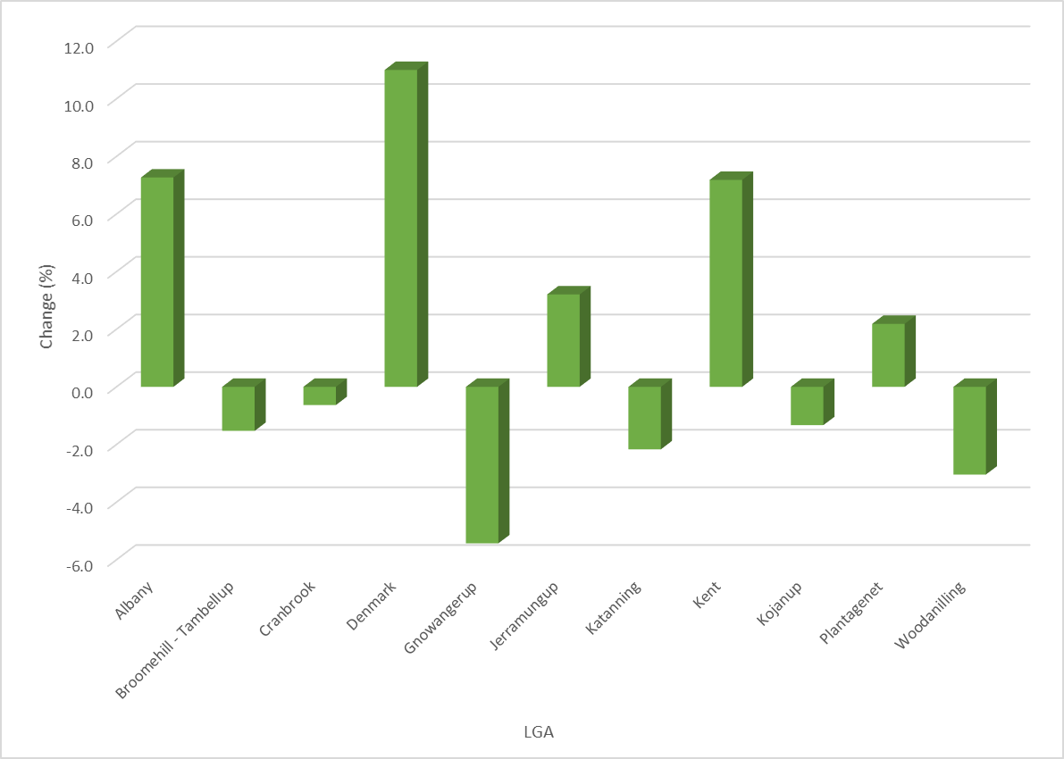
Table 3: Population Projections for the GSR 2016 to 2026 (ABS, 2016 & WA Tomorrow Band D, 2021 & 2026)
Shire/Region | 2016 Population | 2021 Population | 2026 Population | Change 2016 to 2026 | Change 2016 to 2026 (%)
Albany | 37,407 | 39,140 | 41,270 | 3,863 | 10.3
Broomehill-Tambellup | 1,160 | 1,060 | 980 | -180 | -15.5
Cranbrook | 1,103 | 980 | 910 | -193 | -17.5
Denmark | 5,964 | 6,400 | 6,910 | 946 | 15.9
Gnowangerup | 1,236 | 1,140 | 1,070 | -166 | -13.4
Jerramungup | 1,126 | 1,390 | 2,330 | 1,204 | 106.9
Katanning | 4,197 | 4,680 | 4,790 | 593 | 14.1
Kent | 567 | 470 | 460 | -107 | -18.9
Kojonup | 2,003 | 1,920 | 1,780 | -223 | -11.1
Plantagenet | 5,142 | 5,340 | 5,410 | 268 | 5.2
Woodanilling | 414 | 420 | 430 | 16 | 3.9
Total | 22,930 | 23,700 | 25,070 | 2,140 | 9.3%

Figure 2: Predicted Population Change 2016 to 2026 for the GSR (Source: WA Tomorrow, 2015)
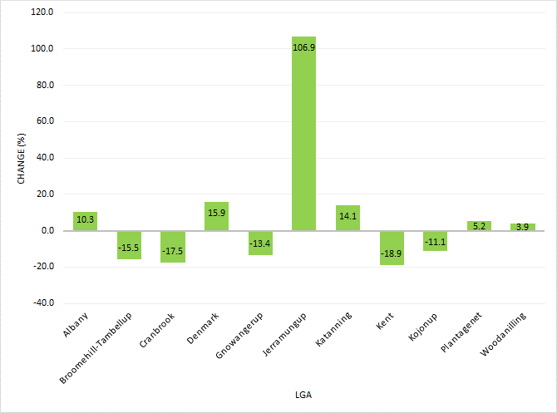

Table 4: Population by Age Group – GSR (ABS, 2017)
LGA | 0 to 14 | 15 to 24 | 25 to 44 | 45 to 64 | 65+ | Median Age
Albany | 18.6 | 11.4 | 22.0 | 27.4 | 20.6 | 43
Broomehill-Tambellup | 23.8 | 8.5 | 24.0 | 29.1 | 14.7 | 39
Cranbrook | 18.1 | 6.0 | 24.0 | 31.1 | 20.7 | 46
Denmark | 17.3 | 8.7 | 17.4 | 31.6 | 25.0 | 49
Gnowangerup | 20.2 | 8.9 | 26.8 | 31.9 | 12.3 | 40
Jerramungup | 20.3 | 6.4 | 26.0 | 32.8 | 14.4 | 41
Katanning | 20.3 | 11.3 | 24.5 | 26.9 | 17.2 | 40
Kent | 22.3 | 6.1 | 28.6 | 28.2 | 14.6 | 39
Kojonup | 21.2 | 6.8 | 22.0 | 29.9 | 20.0 | 44
Plantagenet | 17.5 | 9.9 | 19.9 | 31.9 | 20.9 | 46
Woodanilling | 21.2 | 6.5 | 24.2 | 34.6 | 13.4 | 43
Western Australia | 19.2 | 12.6 | 29.4 | 25.0 | 14.0 | 36

Figure 3: Population Change by Age Cohorts for GSR (Source: WA Tomorrow, 2015, Band C)
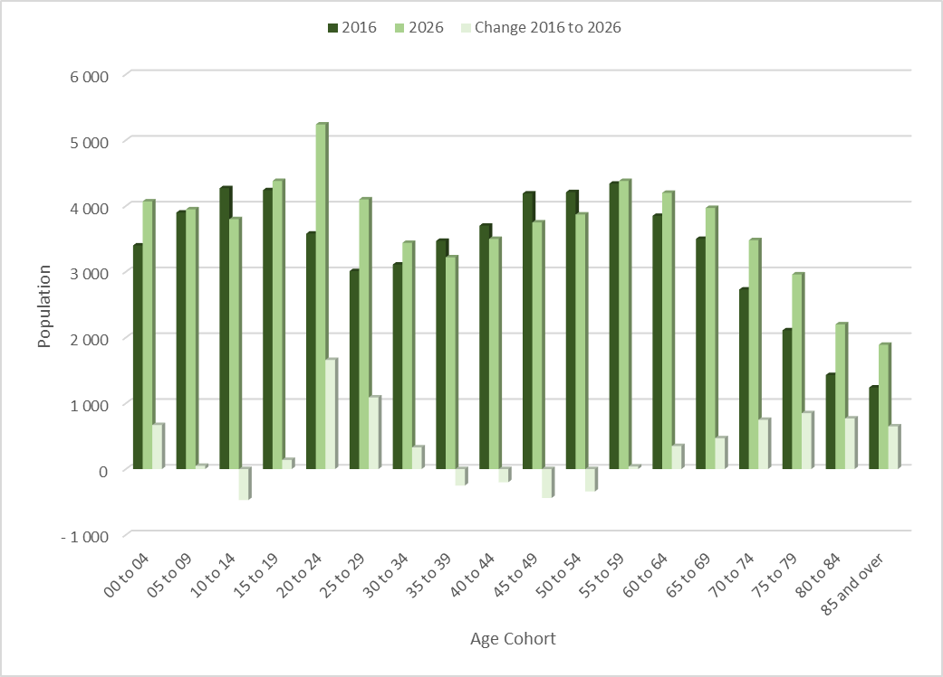
Income
Median weekly household income for all LG areas in the Great Southern is lower than WA as a whole. This highlights, indicatively, a potentially low ability to pay for discretionary services.
Table 5: Median Weekly Income of Great Southern LG Areas (Source: ABS)
LGA | Median Weekly Household Income
Albany | 1,209
Broomehill-Tambellup | 1,242
Cranbrook | 1,047
Denmark | 1,013
Gnowangerup | 1,319
Jerramungup | 1,284
Katanning | 1,205
Kent | 1,342
Kojonup | 1,303
Plantagenet | 1,035
Woodanilling | 1,228
WA | 1,595
The Great Southern has a significantly higher proportion of low income households than WA as a whole.
Figure 4: Low Income Households as a Percentage of the Population
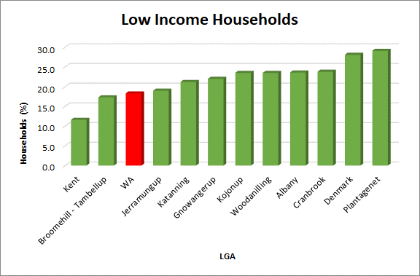
Figure 5: High Income Households as a Percentage of Population (Source: ABS)
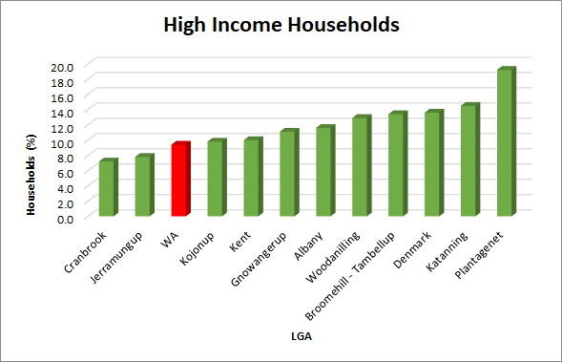
The GSR has a higher proportion of high income households than WA as a whole indicating that there is a strong discrepancy between those who have potentially high levels of disposable incomes and those that do not. This is particularly relevant when considering an individuals or families ability to pay for discretionary services such as those associated with sport, leisure and recreation.
Family Composition
Table 6 identifies the percentages of couples with and without children within the LG’s of the Great Southern. In all areas (apart from the Shire of Kent) the region has a lower percentage than the state average for couples with children and a higher number as a percentage of couples without children in all areas than the state average. This further emphasises the ageing demographic and potentially the ability to retain older children within the local areas.
Table 6: Family Composition across the Great Southern (Source: ABS Census)
LGA | Couples with Children | Couples without Children
Albany | 38.4 | 45.3
Broomehill-Tambellup | 40.1 | 43.1
Cranbrook | 39.0 | 53.0
Denmark | 35.1 | 51.1
Gnowangerup | 42.2 | 44.6
Jerramungup | 40.7 | 48.7
Katanning | 38.7 | 43.9
Kent | 53.5 | 40.8
Kojonup | 39.2 | 49.1
Plantagenet | 35.3 | 49.7
Woodanilling | 43.0 | 48.6
WA | 45.3 | 38.5

Culture
Broomehill – Tambellup has a significant proportion of Aboriginal and Torres Strait Islander population (11.5%), followed by Gnowangerup (8.4%) and Katanning (7.6). This compares with an ATSI population for the whole of WA of 3.1%.
Figure 6: Aboriginal and Torres Strait Islander (Source: ABS)

The majority (72.8%) of people in the GSR were born in Australia, compared with 60.3% for Western Australia as a whole. Of those born outside Australia, England (6.9%) was the most common birthplace, followed by New Zealand (2.2%), the Philippines (1.2%) and South Africa (1.0%).
Figure 7: Country of Birth (Source: ABS)

Appendix C: Consultation Outputs
The following framework was followed throughout the LG interview process:
- Overview:
  - Strategic Sites
  - Alignments
  - Issues
  - Viability
  - Flexibility
  - Funding Commitments
- Sports/Recreational Priorities
  - AFL
  - Football (soccer)
  - Cricket
  - Netball
  - Basketball
  - Hockey
  - Rugby League/Touch
  - Rugby Union
  - Motor Sports: Motocross, speedway, 4WD, Driver training/track, Enduro/Trials/Trails
  - Ballistics
  - Golf
  - Aquatic: Water Polo; Swimming, Masters, Triathlon
  - Cycling and trails
  - BMX and Mountain Biking
  - Tennis
  - Bowls
  - Equestrian
  - Water – coast – Surf Life Saving, Motorised water sports, sailing/boating
  - Water – River Environment – Canoes/Accessibility etc.
  - Adventure Sport – endurance events/Ropes/Trees etc.
  - Fitness/Gym
  - Martial Arts
  - Gymnastics
  - Play/Nature – destination points
  - Dance
- School agreements and current successes/challenges
- Cross Boundary priorities
  - Developmental
  - Competition
  - Events
  - Tourism
  - Economic Development
  - Cost sharing
- Benchmarking – optimum/ideal models
- Management – preferred models
- Asset Management.
Table 7: LG Consultation Output Summary
Representatives | Main Considerations | Implications
City of Albany | General:  - Key priorities are their strategic plan: Clean, Green, Sense of Community. Current perceptions survey scored the service above the state average. There is a need to maintain and improve. Completion of Centennial Park with the completion of the junior Australian Rules Football node ($6M investment).  - Tennis feasibility study is to be undertaken in partnership with Tennis West to rationalise current infrastructure.  - Hockey turf is in need of replacement.  - The need for a 50m pool requires investigation.  - Collingwood Park (Bayonet Head Complex).  - Sport and Recreation plan is not yet completed but audits of all sports have been undertaken and completed.  - The futures plan advocates addressing obesity and keeping people active through Active People. Active Places seek to support ongoing maintenance etc.  - Active Albany is an overarching program to get people active and is linked to the Public Health Plan. It picks up population groups and is being rolled out 4 times this year. There is the opportunity to embed outdoor adventure with the program. Healthy Albany will undertake the evaluation.  - A smart club program is operated and embedded within Active Albany. A holiday program is linked in.  - Junior sport is increasing in Albany which is bucking the trend nationally. All juniors are stand-alone associations. Hockey and Netball are the only sports aligned to adults together with the Surf Life Saving Club. It is however not good for clubs as it impacts in succession planning and club development.  - There is strong rural family input into cities with a strong volunteer network. There are issues with seniors not having sufficient volunteers. The City alone cannot attack this matter singularly as a far bigger approach is required.  - The City has a fantastic tourism approach and well-developed alliance with Shires of Plantagenet, Denmark and City of Albany.  - There is currently no equine in the sports plan and no recognised BMX activity in Albany.  - Cycling is focused on mountain biking and Over 50’s. Orienteering and triathlon are also active.  - Equine – very popular with high performance athletes. An indoor arena exists on Robinson which is the only covered indoor arena in the region – a number of clubs are based there. Riding for the Disabled (King River) is provided.  - Centennial Park meets the sporting needs in all but Tennis and Hockey (who want a second turf to service a membership of 700-800). Lighting is the next big-ticket item to ensure the site is used more intensively.  School agreements:  - There is good support from schools and they have good models in place.  - Have used schools with positive results – St Josephs with junior football. There is an opportunity for clubs to partner with schools to deliver sport.  Opportunities to work in partnership:  - Denmark and Plantagenet partnership is good and there should be other opportunities explored to work together.  Benchmarking:  - Main comparative benchmark LG’s are Esperance, Bunbury, Geraldton and Busselton.  - The fee structure for Centennial Park came from Melbourne – Fields are booked and coordinated through the City. It all links to maintenance. Associations collect money for core fees. Sports manages sport.  Issues:  - Governance has improved and relationships are building with the City. There is still some work to do to improve further.  Management agreements:  - Preferred multi-sport, multi-functional summer and winter use with seasonal sports combined. License agreements for the season with MOU. There needs to be consistency and the City want control over the management and require control over the asset.  Asset Management:  - There is a 1/3rd 2/3rd split with the clubs – there is a push for user pays as much as possible.  - Collingwood and Centennial Park are the main assets under the control of the City.  - All leased clubs are not on the asset register as all responsibilities are leased out. The City is now trying to get everyone on the same terms.  - Centennial Park is unique with 90% of sports within one complex/area. This has allowed the City to move away from the leasing model.  - The City have used the 1/3rd 2/3rd model from the Town of Cambridge for facility contributions from clubs/City.  - Floodlighting – all have been modelled and upgraded. The City have increased the fee to cover for increased energy costs but not for infrastructure.  - A report to council is provided each year with asset plans updated annually – renewal is based on the long-term plan. Terrain is also valued. The levels of service are based on community service outputs. Licenses still need to be put in place for the stadium. Currently senior football (soccer) and cricket are holding off on signing the licenses but it is expected to be resolved. Multiple asset classes are provided in one space. Categories follow the DSR classification and there are two levels for the sporting infrastructure – Centennial Park (Regional) and Collingwood Park (Local).  - It is expected that all asset owners take control and understand the whole of life costs. Training is being provided to ensure this is implemented.  - There will not be too much growth in the recreation space with priorities identified as Little Athletics (knock down and rebuild) and tennis (although the City has no ownership over any facility – more of a strategic role).  - Funding for clubs and getting funding for clubs is the City’s strategic role as facilitator. City would seek to license and control.  Parks Management:  - Expectations of the public are getting higher and higher.  - Every sporting field is maintained by the City in Albany. This has become a higher profile in recent years particularly with the development of Centennial Park. A booking officer and club development officer position has changed relationships and there is now more engagement.  - Focus for the City is spraying, mowing, fertilising, roads, fencing etc.  - The main issue is use with the new development which has been a challenge to accommodate user groups and for them to accept a different way of working.  - Sports are met every Friday to go through issues (both winter and summer sports).  - The City help out other LG’s where there are issues in getting contractors in to do the work (Denmark and Plantagenet). There is now a push for the City to liaise with the shires.  - Issues to manage on an ongoing basis: clubs will never get the fields back; volunteers are getting harder to find although the clubs are happy with the approach of the City. Turf is a huge upkeep but the City is committed to working across boundary to assist other shires (this however will necessitate the purchase of additional machinery).  - Sharing knowledge and experience with all LG areas is important and needs to be formalised.  - There needs to be consistent messaging across SSA’s and LG’s.  Land Use Planning:  - The Local Planning Strategy is in the process of being prepared. Population projections and demographic implications have had to be amended following the publication of the 2016 census data which has reduced the City’s resident population by over 1,000.  - McKail and Bayonet Head are the major growth areas where new infrastructure potentially will be required at a local level.  - Liveable Neighbourhoods cannot be applied to Albany. The PLA WA guidelines have been used to benchmark and the City is looking more actively at shared use school provision.  - 2 main considerations are to protect Collingwood Park as a district facility and co-locate other infrastructure wherever possible.  - There is currently no DCP for community infrastructure and there is a need to know where and what should be undertaken. Currently a per lot contribution is used.  - There is a need to start costing the facilities.  - In regional areas there is great difficulty due to the slow rate of development. Population growth throughout Albany is slow but steady.  - Economic assessments undertaken indicate a number of economic development growth opportunities related to health, tourism, education and agriculture.  - Diversity will attract economic growth but is unlikely to happen. The exportation of material from Albany Port would have been a driver but with the loss of the iron ore project, this has resulted in a lost opportunity.  - Key considerations: growth in holiday accommodation and 17% vacancy in rentals. There is a need now to focus on activity centres and consolidate around these. | Current and future facility development from a City of Albany perspective can be summarised as:  - The continued promotion of Active Albany programs and the need to ensure equality and diversity of opportunity for all. This ideally should be integrated with the investment by the state in complimentary outdoor adventure programs and services.  - Maintaining and enhancing the current level and quality of service provision.  - Ensuring that there is consistency across all sports in the level of provision and management of infrastructure.  - Continuing to develop appropriate standards/ benchmarks which are then adopted and continue to be implemented.  - To continue to educate and alter the mindset from separate junior/senior provision to an integrated service delivery model to develop sustainable clubs.  - Foster and develop alliances and partnerships with neighbouring LG’s.  - Continue to enhance and improve asset management practices and particularly train and develop clubs understanding of their obligations.  - The primary development focus of the City will continue to be on rationalisation and shared infrastructure development with a particular focus on:  - Centennial Park completion and its ongoing management.  - Collingwood Park – to master plan and consolidate sporting activities.  - The future evolution and long-term viability of hockey and tennis.  - To evolve current asset management practices and provide opportunities for other partner LG’s to benefit from sharing of best practice and standardising an approach.  - Consider the provision of a regional ‘one-stop-shop’ to assist and promote the development of good business systems and processes across GSRLG’s.  - Those sporting facilities which are not within the control of the City will require ongoing facilitation support to ensure their long-term viability is maintained.  - The funding component relating to asset apportionment will requiring ongoing involvement with the clubs to re-enforce obligations and a changing of current mindsets.  - To investigate the opportunity to share resources between LG for contractor services to reduce costs and increase capacity for the overall benefit of the Great Southern.  - Consideration should be given to the development of an integrated regional events strategy in partnership with other GSRLG’s.  - The continued evolution and development of the City’s sport and recreation plan should incorporate a strong alignment to influencing a Developer Contributions Plan to provide greater certainty of investment.  - The City as the main population centre within the Great Southern has the potential to lead and support other LG’s across tourism, economic development, business and operational practices.
Shire of Broomehill-Tambellup: | General:  - Consider that Katanning is the shires regional centre for sport.  - The loss of a football team due to population downturn is an issue which is unlikely to be resolved. Sports however are fairly resilient.  - Netball is not played in the shire and Basketball has shifted to Katanning.  - Tennis has dwindled in both towns.  - The shire is missing the sports development officer, following the lack of success in securing funding. There is a lack of capability and capacity to undertake that role currently.  - The nature of volunteering has changed. Succession planning is not big but clubs are relatively strong. Tambellup has established a management committee for the new sports facility based on that existing at Broomehill which has worked relatively well. Hockey, cricket, bowls, junior football and tennis are the key sports.  - Building is the shires responsibility as is the maintenance of the oval.  - Golf course is operated independently.  - Sinking funds are required of the recent funding agreement.  - Broomehill is financially sound and Tambellup is starting with a cash injection. Both towns pay a lease fee and operate a separate replacement fund.  - The relationship with other LG’s has improved with alliancing. This however hasn’t been considered outside of funding. VROC has proved successful with sharing of Building and Environmental Officers. It doesn’t however extend into operating infrastructure.  - Shire is not looking at significant further investment – there are no national parks or significant trails. They do not have any significant tourism points although the shire is involved in Hidden Treasures.  - Motocross in Cranbrook will offset future need for off-road activities.  - Caravan Park – shire has identified bowls club as a potential option as a caravan park. The idea has been floating for a number of years as it is a good building which can be converted at a low cost. Site is flat and large – there is a need for showers and toilets.  - There are no emerging themes although future focus is likely to be on sustainability.  - How to retain residents.  - Grant application for housing – farm workers housing and itinerant workers. The option for dual tourism/farm worker dwellings is being considered.  - Without infrastructure the shire will continue to decline in numbers.  - 6 independent living units (5 out of 6 are now occupied) – likely to be a continuing requirement with HACC funding in part the senior’s aspect.  - Sporting infrastructure is critical for providing an opportunity for people to come together.  - The shire would like to have come-and-try sessions for all sports and provide opportunities to access either Katanning or Albany. The shire however hasn’t considered demand as part of the community strategy.  - Walk trails within the township are important, but there are greater needs than expanding this further.  - There is an issue with SSA’s not stepping up to the mark in servicing regional areas.  - Funding commitments are limited to routine maintenance.  Sports:  - AFL: juniors in Tambellup (Auskick). Sport is in recess. It is problematic as there are three associations locally. Associations are not aligned with other sports.  - Cricket – both towns have senior cricket operating in the Central Great Southern.  - Hockey is very strong with men’s, women’s and juniors in both towns. Putting a turf into an association changes the community dynamics and this should be considered carefully before investing.  - Golf – 2 clubs but not many women playing. They are actively seeking new members and increased use.  - Tennis – currently going backwards.  - Bowls – strong and active.  - Equine – mainly undertaken on farms.  - Gym – currently do not have significant space. Could be considered on a cost recovery basis. Access to Katanning provides the option to use infrastructure.  - Football (soccer), netball, basketball, motorsports, ballistics.  - Water sports – the Gordon River allows canoe access and provides opportunities but is not promoted.  - Cycling – difficult to know demand due to lack of availability.  - Population is insufficient to justify investment in a skate park.  Schools:  - Have been reluctant to allow access to facilities after hours.  Cross Boundary Opportunities:  - Partnership with housing to be expanded.  - Would always participate if invited and are engaged with tourism opportunities.  - VROC could pursue the club/community development officer path.  - The shire can piggyback but cannot lead.  - Potential to align events across partners.  - A standardised community perceptions survey is being developed across the 4 VROC councils.  Benchmarking:  - It would be useful to have standardised services across LG’s. Cranbrook and Gnowangerup are considered to be the best comparators.  Asset Management:  - Currently in place for plant and equipment. They undertake it on behalf of the clubs, but this may change with the new pavilion.  - There is a requirement to put money aside for rejuvenation. | Current and future facility development from a Shire of Broomehill-Tambellup perspective can be summarised as:  - The lack of a club development officer has impacted upon the shires capability and capacity to undertake effective support for clubs. This potentially leaves the shire at high risk following recent investment in Tambellup. Support will be needed to ensure that effective governance and appropriate sinking funds are committed to sustaining the facility.  - Whilst it is considered that clubs are relatively strong, the management committee for the new sports facility will need direction.  - The shire has found value in VROC with the sharing of Building and Environmental Officers. This could be extended further to incorporate community and club development support and in addition a collective approach to asset management.  - It is recognised that good quality infrastructure is required to address the decline in numbers. Sporting infrastructure is critical for providing an opportunity for people to come together and therefore the value of investing in volunteer support and effective governance models is critical.  - As with other LG’s the shire has raised concerns with SSA’s not stepping up to the mark in servicing regional areas.  - The lack of a developed asset management process will place the shire at risk given the extent of infrastructure currently provided across the two towns. The need to put money aside for replacement and/or redevelopment (in addition to routine maintenance) is important and should be considered as part of future budget planning.  - The loss of AFL is problematic and is likely to impact on the ability for residents to gain access to sporting competition. The role that sport plays in the community is for both social engagement and mental/physical health and wellbeing.
Shire of Cranbrook | General:  - The shire has invested considerable resources in the past 10 years at Frederick Street in Cranbrook. This has included change rooms and pavilion, resurfacing of courts (2012) and the bowling green is now 7 years old.  - There has been a lot of fundraising but the facility has struggled with finances and members. The club maintain control.  - The facility can cater for 150 people with a bar, commercial kitchen, meeting room, creche etc.  - The oval is subject to a storm water harvesting project.  - The Frankland River Country Club is in a central location with a new bowling green, oval and synthetic cricket wicket. The shire would like to see a redevelopment of the country club to create a larger pavilion (identified in the strategic plan). It is reasonably financial.  - Tenterden only has a tennis club. Investment made in the clubhouse 2 years ago but the need to improve ablutions has been identified. It is managed by the tennis club and has strong junior membership.  - Motocross is the main strategic project – a regional facility for the Great Southern. They are on the intercross series and need to secure a national event. Feasibility study undertaken by Trailbike Australia was completed in 2015. Seen as a major tourism driver.  - Stirling Ranges/Wildflowers/Wineries attract caravanners but there is a need to have something that holds people in Cranbrook.  - Sports are very basic in the town with darts, cricket and netball being the most popular.  - Water ski clubs have been visiting Lake Poorrarecup this year as it is a cheap resource for Perth Clubs (only camping fees are charged).  - Airstrip in Cranbrook could potentially be used for hot air balloons.  - Fantastic uptake of Kidsport in the town.  - There is a rates reserve account with 10% of all early payments going into a community facilities fund. Frankland River has $200k currently in the account.  - An ageing demographic coupled with the loss of year 7’s two years ago has created further problems. Whilst City people have moved down, they tend to be less heavily involved in volunteering.  - The strategic community plan indicates a push on passive recreation, nature play and exercise equipment.  - Seniors housing is in demand to retain the community in place.  Alignments:  - Part of VROC which is considered to be an important cross boundary group.  - Predominantly head down to Albany for sports (also Mount Barker).  - Shire have a club development officer in conjunction with Plantagenet which takes the workload off the shire officers. They would wish to see the partnership continue.  - Tourism – part of Hidden Treasures and nature based promotions. There is a need to focus on overnight visitor stays.  - Economic – wine industry needs to grow in tandem with Margaret River.  Issues:  - Rationalisation of all sports has been a big issue. In Cranbrook a number of sporting clubs have been lost and consequently there has been a loss of social infrastructure.  - People will not travel to Cranbrook to play. Associations are based principally in Albany or Katanning.  - Getting juniors involved.  - It is a socio-economically challenged shire.  - Volunteering – the key challenge and particularly succession planning.  - Strategic planning and the lack of a long-term vision.  - Changing culture – the way people think and act needs to be more like a business. Focus needs to be on good governance, strategic planning and grants (facilitated by the club development officer).  - Fees for clubs are high.  - Travel costs are an issue and there is no shire funded grant program.  - All sports operate at different times and different nights.  - Drugs – clubs have however been very proactive with addressing mental health issues.  Sports:  - Cricket – Frankland River Cricket Club is vibrant with good numbers. None at Cranbrook due to lack of numbers.  - AFL – no Auskick this year due to numbers. Seniors travel to Mount Barker. Generally just Auskick in Cranbrook.  - Netball – strong club with 5 to 6 teams which play in the Albany Association (competition in Albany but train in Cranbrook).  - Basketball play in Mount Barker and there is provision to shoot hoops in Cranbrook.  - Hockey – none locally as they travel to Kojonup or Mount Barker.  - Golf – one active golf club but also provision at Frankland River.  - No football (soccer), ballistics, water sports.  - Aquatics – access to Albany is main option although Mount Barker provides more localised learn to swim. Water play is to be provided at the oval. Master planning is to be undertaken within the next financial year.  - Cycling and trails – no formal groups but have looked to develop heritage trails within the shire.  - Mountain biking – opportunities within the motocross site. There is no BMX.  - Teenage/Youth activity – always pressure but no real issues. Frederick Square needs to be more youth friendly. Skate parks (2) need upgrading over time.  - Tennis – strong in Tenterden, social in Frankland River and pennants in Cranbrook.  - Bowls – Cranbrook and Frankland River but subject to membership fluctuations.  - Equine – mainly focused at Mount Barker.  - Adventure Sports – there is potential to investigate further in relation to natural resources.  - Gym – Frankland River have expressed an interest for a gym.  - Gymnastics is focused at Mount Barker. Shire provides money to upskill residents on coaching. There are fitness instructors in town which utilise shire hall and studios at Frankland River.  Asset Management:  - Cranbrook – Well advanced and structures have been put in place. Lease with building maintenance responsibility.  - Bowling Club – contribute to replacement cost of green.  - Golf Club are very proactive.  - All structural aspects reside with the shire, including maintenance of the oval, playground and skate parks.  - Frankland River – Shire manage oval and courts. Club own the building. The golf club has stopped and the building is in a very poor state.  - Tenterden is a shire reserve and facilities will therefore be managed and maintained by the shire.  - Viability is mixed due to culture of clubs.  Shared Use Agreements – Schools:  - Excellent and proactive relationship with Cranbrook Primary School. Cranbrook is a central hub for inter-school carnivals.  - The shire has liaised closely with schools to get children more physically active.  Funding Commitments:  - Frankland River – but there is a need to develop a steering committee to drive the project. Oval is currently being re-done.  - Tenterden is to receive funding for a stage 2 development.  - Tender due to be released in July 2017 for motocross first aid, scrutineering and covered start area. The construction of the track with basic fencing of block and safety around track has been completed. Irrigation of track is currently being looked at. Stage 2 will involve the development of a pavilion/kitchen/car park and stage 3 improved track fencing and camping area to provide for wider use.  Benchmarking:  - None – the shire is very proactive for its size.  - Very proactive community who are seen as the main drivers of any infrastructure development. | Current and future facility development from a Shire of Cranbrook perspective can be summarised as:  - Motocross is the main strategic project – a Centre for the Great Southern. This is strongly supported by a number of partner LG’s in the Great Southern and therefore is a priority across the regional area.  - The Frankland Country Club is ageing and need of investment. In order to fulfil the requirement of the shires strategic plan a masterplan for the site should be developed to identify a staged implementation of a replacement country club to create a larger pavilion and relate functionally to all surrounding sport and recreational infrastructure.  - There is a need to continue the investment (and potential expansion) of Kidsport which has provided a significant contribution to enable low income families to access sporting opportunities.  - As with the Shire of Plantagenet VROC is considered to be an important cross boundary group with the potential to expand beyond its current role.  - The value of the close proximity of the Stirling Ranges; presence of unique wildflowers and proximity of wineries provides the opportunity to attract people to Cranbrook. The use of sporting infrastructure to support these events and provide broader social engagement opportunities should not be underestimated.  - The shire value the input and involvement of the shared club development officer which offsets the lack of resources available to support social, recreational and sporting infrastructure. It is important to retain this capability but with a more broader community focus.  - As part of Hidden Treasures and nature based promotions there may be opportunities to also link these more effectively with the use of club based infrastructure to increase viability.  - Volunteering, as with other regional LG’s is a key challenge and in particular, succession planning. This could be improved with more effective coordination between sports and recreational groups.  - Drugs, mental health and general wellbeing has been identified as a critical issue which clubs have sought to address. This could be integrated with more effective mental health and wellbeing initiatives undertaken by the shire in partnership with state government.  - Another similar theme to other LG’s is the changing culture relating to good governance, strategic planning and attracting grant assistance. There is now a need for clubs to reconsider their current structure and embrace their role more effectively as a social hub for the wider shire community with sport and recreation being used as the vehicle to support and retain residents locally.
Shire of Denmark | General:  - The strategic community plan is currently in development with environment, sport, recreation and culture identified as high investment priorities. This includes maximising natural environmental opportunities (trails; mountain bike events; improved green space etc.).  - There is a high number of aged people and primary school entrants.  Alignments:  - The alliance with Plantagenet and City of Albany is the most important. A tourism focus with diversification opportunities.  - Strong working relationships have been developed with state government departments.  - Denmark Arts and Tourism has been effective as has the relationship with Department of Biodiversity Conservation and Attractions in respect of trails.  Issues:  - Green space at McLean Park – competing for time and space. One facility with lights effectively managed is required.  - Football (soccer) has grown and is the largest junior participation sport which requires space to play.  - The recreation centre space is a serious concern – used heavily after 3pm and by high school and other schools.  - There is a need for another green field in the shire which is well located being central to the main administrative town of Denmark. A sporting hub and not a satellite site.  - There are two active groups DACCI for swimming provision and gymnastics who are seeking a stand-alone gymnastics facility.  - Volunteer support is a weakness for every club. There is a need to train and develop volunteer capability but this takes time. There is a concern that some club positions are now paid. The club development officer will assist but if funding is pulled shire would have to consider taking the position on in-house.  School agreements:  - There is an agreement with the high school for after-hours use, but there are only basic facilities on site. Agreement is in place until 2021 but Education Department have no control and there is a real threat to the loss of green space.  Funding commitments:  - $500-600k to go into existing oval adjacent to recreation centre.  - A second oval is the next priority.  - A commitment to redevelop the Surf Life Saving club has been given to invest $3M to $4M over the next 2-4 years.  - A gym is incorporated within the shires long term financial plan.  - Gymnastics investment may be considered through the potential re-use of an existing building.  - The shire does not have sufficient capital reserves to invest. Groups do not have the available financial resources either.  Sports:  - AFL is very strong in town – weakness is two separate clubs (juniors and seniors) which has been a divide. They could operate under one banner. The junior club is strong with good membership numbers. The oval is for community use and not purely for football. Drainage of the oval is shot and needs immediate upgrading. There is a danger the shire will not have an oval for 12 months in order to address this issue.  - Football (soccer) – the highest growth sport with a strong and viable junior base. There are 3 x women’s senior teams and 1 x men’s. They have games on the eastern side of the oval but play mainly in Albany. Would require enhanced changing facilities to provide for both home and away teams.  - Cricket – A growing senior club with 2 senior teams and juniors up to 14. There is a drop off around the 15-16 age range and in particular young adult. They tend to migrate back to town from the age of 40+. The agricultural college provide team members but they leave after 3 years. Facilities are poor. There are 2 nets at McLean Oval but poor hard wickets and not suitable from a health and safety perspective. The long-term vision is for a turf wicket on the second oval.  - Netball – a strong junior set-up and senior competition. They play in the Albany competition. There is a senior comp of 14 teams in Denmark. The future is potentially to develop an additional court.  - Basketball – programming space is an issue but use is still strong. There is potential for a basketball extension at the high school, 200 senior members and 300 juniors.  - Hockey – no club but people play in Albany. Occasional indoor hockey but no real interest in further development.  - Touch rugby – have a touch group which operate in the summer for social/fitness purposes. No rugby league.  - Rugby union – previously had a club but in recess. Potential to participate in 7’s.  - Motorsports – there are no formalised tracks and no issues with unauthorised off-road activity.  - Ballistics – pistol (quite active and have received grants for infrastructure) and clay target (small but have requested a skeet throw) clubs.  - Golf – well catered for with grass greens based at the country club – it is managed independently and do es not call on shire resources. The club appears to be operating successfully with a strong ladies’ membership.  - Aquatic – Greens Pool is the main focus. There is no indoor or outdoor facility, but this is on the radar all of the time. Albany aquatic centre is used by the Denmark swimmers. The local hydro pool closed down due to cost and legislation obligations.  - Cycle and trails - A huge issue and demand – could also include mountain biking. Trail from Ocean Beach to Lights Beach to be developed – potential major tourism investment for the cashed-up demographic. There are currently no BMX or pump tracks – this could be developed as part of an integrated youth precinct.  - Tennis – operate from the country club and are strong. There are 8 synthetic courts with no floodlighting in Denmark and satellite clubs elsewhere. Floodlighting is required at the main club site.  - Bowls have 2 synthetic greens and have been well serviced. The riverside club also provides for canoeing, classic boat, kayaking and dragon boating. A good example of a new multi-functional facility which has been very popular and marketed well. Low cost alcohol has increased membership.  - Equine – equestrian centre houses Riding for the Disabled, equestrian club and other users. A master plan has been undertaken for the site which is leased and subject to an MOU with the club. It is a very good space in good condition and well-resourced.  - Watersports – There is Denmark Yacht Club, Boating and Angling Club and Surf Life Saving Club. There is a working group looking at a new facility with a strong focus. Currently undertaking coastal research on the impact of climate change and potential implication of the repositioning of the Surf Life Saving Club. Ideally would combine uses into one building.  - The shire is looking to develop a water trail. The second phase is in place now for a waterfront development. There is no access to the ocean but canoeing is really good.  - Adventure Sports – Monkey Rock climbing facility and Whaleback Trail. There is huge scope for mountain biking and has potential to hold an Anaconda event (easy to develop an adventure race based on current tracks and trails).  - Fitness/Gym – a fully operational 24 hour gym exists at the recreation centre. There could always be more space but group fitness is well catered for – potential opportunity to develop a sprung floor. Court space is used for classes.  - Martial arts are in recess having focused on private enterprise.  - Gymnastics is more of a private enterprise. It is run by one person and concerns have been raised over the need for the shire to support a commercial operation. A delineation is required between the commercial venture and council obligations.  - Nature Play – a good local provision is located near the hospital.  - The skate park needs to be relocated in a centralised area with integrated youth activities – potentially integrated with a pump track.  - Dance – operated by private enterprise.  School agreements:  - Doesn’t currently work that well with the High School – oval works as a training facility but in need of investment. The potential loss of the oval is a massive threat as it caters for football (soccer) and junior cricket and offsets the demand for McLean Oval.  Cross Boundary priorities:  - Potential use of cross boundary staff – City of Albany is gaining knowledge from new development and advisors and is upskilling staff.  - Competitions are run in Albany which is a concern as all decision making is focused on the City. Albany teams are generally too strong. Associations need to provide leadership and delegation of talent.  - The competition does however push the shire to enhance its facilities.  - Events – focus on tastes (food and wine), arts and Festival of the Voice. There is the opportunity to look at sport and recreation events in the future.  - There is a need to set up a marketing brand for the Great Southern together with an integrated calendar of events with satellite sites in Denmark.  Benchmarking:  - Centre is registered with Centre of Economic Resource Management (CERM). Shire of Murray is nearest shire benchmark although the Shire of Denmark doesn’t have the level of population growth. Dardanup and Margaret River are also appropriate benchmarks.  Management Models:  - Would prefer to develop a model based on multi-use facilities and multi-functional activities with one club/sporting organisation responsible for management. This would be dependent on the maturity of the sporting clubs.  Asset Management:  - None is in place at present and the shire is working through the process to provide a scope of works on what needs to be done. | Current and future facility development from a Shire of Denmark perspective can be summarised as:  - The environment, sport, recreation and culture is consistently identified as high investment priorities for the shire. It is therefore important that a strategic approach to investment is maintained which appropriately controls expenditure in line with available budgets and return on investment.  - Projects which need to be prioritised include:  - Development of green space at McLean Park as the main sporting hub with appropriate lighting and effectively managed.  - The development of a subsidiary green field centrally located as a sporting hub to offset the demand at McLean Oval for football (soccer) and junior cricket. This ideally should be at the High School through an extended shared use agreement.  - The considered development of an outdoor pool having regard to current and future financial limitations.  - Further extensions to Denmark Recreation Centre to enhance gym and storage infrastructure should be considered.  - Trails and cycleways (including mountain biking) have strong tourism potential and investment will need to be set aside to implement a strategic trails plan in conjunction with regional partners.  - The alliance with Plantagenet and City of Albany is the most important. The current tourism focus should ultimately be expanded and diversified to incorporate shared learning and understanding of facility provision, asset management, events, performance management and project implementation.  - As with many LG’s the Shire of Denmark is experiencing difficulties with volunteerism and the lack of capacity within the community. A program to train and develop volunteer capability shared across GSRLG’s could provide an effective utilisation of limited resources.  - A consistent approach to integrating seniors and junior club development activities should be pursued across all GSRLG’s.  - The equestrian centre Master Plan requires considered implementation with regard to equine activities being provided in Mount Barker, Albany and Kojonup. Ideally all sites have the potential to develop a regional tourism and events service offer that focuses on the horse industry. This could also be combined with other sporting, trails and food/wine events.  - The development of youth activities (including the relocation of the skate park in a centralised area with integrated youth activities and a pump track) should be underpinned by a youth strategy. The Shire of Denmark is experiencing similar issues to other GS LG’s in having to provide for an ageing population whilst addressing the previous lack of investment in youth. This twin tracked approach will require innovative practices to be developed.  - The development of multi-use facilities and multi-functional activities at one site should be targeted at McLean Park. The shire should seek to facilitate the adoption of an effective governance structure and communications.  - The lack of asset management systems and processes puts the shire in a high-risk category relative to the sport and recreation assets they maintain. All infrastructure is in need of maintenance investment and planned replacement. It is unlikely that this could be achieved without adopting a phased investment process. This should be developed in conjunction with advice and best practice learning from partner GSRLG’s.
Shire of Gnowangerup | General:  - The shire has 3 sporting complexes within its boundary:  - Ongerup lost its football a few years ago and is very rarely used.  - Borden Pavilion which was built as a music venue with bowling and tennis and has recently lost its football.  - Gnowangerup which has recently received significant levels of investment.  - Each town has a unique community and used to be very competitive.  - Money is obtained through the cropping program (originally a community program but sport took it over)– Borden and Gnowangerup have excellent resources but would not be sustainable without the program. $100k from crops went into the recent swimming pool development. No plan is in place if it were to fail or to be re-diverted to broader community requirements but people are averse to change.  - Old agricultural land was used which is to be handed over under native title (Land and Sea Council obligations).  - All complexes have a strategic plan and are putting money aside to manage replacement of assets. The shire provides an operational subsidy (17% to Gnowangerup due to its size and 100% to Borden).  - If the council can’t pay this would be an issue – a population of 1,200 which is shrinking cannot support the level of infrastructure developed.  - New people coming in are generally Philippine’s who stay for 2 years and have limited interest in traditional sport.  - Currently no succession planning. This is a high risk when generations change. People are now not wanting to commit and as a result there has been a loss of sports. Kidsport has helped but assistance is required for travel (fuel).  - It is not sustainable to have 3 of everything. Bowling Clubs have however raised money to replace their current surface and won’t move to the sporting complex which potentially creates issues for long term viability.  - They have a 24 hour gym with swipe card access in Gnowangerup.  - Swimming pool was a controversial project as initially it was proposed to be larger, but would not have attracted government funding. It also involved the relocation from the old pool (heritage) site on the advice of DLGSC. It has however been a success. Sharing of change rooms has been a success due to seasonality of use. It is however only open 6 days a week due to inability to provide a life guard during the season.  - The centre has a full-time manager – 15 hours backed up with the Club Development Officer position. There was difficulty with attracting the right calibre of person to undertake the job on a 6-month contract – this is an issue moving forward as the Club Development post has ceased.  - There is a need to incentivise to get people to take part and attend facilities.  Sports:  - Hockey and Tennis in Gnowangerup is very strong.  - Gym = 60m² at Gnowangerup and has been a success.  - AFL: Gnowangerup is reasonably successful with good numbers for a reserves, juniors and senior teams. Ongerup Football Association compete with other shires – 5 teams in the Association.  - Netball: Gnowangerup has 3 grades; no teams elsewhere and mainly travel to Albany to compete.  - Basketball: men’s and ladies’ travel to Jerramungup but seeking to set up a team in Gnowangerup.  - Hockey: strong ladies and juniors  - Ballistics at Gnowangerup (Pistol Club) but no strong involvement with council.  - Golf: Borden is privately run and Gnowangerup is located near the Ag School with sand greens. Numbers have dwindled.  - Aquatic: variety of programs from synchro to morning swimming, life saver training etc. Looking to re-form the swimming club and focus on disability/rehabilitation. There is a need to work the asset more.  - Need to look at coordinating events program.  - Cycling and trails: there is a need to invest in developing a walk throughout the town site of Gnowangerup for individuals/families. This is a priority to be addressed.  - BMX/Biking: no skate park now as it was removed. Council is not supportive.  - Tennis: relatively strong in Gnowangerup with junior development but social in Borden and Ongerup.  - Bowls: three clubs with Gnowangerup winning state club of the year – struggling with numbers.  - No football (soccer), cricket (folded 6 years ago following relocation of pitch), touch, motorised sports, equine, water based activities.  - Fitness, gym, dance, yoga etc. are provided through hire of halls if a local person is prepared to facilitate.  LG Partnerships:  - Something that could be undertaken more effectively.  - No support has been given to the pool and there is no/limited sharing of resources across boundaries.  - There is a need to look at workshop and Club Development Officer sharing.  - Hidden Treasures is the only tourism alliance.  Strategically:  - Strategic Community Plan consultation identifies a need to retain what the shire has – inclusion and unity is strong as is skill sharing.  - Natural resources aligned to tourism is critical.  - Economic development – a need to keep local businesses in the shire. Keep people living in the area. Create vibrancy and increase passive recreation.  School Agreements:  - Not aware of any. School uses the sporting oval.  Benchmarking:  - Not undertaken against other LG’s.  Club Management models:  - Voluntarily run and operated – pitfalls are sustainability and reliant on a very small community group.  Issues:  - Dealing with committees can often be difficult.  - Competition between towns has caused problems and a relative high level of provision.  - Rate of suicide is an issue – no sport = no community interaction.  Asset Management:  - Day to day maintenance is the responsibility of clubs through agreement. No plans are in place for renewals.  - Starting process of renewing and reviewing leases for all clubs now.  - Rationalisation and diversification will need to be considered as there is a real concern that the shire could not afford to take on responsibility of managing current infrastructure.  - Management of the pool is likely to cost in the region of $250,000 to run and there will be a need to look at a different model in future. | Current and future facility development from a Shire of Gnowangerup perspective can be summarised as:  - Asset management and the risk associated with maintaining the level of current infrastructure serving a relatively small population base.  - Rationalisation, multi-functional use and increased capability of infrastructure to service more broader community needs. This needs to be considered in conjunction with rationalising infrastructure within all towns and potential consolidation on one site ultimately.  - Governance and volunteer management. The gradual loss of population and its transient nature which impacts on the commitment to volunteering needs to be addressed.  - Alternative sources of funding need to be identified to that of the cropping program. This will continue to be high risk should the crops fail or an alternative approach is taken to investment of broader cultural activities.  - Sharing of resources and increased commitments to alliances and partnerships with neighbouring LG’s needs to be explored further.  - The staffing and ability to attract adequately qualified and committed personnel to manage and operate facilities.  - The loss of clubs and consistent competitive infrastructure.  - The primary development focus will continue to be on:  - Facilitating the improvement to governance structures and long-term viability of clubs.  - Management of assets in a sustainable manner with regard to the limited and reducing rate base and available budgets.  - Investment in passive recreational opportunities including trails within and servicing town sites.  - Keeping people in the area through non-sport and recreation initiatives linked to housing, tourism and economic development opportunities.  - There will be an ongoing requirement for clubs and associations within Gnowangerup to receive support and advice from neighbouring associations if the use of sporting infrastructure is to be maximised. This will include the extension of aquatic infrastructure use (potentially a swimming club), diversity of sporting use on the synthetic turf and greater social activities focused on the sporting precinct site. Over time this should also include the incorporation of other uses such as bowls to offset ongoing servicing costs.
Shire of Jerramungup | General:  - Asset management is the major concern and how this is dealt with through the planning process.  - A motocross track has recently been established on the boundary with Gnowangerup and there is CSRFF application to provide $750k funding to upgrade sporting provision at Boxwood Sporting Complex.  - Bremer Bay has recently had investment in synthetic bowling and major refurbishments recently at Jerramungup.  - Jerramungup needs a new hot water system. The entertainment centre provides a 2-court basketball facility although the lines don’t meet requirements.  - There is a very strong sporting community. If the facilities receive funding it will provide them with 20 years life expectancy.  - 1/3rd is provided by the shire for maintenance.  Department of Education Shared use:  - Issue with school pool which is likely to come to the end of its life - $2.2M is required to make good and DoE have indicated they are likely to close the facility. The shire however will not let it shut and are currently preparing paperwork for funding. Looking at a potential cropping program. The shire currently contributes $70k annually to its operation. Pool is used by people from a 120km radius.  Governance:  - Clubs are generally good with constitutions and plans in place.  - Volunteers are the biggest struggle.  - Golf clubs are generally operated independently on a membership basis with the shire contributing to mowing and maintenance.  - There has been a lack of attention and capacity to deal with the development of clubs.  Management Models:  - There needs to be a head sporting club who takes on responsibility. Shire reps should be on the management body.  - A leasing agreement is set up with the sporting clubs who have total control under a peppercorn rate.  Asset Management:  - The shires position is that they have no register, no record of maintenance and no written evidence of what has been undertaken.  - The 10-year financial plan allows for major upgrades.  - Skate park at Bremer Bay is due to be constructed this year.  - There is a need to link in the trails at Bremer Bay.  Benchmarking:  - The shire does not compare services against anyone. The shire believes they are in a better position than neighbouring shires.  Partnerships:  - There is no significant sharing across boundaries related to sport and the only competition across boundaries is basketball.  - An economic development policy centred around tourism and in partnership with the City of Albany, and Shires of Plantagenet and Denmark is evolving. | Current and future facility development from a Shire of Jerramungup perspective can be summarised as:  - The lack of asset management systems and processes is a high risk for the shire. This will need to be addressed to ensure effective annual and long-term budgeting.  - There will be a need to establish a sound process and investment program.  - Volunteer management support and facilitation will be needed as an ongoing requirement to sustain viable club infrastructure.  - The issue associated with the pool will need to be resolved as a matter of urgency given the imminent decision is likely to be taken by DoE to decommission the facility.  - The opportunity to share resources across LG’s has been highlighted as having potential benefits to offset limited local resourcing and maximise tourism potential. The evolution of the Tourism Alliance will assist.  - The importance of benchmarking should not be underestimated and it will be important to establish an agreed process with neighbouring LG’s to assist with future investment planning.
Shire of Katanning | General:  - The strategic community plan is currently evolving and has a number of key themes which are important – connections across a diverse community to bring groups together; youth; seniors and health (with particular reference to early childhood).  - Key strategic sites are: The Katanning Leisure Centre (KLC), Katanning Country Club, Bowling Club (to be relocated to the country club), Callaghan Park (earmarked for itinerant housing), Kupara Park (a former football oval - strategy for use of the area is to be determined), Forrest Hill Golf Club, Pistol/Rifle Club amalgamation, Speedway (recently developed), croquet (to keep the site and replace the clubhouse building) and town tennis court redevelopment site (following move to the Country Club).  - A master plan has been developed for the bowls and country club.  - Pony club within Katanning needs to determine its future.  - The Agricultural Society is based at the leisure centre which also incorporates shearing and the farmers market. Equestrian are a separate body. A draft master plan is in place for Katanning Leisure Centre.  - A number of major events including Hidden Treasures, Agricultural Show, Texpo, Southern Dirt Festival, Multi-Culturalism Festival, Greater Southern Merino Sheep and Breeder, Bloom Festival, Eco-week etc. There is a need for a coordinated events program as it is ad hoc at the moment. Also undertake youth events throughout. There is a public relations and events officer within the community development team.  - Clubs have good relationships with state and regional sporting bodies – regular visits occur. Whilst communication with SSA’s is getting better there is still a lot that needs to be undertaken with respect to strategic development work.  - Multi-cultural population is high but female diversity is low.  - The shire has tried to develop small court usage for a variety of Asian user groups (Badminton is run for 2.5 terms).  - The Aboriginal community – good avenues have been developed through the school but it has been slow moving. Wirrpanda Foundation link is strong and there is benefit in having a liaison officer but the role needs to evolve. Noongar Sports and Wellbeing comes and goes but is not sustainable. There needs to be a structure put in place – lot of ideas, lot of talk, good strategic talk, but lack of sustainable strategic base. Engagement would be important between the youth development and Noongar Group.  Flexibility of main recreation area:  - The shire has been proactive with the development of a master plan for the KLC. The option for equestrian to co-locate should be developed based on a 15,000 increase in population. The building is flexible but there is a need for a multi-purpose room for seniors. The building also does not have a dedicated room for group fitness. The gym extension has allowed for that and there is now a need to publicise and educate the community.  - There is an opportunity to develop a hydrotherapy pool at the KLC and partner with the hospital.  - Currently working on water catchment run-off and re-use. The oval has improved significantly.  Issues:  - Volunteer base – in small communities there is great volunteering but not in Katanning.  - A huge expectation by the community that everything will be provided.  - Succession planning is really tricky.  - The low economic situation – cost effectiveness is critical (Kidsport has been useful). 50% are less likely to contribute financially but can volunteer.  - Seniors – there are a lot of programs at KLC and a lot of groups but don’t come together. It is not overly cohesive and could be a lot better.  - General Health and wellbeing. There is an opportunity to do more on health and fitness. There are similar issues with drugs, mental health linked to safety and provision of safe spaces in town. The low employment rate is an issue.  Viability Concerns:  - Facilities are mainly based at KLC and the Country Club. Many clubs operate on licenses/leases on a low/peppercorn rate. They are strategically trying to move sports to two locations.  - Current budget – 50% of shire expenditure is recovered currently.  - Aquatic centre is managed by the YMCA under a 5-year contract (from 2016). Currently unhappy with the service provided up to now – a local management issue. There has been a recent decrease in usage and programs/activities have been reduced. Rationale for YMCA was to address loss of staff and lack of ability for the shire to retain staff.  - Not much in the way of business planning of the KLC and need to review against benchmarking.  - Focus of town has changed to be more practical in its approach. In a year or two’s time it may be possible to bring the pool back under shire control.  Alignments:  - Cross boundary – central southern for hockey, surrounding towns for basketball and netball and Upper Great Southern for Katanning Football Club.  - Bowls generates alliances with other towns.  Funding Commitments:  - Lake Ewlyamartup is a community driven project for a new boat ramp, toilets and park furniture. Part of the Living Lakes Project which has been nearly completed (provides for canoeing, kayaking and water skiing).  - $15-17M redevelopment of Welcome Precinct – a 3-year program with a master plan currently being completed. The shire has committed up to $1.5M.  - Gym extension – loan was taken out to undertake the extension ($400k).  - Master Plan for the KLC is still to be implemented and developed.  - There is a small program for clubs – includes lighting for gun club (on-hold).  - A new administration/civic centre development.  Sports:  - The shire has a club development officer working on a part-time basis (3 days per week) with a complementary role for senior’s coordination.  - AFL is a very active group with a strong membership base and strong leadership. A full range of junior to senior teams with good support from ex-players and families. The license to occupy is currently being updated. Governance across all clubs needs to be looked at and there is a careful balance which needs to be struck between the shires and clubs requirements.  - Football (soccer) club is currently in recess and whilst they have tried to push the club actively it lacks viability. Indoor Futsal has been tried and failed. Multi-cultural issues have been a barrier – lot of CaLD interest but no coordination has been developed. There is no cost in football (soccer) but there is currently nowhere to go. Prosser Park needs to be developed into an informal recreation space – few sports are played informally at present. Ablutions are close to the site and it may provide the solution. A committee and governance structure exists.  - Cricket: 2 x clubs which are both active. Katanning Wanderers has the strongest base. The culture is getting better and they have been more proactive in engaging the community. Succession planning however is not strong. Austrils North is a one team club which plays at KLC. Numbers are not great and club situation is poor.  - Netball: strong with a good executive and good governance. Programs have improved with an increase in numbers. They are proactive with sponsorship and are healthy financially. Operate within the Great Southern Netball Region (hold up to 5 events per year). Good communication with regional board.  - Basketball: very strong with good volunteer base. Numbers are good and provides a junior and senior set-up. Governance could be improved as could communication. There is a need to expand the volunteer base further to keep pace with demand.  - Hockey has increased but struggled with executive committee. There is a good mix of juniors coming through. No clubhouse but kitchen, kiosk and storage is available. Oval has seen an increase in use and part of the master plan includes a clubhouse.  - There is no rugby league and rugby union is in recess – all outsourced to Bunbury, Collie and Margaret River. There is the occasional home game and carnival.  - Motorsports: there is a motorcycle group at a private property (Warren Road) – 2 areas are used and is very informal. There is a community motocross group and the shire support the Cranbrook development. Speedway (cars) is active.  - Ballistics: 3 clubs are looking to amalgamate. Katanning Clay Target, Big Bore and Pistol Club. Also, Wurgabup Rifle Club Inc. A small club – lighting has been deferred due to further consideration of incorporating another club.  - Golf: strong in Katanning with tennis and squash on the same site and potential for bowls. Sand greens, good operation with strong succession planning in place. Forest Hills has grass greens and is operated for social purposes.  - Aquatic: 8 lane Olympic pool which provides a range of water based activities including carnivals, learn to swim, school use, aqua aerobics etc. Swimming Club is in recess. It operates seasonally.  - Cycling and trails: not formal. Funding is to be applied for a Cycle Plan. Options have been considered along railway lines and existing trails. There is currently no mountain biking. There is a BMX track but no club.  - Tennis: an 8-court facility with an active club based at the country club having relocated. It struggles for committee reps. No formal competitions, night pennants, erratic with scheduling. A junior and senior tournament is held each year. It is the base for the Great Southern Tennis Zone (a small organiation which struggles for volunteers).  - Bowls: not huge numbers and are to be relocated to Country Club.  - Adventure sports: nothing at present.  - Fitness gym: fully equipped gym at KLC which is well used. Membership levels at 250+ with optimum of 300.  - Martial Arts/Gymnastics (have just got off the ground – private club). Incorporated a new gymnastics room at the KLC which is used for martial arts and gymnastics. Martial Arts have limited execs but good support. Numbers for juniors is increasing. They both go out of town for competitions.  - Nature Play: to go into Peace Lake with additional outdoor gym equipment.  - Dance: in recess and run privately. Operated in a different venue.  - Badminton: run through a social club which is informal and has few members.  - Volleyball: social at KLC.  - Roller blading: a recreational opportunity within KLC.  - There are currently 2 gymnastics clubs in town.  - Great Southern Merino Sheep Breeders have their events on 2 hard surface courts (6 courts in total – 4 sprung).  - Darts/Pool: independently operated in a pool hall (Amhurst) and darts through hotels.  School Agreements:  - 3 primary and 1 senior school with a proposed middle school. Not sure of any formal agreements. There is a reduction in costs for use of facilities by schools booked through the shire.  - Carnivals are held at the swimming pool.  Cross Boundary Opportunities:  - Tourism has potential with 2 large projects to be developed. The visitor centre model is to be developed in conjunction with the development of Dome in the town. The Welcome Precinct is to be a visitor attractor. The shire recognise Katanning as a concierge town for the Great Southern.  - Competition is becoming more centralised and likely to be maintained.  - Economic development is to be a strong focus moving forward. This however needs to be developed. Needs to work in partnership with the Katanning Regional Business Association.  Benchmarking:  - None undertaken at present.  Preferred Management Models:  - Lease/License for 6 months of the year. Football has exclusive use.  Asset Management:  - This has not been very good and has not been planned for. If something major goes wrong the shire would have to borrow/loan to finance any asset replacement.  - No asset management plan in place.  The shire is good at upkeep and maintenance but replacement is a big issue. | Current and future facility development from a Shire of Katanning perspective can be summarised as:  - Major investment projects include:  - Katanning Leisure Centre (KLC).  - Katanning Country Club including the relocation of the Bowling Club.  - Callaghan Park.  - Kupara Park to potentially provide informal recreational opportunities and football (soccer) provision.  - Forrest Hill Golf Club.  - Pistol/Rifle Club amalgamation and lighting investment to be re-engaged.  - The croquet clubhouse development.  - Whilst a 5-10year contract has been let to YMCA, the shire should undertake due diligence over the next 18 months to determine whether in the long term this will service the greater good of their community and effective performance controls can be exercised to deliver against Strategic Community Plan targets.  - The need for a coordinated events program is evidenced and should be developed in partnership with GSRLG’s.  - The relationship with SSA’s, along with other LG’s has been raised as an area of concern which needs to be addressed. This should also be undertaken in partnership with GSRLG’s to ensure the outcome provides a sustainable benefit to the region. This should also include more effective engagement with Aboriginal community groups and associations.  - The issues with volunteering in Katanning appears to be more acute than in other LG areas. Nevertheless, the issues are similar and would benefit from a shared approach to provide innovative cost sharing solutions.  - The benefit of Kidsport and the potential to expand the program in low socio- economic areas is critical and is consistent with other LG concerns related to ability to pay and access to transport.  - There is a need to develop consistent seniors programs to ensure resourcing is effectively utilised. Seniors could provide a wealth of volunteer capacity to support club development.  - General Health and wellbeing. There is an opportunity to do more on health and fitness. The importance of using sport as a vehicle to address drug use, mental health and wellbeing is a consistent theme across GSRLG’s and should be further developed as a shared resource.
Shire of Kent | General:  - There are 550 resident people.  - Shire is responsible for upgrading facilities and are currently in the process of upgrading Pingrup.  - There are no formalised sports – bowls and Auskick are the only organised sports.  - Half a dozen mixed netball games are played annually and an annual north v south football match.  - Bowls is relatively popular.  - Pavilion is used more than the shire hall and they are seeking to promote its use more. Pavilions are used by playgroups. It is the primary meeting place in both shire towns.  - Nyabing Sports Club is financially sound with historic investment. Football however ceased 3 years ago.  - Pingrup is affiliated to Lake Grace and resource share – facility is tired and in need of upgrading as a major project.  - Recent community survey did not identify sports as a priority.  - Major issue is seniors – still on farm. Major push is to retain the population. Big farms are getting bigger and small farmers are selling up and leaving.  - Rates are $2M per year and therefore they need to be spent wisely – road infrastructure is a priority.  - There are no services from the state operating in the shire.  - Housing is provided for well-aged seniors.  - A relatively affluent population.  Benchmarking:  - The shire doesn’t benchmark against anyone due to its unique set of circumstances. They have a pragmatic rate base which realise they are unable to have everything. Providing opportunities is critical.  Strategically:  - Requirement for better telecommunications.  - Allied Health Services coupled with general health and wellbeing. If people have a disability they have to leave town to receive the appropriate level of support.  Sports:  - None specifically – need to consider exercise stations in towns (outdoor).  Schools:  - The shire has tried to acquire the former oval but has been left vacant due to Aboriginal heritage issues. Article 18 approval is required.  Cross Boundary Opportunities:  - Shared building surveyor (Narrogin), Community Services (Lake Grace) and NRM Officer (Lake Grace).  - A member of a number of formal/informal alliances. This includes a housing alliance program.  Asset Management:  - A 10-year building maintenance program is in place and a 5-year parks and gardens plan.  - Expenditure is managed through a 10-year budget.  - Buildings are shires responsibility and therefore they manage them.  - The bowling club is responsible for its own green.  - Sports club keep money in reserve with the shire.  Financial position of the shire is strong with low debt and a good surplus. | Current and future facility development from a Shire of Kent perspective can be summarised as:  - The sporting infrastructure are principally social meeting places and perform a much broader role than that of sporting uses. It is important that investment is maintained at current levels and each site is continued to be promoted as community centres.  - Due to the unique set of circumstances, the shire has limited requirements to work across LG boundaries and should merely enable clubs to develop their social playing structures.  - An ongoing requirement will be to provide services to keep people well-aged within the community. Therefore, the investment in broader fitness and passive recreational pursuits will be important. This should link to trail/path access and social infrastructure.  - As current asset management processes are well developed (although not strictly in accordance with the state governments integrated planning framework requirements) and the shire is relatively strong financially, the need for additional assistance and further investment in new infrastructure is minimal.
Shire of Kojonup | General:  - Ageing population which used to have a strong volunteer group which has declined significantly.  - Legacy planning is now a big issue.  - Sustainability is a critical issue for the shire. The biggest issue for the sporting complex (which has been the subject of previous master planning, which is now in the process of being peeled back) is overheads. Solar has been installed and 50% of savings have now been put into a reserve account.  - There is a need to change current processes as the shire will not address its issues through providing more infrastructure. The money was wasted on the complex upgrade as it only really serves football. The building is poorly designed and non-compliant.  - The shire has difficulties in keeping young families there.  - A focus now is on trails. Cycle paths will be helpful for youth and to maintain general resident health. This should integrate with health and wellbeing objectives and opportunities explored for horse, cycle and walking trails linked to heritage sites. There is also potential to link with aged care facilities.  - There also needs to be greater connectivity with the golf club, showground and tennis club. There is however no trails plan in place – the old stock trail route from Kojonup to Denmark could be a consideration for bringing in additional tourism dollars.  - There is a need to consider a destination family area (i.e. similar to Darkin) to provide a whole family experience.  - The mitigation measures for the sports complex need consideration – expectation of facilities and reality are poles apart. The oval and hockey grounds are superb but are only used 8 times per year. Very little investment is justified based on sporadic use.  - Club development officer did not provide a satisfactory solution as there is a need to look at broader community recreation and sport – there is an ongoing need to undertake training in house and build capacity within the volunteer base to address club governance. There has been a history of people coming into the community, starting things up and leaving.  - Strategic plan identified the need to focus less on ageing and more on youth.  Issues:  - The showground asset is a significant liability. A sense of entitlement has created a problem and a reluctance to change. Ideally the showground should be moved into town and the sportsground used for the show. The netball area could be covered over and used for markets. The sportsground complies with event requirements, whereas the showgrounds do not.  - Skate park needs to be better located.  - The town is noted for its parks/playground rest stop – it does not want to be known as the best rest stop but as a destination area.  Shared Use, School Agreements:  - There is an agreement in place but they don’t have the ability to run school and shire combined programs.  - The exodus of youth to Perth from grade 6 onwards is a serious concern as under 12’s competitions cannot be fulfilled.  - Agreement looks at usage but not the sharing of resources. There is a need to extend after school hours activities. Building up the relationship is important but will fail if it is just resource and dollar based.  Sports:  - Football (Australian Rules): Much weaker than it used to be as players have been lost – issues associated with drugs, mental health and culture. Wirrpanda Foundation are working with the younger age group to address this.  - Cricket used to be strong but now having difficulty fielding teams. They do not compete. Juniors are reliant on transportation and its availability.  - No football (soccer), rugby union.  - Netball played in Katanning as courts need to be put into good order for training.  - Basketball is Katanning based.  - Hockey is strong regionally. They have alternate and restricted use of the oval.  - Equine: Kojonup is one of the strongest polocrosse centres in the area (Wandella and Mobrup) which holds riding schools, polocrosse and workhorse carts. There are no indoor arenas. There is potential to look at a regional eventing festival and the club need to start thinking strategically.  - Tennis is well supported but tennis courts are out of town at the golf course which has a poor connection.  - Bowls: duplication of bowls club and neighbouring sporting use – this needs to be brought together.  - Golf Club is reasonable but needs to forward plan their asset management obligations.  - Water Sports: Lake Towerrinning is the shires water playground for water skiing, swimming and yachting.  - Ballistics: the shire have tried to get shotgun, pistols (clay then gun club) and archery to work together.  - Motorsport: there used to be speedway and motocross but these have now ceased. The shire support Cranbrook as the regional centre for motocross. No legitimate off-road area within the shire, but there appears to be no demand.  - BMX/Mountain biking: a huge opportunity as the showgrounds lends itself to such use.  - Dance/Martial Arts/Gym: the shire supports such activity by providing access to infrastructure.  - Canoeing: use of the Blackwood River is the only area where activities could be promoted and is dependent on rain.  - Adventure sports: old quarry area could be used for abseiling and other activities.  Partnerships/Alliances:  - Tourism WA: part of Hidden Treasures. This is more of a loose alliance. Current events include Race Carnivals (Wandella), Wildflower Festivals (Kojonup). Looking to develop an Upper Great Southern Alliances but nothing in place yet.  - VROC is the only formal alliance.  - Economic: not on the agenda at present but would likely focus on the agricultural base.  - West part of the shire has a greater alignment with Boyup Brook and the southern with Cranbrook.  Funding Commitments:  - New access to the pool and funds have been set aside to assess its life expectancy and potential investment required to extend its life. The shire would like to build a roof over the plant room.  - An additional shade sail on the pool area ($30k).  - Work towards extended solar panels to offset overheads through grant funding opportunities.  - Ensure sporting complex is compliant (particularly DDA).  - Improved storage for function and gym – the existing pavilion was rushed with little thought to these aspects.  - Looking at power, surfacing and cover over netball courts to enable multi-functional use.  - Consideration of Nature Play infrastructure.  - A need to sort out issues with oval drainage.  - Football lighting needs replacing and repositioning – potential to investigate LED lighting (currently poor and used for training only).  Benchmarking:  - Don’t currently benchmark against other LG’s as the economy and diversity is totally different.  Management Models:  - Currently loose agreements are in place and are in the process of being resolved. It is an educative process with a need to fix mindset and governance practices.  - The intention is to educate on financial obligations, risk and implications of not managing risk effectively.  Asset Management:  - A 10-year asset management, replacement and maintenance plan is being developed.  - Swimming pool may have dramatic consequences once the lifecycle cost is known.  Rationalisation is now a consideration – groups have taken ownership of facilities without investing in them. The shire is in a reasonable financial position but needs to resolve these issues to maintain that stance. | Current and future facility development from a Shire of Kojonup perspective can be summarised as:  - The sustainability of existing infrastructure. In particular the re-alignment of both the towns sporting complex and agricultural showground which should benefit from shared services associated with co-location. This would assist in addressing current under-use and infrastructure lying idle for extended periods.  - The current master plan should be reviewed and re-aligned in accordance with resourcing capabilities and seek to rationalise current infrastructure over a 20-year time frame.  - Priorities for future staged investment should include:  - Redesign of current building and ensure compliance with Australian Building Standards and DDA.  - Cover the netball courts for multi-functional sporting and occasional market use.  - Re-align the skate park to align more effectively with the sporting complex and adjacent school.  - Investment in the swimming pool including shade and increasing the life of the pool tank.  - There is an identified need to undertake a Cycle Plan for the townsite to connect to heritage/cultural and sporting/recreation infrastructure to provide effective connectivity and opportunities to enhance resident health and wellbeing. Opportunities should be explored to align horse, cycle and walking trails.  - The connectivity of sport and recreation infrastructure is critical and has been referenced by a number of GSRLG’s. This should also align to the broader trails infrastructure to connect business opportunities (i.e. golf club, showground and tennis club).  - The old stock route from Kojonup to Denmark should be a consideration for future development but can only be achieved in partnership with neighbouring LG’s.  - There is a recognition that the shire needs to build capacity in the community and will have to play a critical facilitation role to support the volunteer base and ensure effective club governance is implemented. It will also include an ongoing educational program related to financial viability and business planning to offset the current risk held by the shire.  - Further engagement with DoE is required to explore alternative ways of delivering sport and recreational opportunities which could reduce costs of servicing and provide a greater localised benefit. This approach should be considered across the Great Southern.  - The importance of using sport as a vehicle to address drug use, mental health and wellbeing is a consistent theme across GSRLG’s and should be further developed as a shared resource.  - There is potential to look at a regional eventing festival to support the equine industry and to strategically manage investment through a potential partnership with the Shire of Plantagenet.
Shire of Plantagenet | General:  - The main strategic site for ball sports within the shire include Sounness Park – primarily for ball sports of football (soccer), Australian Rules Football, hockey and cricket. They are the founding members of Plantagenet Sporting Club. They manage the built facilities from July 1st 2017. The shire takes responsibility for the playing surfaces and the clubs for the building. The shire has a seat on the board.  - The shire does not charge for the use of playing facilities.  - The investment was developed in 3 stages - stage 1: Australian Rules Football oval; stage 2 and 3: hockey and cricket which was undertaken 18 months ago.  - Frost Park is earmarked as the equestrian area. The Australian Rules Football pitch has recently been decommissioned. The cricket wicket is still to be removed.  - The equestrian site has been planned but is now quite old – indoor arena, realigned race track (Riding for the Disabled use the site). The old shed is to be demolished and replaced. Funds have yet to be forthcoming to re-align the track. It will be a 10-15 year plan. Main users are camp draft, RDA, Turf Club and Pony Club. West Plantagenet has a facility out of town at present.  - Rocky Gully has an oval but no organised sport. They have looked at a skate park but it can’t be justified.  - Narrikup: a cricket oval which is self-managed – the shire does very little other than mowing. It is an active club with public tennis courts (not being used).  - Kendenup: One oval with cricket wicket. They applied for funding for irrigation and money has been received. Club developed and managed.  - Mount Barker Swimming Pool: A 50m six lane pool which currently lies empty as there is a need to tile the pool. The shire has held over the annual DSR funding commitments. An engineer has confirmed that the tank is sound and there is no water incursion. The plant room needs upgrading and replacing.  - There is no significant water area in the shire – all outdoor recreation is nature based with a focus on Porongurup and the Stirling Ranges with the state forest running down to Walpole.  - There are 3 golf clubs, 2 bowling clubs. They are all membership based clubs.  - Mount Barker Speedway: cars only. It is an amateur club operating on leased land. It is in good order and have upgraded the dam adjacent.  - Ballistics are located next to the speedway. A rifle range goes into the conservation bush which has been a concern. There is also the associated issue with bushfire control. Public safety mitigation measures have been undertaken and the club now has ultimate responsibility to maintain the fire break. Pistols use a separate facility adjacent.  Issues:  - Ageing infrastructure: providing new infrastructure and managing the asset.  - Pressure on keeping rates low. There is a need to divest management and shires responsibility/risk. Downside is loss of control.  - Club Development Officer role: shared with Denmark and Cranbrook – essential support for clubs. Its loss would be detrimental to improving governance, capacity and applying for grants.  - Viability issues are centred around the football club (volunteers and financials) and rifle club (few members).  - Camp draft is an exciting spectator sport but there is an issue with volunteers. It should be able to be promoted more effectively.  Flexibility of use:  - All new facilities are expected to be multi-use. 2 ovals have been developed – one for AFL and one for cricket (although can be used for both sports). The floodlighting at the main oval is at 500lux to take AFL games.  - The synthetic surface can be used for football (soccer) to enable the hockey club to increase revenue.  Potential Funding Commitments:  - Replacement plant for the swimming pool (yet to be confirmed by council).  - Beach entry leisure pool for disability access (yet to be confirmed by council).  - Currently working with the school to secure a junior oval on the school grounds to enable the cricket wicket to be removed from Frost Park.  Sports Considerations:  - AFL Club is experiencing issues with volunteers. There is a huge impost on volunteers to run games. The payment of players needs to be looked into as it is destroying the game. As a result, there is significant financial pressure on the AFL club.  - Football (soccer) clubs: do not have the players for men’s competition, but women’s game is quite successful.  - Hockey has grown since the turf was developed (federally funded). There is a hockey carpet reserve fund established and MOU – a hybrid facility which doesn’t require watering. There is a lot of water collection around the precinct which is supported by dams which will require ongoing maintenance.  - Cricket is a growing sport with more junior sides, 2 men’s teams and additional B-grade – it’s more fun and socially driven than competitive. Kendenup generally gravitate to the north whilst Narrikup gravitates towards the south.  - Netball struggle as a club with volunteers but not membership. They play at Mount Barker to avoid going down to Albany.  - Basketball is localised to Mount Barker and quite strong but difficult to manage with limited centre space.  - Touch Rugby: looking to start at a school level at Sounness Park.  - Motorsports: only speedway (car) is catered for.  - Golf is reasonably active and do not ask for much.  - Swimming: active during season for various swimming programs and carnivals. Very strong swimming club (Barracudas).  - Cycling and trails: No clubs as such but looking to create a bike plan for the Townsite. Regional trails plan included Porongurup but nothing has emerged. It is on DBCA land and therefore not within the shires control. DBCA have put in the skywalk and the shire has constructed the roads to support Castle Rock. The Stirling Ranges lie within the shire. In future the council needs to be on the front foot to promote these.  - Mountain biking/BMX: pump tracks are an attractive proposition. Mondurup Reserve is ideally suited for mountain bikes.  - Tennis: clubs at Mount Barker and Kendenup – both strong with pennants and social activity.  - Bowls: active and high membership.  - Equestrian: West Plantagenet have equine use in the north (leased from shire and managed independently). Agricultural Society run a horse event each year but no longer a Royal Show. Carriage Driving use Frost Park. The shire is looking at an endurance horse race but have ascertained it would need to operate over private land.  - Adventure Sports: nothing at present.  - Fitness/Gym: small group fitness and 24/7 gym access provided at Rec Centre. The Rec Centre also provides group fitness, seniors, healthy living programs, Tai Chi, dance and Judo. Social sports are undertaken but are resource hungry.  - Support Denmark Gymnastics Club to operate in Mount Barker.  - Nature Play/Destination points: Wilson Park provides a skate park and nature play adjacent.  School Agreements:  - A great success.  Strategic Community Plan key themes:  - Underperformance in youth services.  Cross Boundary Working:  - The alliance between Denmark, Albany and Mount Barker focusses on economic, tourism and marketing, has been positive. The regional tourism component explores resource sharing. Limited by funding availability.  - Emergency services sharing is good as a relationship builder. MOU exists with DBCA fire-fighting in the Porongurup’s and Stirling Ranges. There is a local emergency management committee.  - Recreation Centre License with DoE. This works well with a license in place for 21 years. There are constraints on when the school can use it. A 24-hour gym is operational and there is a good cooperative arrangement.  - VROC with a principle focus on Hidden Treasures through a partnership with Cranbrook, Kojonup and Broomehill-Tambellup. It is not that active and is a meeting of minds but with little in the way of deliverables.  - Development of Tourism activities and trails which bring benefits to the whole of the region. Moriarty-Camballup Trail – development of an old stock route to Walpole. This needs to be worked across LG areas. It provides good access to Munda Biddi and Bibbulmun Track.  - Need to sort out clubs travelling to play – 50km is not far but the perception appears to be a problem. This also relates to volunteers who are not prepared to travel.  - Economic development potential of nature based activities.  - Tom Quilty: by using DBCA land it would potentially bring people in from overseas to take part in a 2-day 180km horse ride.  - Cost sharing: user pays in Albany whereas the shire provides free facilities in order to promote active lifestyles. A balance needs to be struck to ensure participation is not cost prohibitive and there is a user contribution payment to be recovered.  - Sharing costs of the 50m pool with neighbouring local government users.  Benchmarking:  - Similar to Katanning being multi-cultural. 6,000 population with 6,000km² is an issue.  Preferred Management Models:  - Sporting Club model which needs to be extended to the Equine Centre. Care needs to be taken as it has a critical economic development scorecard and events cannot afford to be cancelled.  Asset Management:  - The shire does the asset management required. Resources are allocated to address asset management. However, larger projects will always require external funding. | Current and future facility development from a Shire of Plantagenet perspective can be summarised as:  - There will be a need to provide continued investment of time in Sounness Park through facilitating the sporting club’s evolution.  - Frost Park as the focal point for all equestrian activities will require ongoing review and investment in master planning and business case development.  - Investment will be required in the swimming pool to maintain the current level of provision. This will also necessitate the replacement of the plant room and reconfiguration of infrastructure to provide a more flexible, safe and adaptable family orientated facility (and thereby increase seasonal throughput). If investment is not set aside to increase the service offer and upgrade infrastructure it will increasingly become an asset liability.  - The lack of a current asset management system and associated investment process is a high risk for the shire. This will need to be addressed to ensure effective annual and long-term budgeting.  - There will be a need to establish a sound process and investment program with regard to the development of new infrastructure at Frost Park and redevelopment of the Swimming Pool and decommissioning of surplus land.  - The development of a partnership with the school/Education Department will need to evolve to offset ongoing operational costs.  - Volunteer management and club development support will continue to be an issue which requires a resolution and the potential adoption of resources to be shared across LG’s.  - The development of a bike plan for the Townsite will potentially be able to identify links with broader trail opportunities.  - The alliance between Denmark, Albany and Plantagenet whilst currently focused on a regional tourism component has the potential to contribute further and explore resource sharing if it were to expand its current objective. Potential alignment with the implementation of long distance trails would assist.  - The alliance with the Dept. of Education for the recreation centre is considered to be positive and could be expanded to provide access to the oval space should demand at Sounness Park (east and west) increase without the need to provide additional infrastructure.  - Consideration should be given to the expansion of current VROC activities. The opportunity to share knowledge and experience in relation to tourism, asset management and sporting/ recreation provision could be a catalyst to provide greater operational and strategic value to the shires involved.
Shire of Woodanilling | General:  - The shire manages the sport and recreation assets and charge very little for their use.  - There is a need to develop succession planning and creating longevity.  - Clubs fall down as they don’t have youth with the volunteer drive.  - The only oval is in Woodanilling – the grass is maintained by the shire.  - The tennis infrastructure was used by an active club but is now unused. Club capability ebbs and flows with youth.  - Golf course is independently managed although on shire land.  - Archery is on private land and independently managed.  - There is a heritage walk around the town.  - One of the shires priorities is to look at gym equipment within the town park and some provision at the recreation centre. There are a number of areas for potential trail development.  - Currently there is a sporting club committee but it is not very active. Their main desire is to achieve more storage space at the centre.  - Within the shire there are 2 lots of well-aged care units – a priority to keep people in the town until they are incapable of looking after themselves. Units are however filled with people from other towns which adds to the population. There is not much in the way of local employment to keep people in town – Katanning and Dumbleyung are the main attractors from an employment perspective.  Alignments:  - Great Southern associated with housing development. Part of Hidden Treasures partnership and Bloom Festival.  - WALGA working group focused on changing LG legislation.  Sports:  - Hockey is the main sport and has struggled with numbers but have a senior male and female team together with juniors.  - Australian Rules Football is not active.  - Cricket is gearing up for the season but may struggle with numbers.  - Tennis is not operational.  - Golf: not much is known about their operation but they are active and meet regularly.  - Motorsport: no major issues.  - Equine is strong with the main focus on Katanning.  - There is no active netball or basketball as surface is not good.  - There is a group which undertake short mat bowls.  - Indoor football (soccer) is provided for the school.  - For aquatics the school goes to Katanning.  - Ballistics: nothing apart from paintball which is a small business in the area.  - There are no adventure sports and Centenary Park provides the only skate park facility.  - Water sports: Lake Queerearrup has been used for skiing for 2-3 years. There is a small biodegradable toilet system there, an informal camp site, boat ramp and BBQ. It is the only water body in the shire.  - There are no major competitions or events in the shire.  - Kidsport is used to offset costs.  - Biggest issue is how to sustain the clubs without a strong youth base.  - The shire is seeking to hire out the recreation centre and town hall more by attracting events.  Funding Commitments:  - They are looking at additional storage for the recreation centre together with lighting for the back shed and resurfacing.  School Agreements:  - The school use their own oval and there is an agreement in place to use shire facilities.  Cross Boundary Opportunities:  - There is a need to share resources for the shires to become sustainable – currently share surveyors cost, part time staff and loan equipment from other shires.  - Wagin, Woodanilling, Dumbleyung and Lake Grace for 4WDL.  - Currently developing an alliance with Katanning.  Benchmarking:  - The shire stands alone with a strong community and old identity. There is strong community commitment which sustain activities and infrastructure reasonably well.  Management Model:  - Best through a sporting association. The shire currently only has a CEO and deputy on a full-time basis and does not have adequate resources to manage facilities. The Works department works Tues to Fri and manages basic maintenance through agreement under the lease.  - The shire looks at the sporting committees to assist wherever possible. | Current and future facility development from a Shire of Woodanilling perspective can be summarised as:  - A key issue is the lack of succession planning and thereby creating a long-term viable sporting and club entity. The lack of volunteer capacity and capability has clearly impacted on the success or otherwise of participation within shire provided infrastructure.  - A key priority for the shire, which has extremely limited resources is:  - Gym equipment within the town park and recreation centre.  - Storage to the recreation centre and lighting to the back shed and resurfacing.  - There are a number of areas for potential trail development which are likely to link with developments outside of the Great Southern due to being the northern most LG which aligns to other LG’s to the north and east (Wagin, Dumbleyung and Lake Grace).  - As part of the Hidden Treasures partnership there is the potential to extend this activity with partner organisations in the GS.  - The sharing of resources (currently surveyors cost, part time staff and loan of equipment) could be expanded and formalised under an MOU.  - The lack of asset management planning needs to be addressed and could be undertaken in partnership with neighbouring LG’s.
A selection of SSA’s were consulted as part of the evolution of the Strategic plan. They were identified based on current level of infrastructure associated with townships across the Great Southern (i.e. aquatic infrastructure, golf, netball, tennis, bowls, Australian Rules Football, equestrian and basketball). Hockey were also consulted but due to the current position with an interim CEO, a response was not forthcoming. The interviews had a particular focus on what initiatives they had put in place at a regional level, current priorities, competition structure, contribution to local health and wellbeing and Aboriginal engagement. These are all referenced in Table 8 below:
Table 8: SSA Consultation Responses
Representatives | Main Considerations | Implications
Swimming WA: Darren Beasley - CEO | Servicing the clubs and providing a sufficient developmental pathway for regional representatives.  - Swimming WA is seeking to expand the number of clubs across the state – currently 130 pools and only 85 clubs. The South West, including the Great Southern is one of the SSA’s most proactive regional areas.  - The sport will always ask for a 50m pool and would support the development of similar infrastructure in Albany. There is always a need for more lane space at all centres. There needs to be a change in thinking in regards to pool developments where the swimming club should automatically be engaged at the outset of a projects inception.  - Some of the key issues in the sport – kids last for 2.9 years on average, although recent data has indicated this is moving towards 4 years due to intervention measures which have been implemented. Coaches last longer but personalities are an issue inhibiting growth and a ‘quality experience’. Drop out at 16-17 years is high but not too dissimilar to other sports. Huge turnover in committees.  - Would like to partner with LGA’s as sensitivities to what rate payers are saying often compromises design and potential future use.  The competition structure and whether you feel that there is a need to review/refine with regard to changing demographics and the longer-term view of the sustainability of remote regional clubs.  - Swimming WA would like to reduce swimming meets at HBF stadium and diversify to the north and south of the metropolitan areas and develop regional level meets – current provision is not sustainable.  - Dealing with water polo/synchro is an issue. Swimming WA is the biggest player and should be recognised as such.  - The club is the regular customer with controls – community swimming does not sustain throughput and use. Aquatics Strategic Steering Group recognised this and have identified clubs as being the interface with everything else.  - Currently Swimming WA have around 12,000 members. Club capacity varies and is not related to the facility. It is all related to volunteers.  Future direction in taking elite level competitions to regional WA.  - 3 critical issues for the sport – 1) Capability of volunteers and perceptions of the sport (ageing and not welcoming), 2) Access to lanes, 3) Affordability. Royal Life has taken over a number of niche areas and there is now a need to change the narrative.  - Unplug learn to swim (currently 350,000 with 5-6,000 competitors).  - Collaborate more effectively.  - Promote the benefits of the sport.  - Simplify progression.  - Aquatic centres should employ the coach.  Health and Wellbeing: the role the sport plays in supporting the social/mental health/physical health issues in regional areas.  - This has been proven by a number of studies and swimming is one area which provides both foundation skills and ongoing intergenerational activity opportunities.  Current initiatives for the Aboriginal community and those on low income/inability to gain access to transport.  - None at present as it is all linked to funding – current Department of Local Government, Sport and Cultural Industries grant is going backwards following the policy stance of the government. This is unlikely to change and as with other sports, Swimming WA will have to cut their cloth accordingly.  Other:  - Swimming WA are seeking to develop an accredited Learn to Swim program and their first stand-alone centre will be developed in Lakelands, Mandurah. Should this be as successful as anticipated the model will be taken across the state. | The main considerations from a swimming perspective are:  - Aquatic infrastructure is always required to support the growth in club based swimming.  - Viability of the infrastructure is critical and Swimming WA advocate the important role clubs play in attracting users to infrastructure.  - The sport recognises the burn-out with volunteers and is seeking to put in place structures to adapt to regional level meets and competitions. The intention is to diversify and decentralise the sport which should make it easier in regional areas to evolve and develop.  - There is however an issue with affordability with swimming clubs unlikely to generate significant income for the lane space used.  - The movement of Swimming WA in the Learn to Swim space may provide resources in the long term to invest more heavily in sustaining regional level support for clubs. This however will be dependent on the successful implementation of the program which is currently in its infancy.
Bowls WA: Ken Pride - CEO | Servicing the clubs and providing a sufficient developmental pathway for regional representatives.  - Bowls Australia has a Jack Attack program in the local schools.  - Younger people are participating in the sport in the metro area but not so much in the country.  - The smaller towns are affected by the drain of people from their community.  - 20 years ago, the State side was 50/50 metro/country. Now 100/0 metro/country. Country showing little interest in going to the elite level.  - Country week in the metro area is still big but there is little interest in high performance.  - Talent in the country is generally spotted by the metro clubs via their networks and then the individual is enticed up to the metro area to play for a metro club.  The competition structure and whether you feel that there is a need to review/refine having regard to changing demographics and the longer-term view of the sustainability of remote regional clubs.  - Bowls has become a social activity. Clubs cannot rely on membership as a means of survival. Membership has reduced by 50% nationwide compared to 30 years ago.  - Bowls Australia has now released a jack attack corporate competition, run over 7 weeks aimed at social bowls as opposed to competition based bowls. The pennant season is too long, being 18 weeks plus finals.  - Looking at shorter versions of the game - 3 games of 1 hour as opposed to pennants, which is 1 game of 4 hours.  - There are 3 clubs based in Albany. They run pretty independent of Bowls WA. Maximum of 3 greens per club. Smaller towns have 1-2 greens.  - Cost of facilities is an issue with not much change from $200k per green. Greens are 50/50 grass/synthetic. Water, staff and maintenance are all ongoing challenges.  - Infrastructure is getting older with cost to replace not affordable. GS is a poor cousin to the Wheatbelt.  - Most clubs in the GS still exist but they have far less members. Now having to operate on a different basis.  - There is no such thing as a successful bowling club. They are successful small function venues. Revenue is made from the hire of the greens, the hire of the hall and the bar.  - Pennants are no longer the lifeblood. Social and informal games are where participation comes from.  - Main competition is from the Pubs and other function centres.  - Bowling clubs are seen as a family safe community hub.  Future direction in taking elite level competitions to regional WA.  - Only possible in Albany but unlikely.  Health and Wellbeing: the role the sport plays in supporting the social/mental health/physical health issues in regional areas.  - Important game for the elderly. Bowls is a simple game played the same way throughout the world. Friendships are made. It is not physical and men and women are equal.  - Memberships are transferable between clubs and many people travel to play at another club.  - Country bowling clubs are a gathering point for the community, particularly the elderly.  - Disability programs exist and are considered important.  Current initiatives for the Aboriginal community and those on low income/inability to gain access to transport.  - No Aboriginal programs at this point. Bowls WA has tried different things in the past but has failed. | The main considerations from a Bowls perspective are:  - The lack of youth in regional areas participating in bowls and there is now little in the way of elite level provision.  - Clubs can no longer rely on membership as a means of survival and need to diversify. The bowls clubhouse therefore becomes an increasingly important facility for social activity to sustain the sport in regional areas. The role they play in keeping the elderly active and providing opportunities for social interaction is important in contributing to keeping residents in place.  - The lack of investment and setting aside of sinking funds to replace surfaces is likely to impact on the ongoing viability of infrastructure in the Great Southern. Rationalisation of current infrastructure and alignments with other sports will be essential.
WAFC: Josh Bowler – A/Manager Community Engagaement, Joe Georgiades – General Manager WACFL, Tom Moir – Regional Developemnt Specialist | Servicing the clubs and providing a sufficient developmental pathway for regional representatives.  - Pathway not connecting up that well between Juniors and Seniors in Albany. WAFC looking to have one governance model over all of AFL.  - Auskick gets good numbers in Albany and smaller towns but there is a natural attrition rate from 11 years old onwards (10-15% annually).  - Youth drop out is a concern (as it is across the State and in all sports) and the 16-18 year old teams are at capacity. Could not fill another team.  - The change in the high school age has seen a drop of in 11-12 year old’s as they start boarding in Perth.  - The talent program (the Storm) has shown good results in recent years.  The competition structure and whether you feel that there is a need to review/refine having regard to changing demographics and the longer-term view of the sustainability of remote regional clubs.  - Juniors set up has only been going for approximately 20 years. Junior teams are not aligned to senior teams. Juniors are allocated to a senior team based on a draft system. Not ideal as friends want to play in the same team. This is particularly so for Aboriginal players.  - Divide is not so much of an issue in the smaller towns.  - There are 3 strong senior clubs in Albany who are capable of winning a Grand Final. Newest club, Albany Sharks, has won 1 game in 7 years.  - Plantagenet and Denmark are suffering from population issues.  - The mining FIFO trend has seen the transition to a younger senior league (most players are Under 23).  - Ongerup league is a major challenge with teams folding over the past 10-15 years. Ongerup and Borden both folded as opposed to merging.  - Preparedness of teams to bring in players from the metro area in order to field a team. If it costs $50k to do so, this might be spread over 10 farmers at $5k each. AFL fraternity think it is money well spent. Number of teams can cover up the actual number of local players  - Facilities are a mixed bag. Excellent in Albany and generally ok in smaller towns. Lights and umpire training are the main issues.  - Ongerup League – 5 teams (8 teams 10 years ago)  - GSFL – 6 teams (5 teams 10 years ago).  - LSWFA – 7 teams (7 teams 10 years ago).  - UGS – 8 teams (8 teams 10 years ago)  - Issue is that some clubs used to have 50 local players but now have half that. The club exists but how?  - Female AFL is increasing in participation. Likely to have a competition in Albany in 2018.  Future direction in taking elite level competitions to regional WA.  - Mainly through CSES games. Have played WAFL in Albany and AFL pre-season in Mount Barker in recent years. A Claremont zone.  - Talent squads take place in Albany. There is a preparedness to travel to attend these squads.  Health and Wellbeing: the role the sport plays in supporting the social/mental health/physical health issues in regional areas.  - Always considered very important, particularly in the country areas. Participation in team sports such as AFL is highly encouraged. Declining populations a challenge, particularly in the smaller towns.  - Having an AFL team is considered a priority for the smaller towns for the wellbeing of both players and supporters.  - An imperative that AFL and other sports work together to assist each other to maintain viability and participation from local community.  Current initiatives for the Aboriginal community and those on low income/inability to gain access to transport.  - Aboriginal population is not well engaged.  - Many of the youth go through the Clontarf system but do not transition into Club AFL.  - Senior teams in Albany should comprise up to 25% players per team or 6-7 players. Only 6-7 players in entire league.  - Decline starts at junior level. Travel, discipline and cost are factors. Aboriginal youth want to play together as they evolve into seniors but draft system does not allow that. KidSport subsidies do help but more is needed.  - One-day sport is seen as a must for the smaller towns. Sports must help each other.  - Multi-sport days are an option using modified and shorter versions of the various sports.  - RFDC/WACFL model needs to be integrated to get consistent outcomes.  - Volunteers not an issue at the moment but concerns with younger generation coming through.  - A Muslim football team is in progress in Katanning. | The main considerations from an AFL perspective are:  - Development pathways are not connecting up that well between Juniors and Seniors and this has resulted in the evolution of a new governance model for AFL. The draft process has further damaged the viability of the sport and measures need to be put in place to address this.  - As with other sports, the youth dropout rate is high and this impacts on team generation. This is replicated at the 11-12 age range.  - The number of teams folding in smaller regional townships is a major concern and little has been implemented to halt this occurrence.  - Whilst the expenditure related to players being brought in to service regional teams is considered to be a positive, it is not sustainable and does not encourage the development of local talent.  - The growth in female competition is also a positive and a different approach will be required if the structure is to be sustainable.  - It is a concern that as one of the main participatory sports for the Aboriginal community, that they are not well engaged. The lack of transition to a senior club from Aboriginal programs indicates that there is a fundamental flaw in the club development system and effective integration of all players irrespective of culture and background.  - As referenced by a number of LG’s the value of Kidsport is high, but the monies available are insufficient to address the real issues associated with low socio-economic families, access to transport and effective communication.
Tennis West: Graeme Hall – Places to Play Manager | Servicing the clubs and providing a sufficient developmental pathway for regional representatives.  - Albany is important in the pathway program.  - Every town has 2 or more tennis courts. The numbers of courts are not being reduced but, if not used and/or maintained, will effectively reduce via natural attrition.  - Participants, including children, are prepared to travel to Albany to take part in tennis programs.  - TW would prefer a Hub model in Albany with one excellent tennis centre with 15 courts and a number of those having flood lights. At present there are 3 clubs with a total of 21 courts and no lights. They are old clubs and competitive against each other. Coaches could be based at the Hub and travel out to the smaller towns. It is noted that the coaches are commercial operators.  - Elite development must take place on hard courts, not grass.  - TW provides support to bring players, coaches and officials to Perth for development.  - Talent identification is good with a strong network. Players with talent don’t fall through the net.  The competition structure and whether you feel that there is a need to review/refine having regard to changing demographics and the longer-term view of the sustainability of remote regional clubs.  - Focus is on Albany as a regional centre.  - Tennis is unique in that facilities exist within all towns and the regional centre.  - There are 3 clubs in Albany but none of them have floodlights. Remarkable when most of the smaller towns have courts some or all of which have floodlights.  - Albany has a 1 to 1,700 court to resident ratio. TW works on a maximum 1 to 2,000 ratio. Indicates there are plenty of courts.  - Albany has a 1 to 14 court to member ratio. TW works on a maximum 1 to 30 ratio. Indicates there is an excess of courts to members or that membership is weak.  - Smaller towns are in a resident ratio of 1 to 210 and member ratio of 1 to 6. TW works on a maximum of 1 to 500 and 1 to 7 respectively.  - Tennis is well provided for in the GS.  - The growth in tennis is not via membership or weekend competitions. It is social tennis mid-week or under lights. It is noted that lighting is an issue in Albany.  - Social activity is the way forward. People are prepared to pay on a per court basis as opposed to a membership basis. Tennis has become a community gathering point.  - TW focus is Albany. Smaller towns must play their own part.  - Competitions are intra club. There is no league in Albany. Perhaps the occasional informal based games between clubs within a zone.  - Tournaments are run at the Burswood facility where there is the required number of hard courts that provide a consistent competition.  - Albany had 4 clubs a decade ago and now has 3.  Future direction in taking elite level competitions to regional WA.  - Issue is having the required number of hard courts so that a consistent competition can be played. If there was a single hub in Albany with 15 courts, it would be easier to have tournaments but as it stands the courts are spread over 3 clubs with little consistency.  Health and Wellbeing: the role the sport plays in supporting the social/mental health/physical health issues in regional areas.  - No formal programs but it is a given that active involvement in tennis assists in wellbeing and the social side of tennis is becoming increasingly important as the court is becoming a gathering point for community liaison.  - An imperative that tennis and other sports work together to assist each other to maintain viability and participation from local community.  Current initiatives for the Aboriginal community and those on low income/inability to gain access to transport.  - The Aboriginal population is not generally seen as part of the tennis demographic.  - There are only small programs around Indigenous participation but these are not well supported. These programs are generally school based. Scholarships exist for individual talent.  - Cost is seen as prohibitive as is the exclusive nature of a traditionally membership based sport.  Other:  - Tennis is delivered by qualified coaches and not volunteers. | The main considerations from a Tennis perspective are:  - Albany is considered vital for pathway programs which is the natural draw for participants.  - The re-alignment of the 3 clubs in Albany to one centralised hub is identified as a high priority. The movement from grass to hard courts is also considered to be a high priority to enable infrastructure to be effectively sustained.  - There is clearly an abundance of tennis infrastructure in the GS, however the issue relates to access and viability of both the clubs from both a volunteers and players perspective. Similar to bowls, tennis has become a community gathering point and would benefit from a strong alignment with bowls activities.  - The lack of integration with the indigenous community is due to the traditional approach and associated cost which will require changes of time – these will be generational changes rather than immediate.
Equestrian WA: Dwight Pedlow - CEO | Servicing the clubs and providing a sufficient developmental pathway for regional representatives.  - Participants are increasing in the GS as riders take their horses to the country to combat increasing costs in the metro area.  - Connect between Equestrian WA and country clubs needs to be better to attract those participants.  - Good interaction between the Pony Club and Equestrian WA.  - 6 shires in the Great Southern have Clubs/Pony Clubs.  The competition structure and whether you feel that there is a need to review/refine having regard to changing demographics and the longer-term view of the sustainability of remote regional clubs.  - Equestrian is 90% female and 10% male participation.  - Memberships are to Equestrian WA and not to the Clubs. Must be a member in order to compete. Membership costs are $410 Senior, $310 Standard and $195 Grass Roots. Looking at lower cost entry level memberships.  - Equestrian WA has 2,400 members.  - Albany clubs have 100+ members whilst smaller clubs have 30+ members.  - Facilities in country normally comprise a clubhouse, sand course (30mx70m) and cross country.  - Competitions are well structured at the pointy end but not so much down the pyramid.  - Competitions cover Cross Country, Dressage, Jumping and Show Horse. These are done at Brigadoon and regional centres (Albany). A club relates to a discipline. Smaller centres will do Jumping and Dressage.  - Have between 2-4 competitions per year. Other times are for training. Equestrian WA provides the timetable for competitions and accredits the judges and officials.  - Cost of maintain the horse is challenging as is the travel associated with competitions.  Future direction in taking elite level competitions to regional WA.  - Elite level competition is done at Brigadoon. Support is provided by Equestrian WA for country participants to come to Brigadoon.  - Equestrian WA will send coaches down to the GS for training clinics (coaching, education and riding lessons) and competitions.  - Equestrian WA will provide support to train officials by bringing people to the metro area. This enables people to meet other likeminded individuals. These are held every 2 years and are compulsory.  Health and Wellbeing: the role the sport plays in supporting the social/mental health/physical health issues in regional areas.  - Grass roots riding is the major program for destressing. Primarily involves bush riding.  - Caring for the horse is also considered to have therapeutic value.  - The sport is about both the rider and the horse which is different to many sports.  - Riding for the disabled is a popular program using the Pony Club within the closed arena.  Current initiatives for the Aboriginal community and those on low income/inability to gain access to transport.  - No initiatives or proactive programs.  Other:  - Racing and Wagering funds an ‘Off the Track’ program for placing race horses into Equestrian events and general bush riding. | The main considerations from an equestrian perspective are:  - The high level of female participation and relatively good level of provision in regional areas.  - It is evident that the cost of maintaining a horse is challenging and potentially cost prohibitive. In addition, the travel associated with competitions renders the sport inaccessible to a number of residents within the GS.  - The need to participate at Brigadoon similarly creates barriers which are not easy to overcome. The SSA provides support through financial assistance and training clinics. However, there will be a need to review this and consider a decentralised approach if the sport is become more accessible to all.
Netball WA: Mark Watten – Manager Member Services | Servicing the clubs and providing a sufficient developmental pathway for regional representatives.  - Main focus has been on Albany/Katanning/Kojonup where there are the required facilities in place to ensure the NetSetGo program can take place.  - The NetSetGo program has seen growth in these towns.  - The Fast 5 netball program (participation) will also be rolled out into these towns.  The competition structure and whether you feel that there is a need to review/refine having regard to changing demographics and the longer-term view of the sustainability of remote regional clubs.  - Competitions exist at Denmark, Kojonup, Albany, Katanning, Gnowangerup and Jerramungup. The last 2 form part of the Ongerup league.  - Best facilities are at Albany (4 indoor courts) and Katanning (6 indoor courts). People will travel from other towns to attend these centres. Royalties for Regions has helped build these facilities. Other towns are outdoor courts.  - Facility plan is to maintain what is there and then upgrade as required. Only working ok.  - Input from Netball is low when local shires build new sporting facilities.  - Concern around the health of AFL and its impact on Netball if the local club is suffering. Netball and AFL are very co-dependant in the GS. Preference is for AFL and Netball to be played on the one weekend day but there seems to be a trend to play AFL on one day and Netball on the other day. Perhaps a reflection on the lack of volunteers.  - Concern that Female AFL will take away from competitions.  - Concern that the cost of Netball is increasing because of indoor facilities. Less indoor courts are replacing the outdoor courts at a greater cost to maintain. Taking away from what was there. Indoor facilities can be a barrier to participation through both cost and accessibility.  Future direction in taking elite level competitions to regional WA.  - WA Netball League games have been played in Albany with proposal to play more. Katanning would be the only other centre to play elite level games.  Health and Wellbeing: the role the sport plays in supporting the social/mental health/physical health issues in regional areas.  - Always considered very important, particularly in the country areas. Participation in team sports such as Netball is highly encouraged. Declining populations a challenge, particularly in the smaller towns where facilities are only ok.  - An imperative that AFL and Netball assist each other to maintain viability and participation from local community.  Current initiatives for the Aboriginal community and those on low income/inability to gain access to transport.  - Netball has grass roots sites throughout the GS which encourage Aboriginal participation. Did not have a lot of information on this. Not a large Aboriginal population in the GS.  Other:  - Relationships with local Councils are ok but not proactive. There is a reliance on the sport to promote activities.  - An RDO exists in Albany which is beneficial to the GS but the focus is on Albany.  - Narrogin is included in Netball’s GSR.  - The Netball Community Raffle helps with funding (now sponsored by Nissan) where 40% of the proceeds from ticket sales goes to the community and 60% to the individual clubs. | The main considerations from a netball perspective are:  - Albany/Katanning/Kojonup are the main priorities for Netball WA based on current infrastructure although Denmark, Gnowangerup and Jerramungup have a significant role to play for the development of the sport in the GS.  - The alignment of netball with AFL is a critical concern due to the strong link between both club’s competition and developmental structures.  - Volunteer management and numbers is a real concern which replicates the issues raised across a number of LG’s.  - The provision of Katanning in the North and Albany in the south provides a good split to ensure complimentary competitions can be run which service the region.  - Aboriginal engagement, anecdotally appears to be effective although no figures are captured with respect to engagement and/or use.  - A significant issue which needs to be resolved is more proactive engagement from netball to LG’s.
Golf WA: Gary Thomas - CEO | Servicing the clubs and providing a sufficient developmental pathway for regional representatives.  - Golf has an aging demographic in the GS.  - Juniors are a very small part of the participants.  - Pathway programs are only really available at the larger clubs such as Albany and Denmark.  - Parents are sending their children to Boarding schools. Parents are either visiting on weekends or buying properties in the metro area where the Mother stays with the children several nights a week. Takes people out of the community.  - Focus on using schools in the South West to align with clubs.  - There is a pressure to keep the AFL clubs going and, therefore, a preference to play that sport at the junior level.  - Attempting to have golf as the second preferred sport.  The competition structure and whether you feel that there is a need to review/refine having regard to changing demographics and the longer-term view of the sustainability of remote regional clubs.  - Senior women are often the drivers of the competitions.  - Men’s and women’s golf was administered separately until 2011 when Golf WA was formed.  - Last few years has seen a decline in membership in golf generally in WA which is reflected in the mining downturn. Participation had been growing before that.  - Membership is vital to the clubs in the GS, most of which are in reasonable financial shape.  - Albany course is first rate. Grass greens are at Albany, Katanning and Denmark. The rest have sand greens. Maintenance is a big issue for those courses with grass greens and most clubs simply can’t afford it.  - Tambellup club is a great story. Nearly folded in 2014, now strong on the back of Aboriginal administration, participation and fund raising.  - Volunteers are diminishing and this is becoming an issue in the GS.  - Club rules (often administered by senior women) are very rigid (and selfish) and potentially costing membership and participation.  - Competition golf represents 80% of play. May need to be more flexible so that social play has a greater representation.  - Golf trends are beginning to look at shorter games (3 loops of 6 holes, 4/5 holes, shortening the length of holes).  Future direction in taking elite level competitions to regional WA.  - Often take state representative games to the country. State Sand Green was played in Mount Barker in 2016 and Brookton in 2017. Also play Women’s Provincial, Women’s Bronze and Women’s Seniors on the country courses.  Health and Wellbeing: the role the sport plays in supporting the social/mental health/physical health issues in regional areas.  - More focused at the senior’s level but still very important in keeping people active.  - Rigidity of rules are creating a barrier as do politics within the volunteers.  Current initiatives for the Aboriginal community and those on low income/inability to gain access to transport.  - Aboriginal programs are very difficult.  - Trying to get Aboriginal participants to stick with the game has proved a challenge.  - Aboriginal juniors prefer the more explosive sports such as AFL and Basketball.  - Minor Healthway funding is available to assist programs.  Other:  - Relationships with local shires are ok but not proactive.  - Clubs do not promote themselves well. They should align with other tourism events.  - A buddy club system is in place at some clubs in the GS which encourages a member of one club to play at another.  - Not using the DLGSC representative in Albany effectively. | The main considerations from a golf perspective are:  - Golf is provided for an ageing demographic and reliant on strong volunteer support.  - The lack of junior participation is a concern as this potentially impacts on succession planning.  - The integration of the Aboriginal community with golf provision in Tambellup is encouraging and dispels the impression that it is an elitist sport with limited access (whilst it is also noted that Aboriginal programs have proved difficult). There is clearly however, a need to review and refine rules and regulations associated with the sport if golf facilities are to be retained and provide a viable sporting business.  - As with other sports the SSA recognise that their engagement with LG’s is poor.
Basketball WA: Rob Clement – CEO, Christian Rice – Chief Operation Officer | Servicing the clubs and providing a sufficient developmental pathway for regional representatives.  - Basketball is strong in the GS.  - Junior participation is growing and is generally limited by available facilities.  - Pathway programs available depending on volunteer availability. Easier at larger towns such as Albany and Katanning.  - Court priority is given to children over seniors.  - Court time is limited by facilities being multi use and by the hours the Local councils allow the facilities to operate. Albany closes at 9.00pm when play could go to 10.30pm.  The competition structure and whether you feel that there is a need to review/refine having regard to changing demographics and the longer-term view of the sustainability of remote regional clubs.  - Basketball is strong and growing in the GS.  - Priority given to juniors. Seniors suffer because of this.  - Volunteers are diminishing and are mainly comprised of women.  - Good facilities at Albany (7 indoor courts), Mount Barker (2 indoor courts), Katanning (2 indoor courts and 4 outdoor courts) and Newdegate (2 indoor courts).  - Outdoor courts are not seen as a barrier in the country as the sport is played in the summer months.  - People don’t tend to travel and prefer to play in their local town or community.  - There is a desire to play all year round where facilities are available.  Future direction in taking elite level competitions to regional WA.  - Need a minimum of 4 courts for a proper competition.  - Elite level games only really available in Albany, perhaps Katanning.  - Albany most likely to re-enter a team in the SWBL.  - CSES funding from DLGSC assists in taking State League teams to Albany.  Health and Wellbeing: the role the sport plays in supporting the social/mental health/physical health issues in regional areas.  - Definitely better to have participation in sport but believe there is a lack of research on what this means in terms of benefits to mental health.  Current initiatives for the Aboriginal community and those on low income/inability to gain access to transport.  - Not a major Aboriginal population in the GS.  - Basketball is one of the cheaper sports to play and hence there is good demand.  - Aboriginal children are generally naturals for the sport.  - KidSport program helps out with cost.  - Social programs are in place to attract Aboriginal participation.  - Study is being conducted by Leon Van Erp on the delivery of sport into Aboriginal communities.  Other:  - Working with DoE to access school courts but find this can be difficult due to location often being in the centre of the school. | The main considerations from a basketball perspective are:  - Basketball is recognised as a strong participatory sport and engages positively with the Aboriginal community. It is however limited by access to court time and volunteer capacity.  - The impact on senior sport is generally at the expense of junior participation. This will need to be addressed, potentially through greater flexibility related to game time and off-peak court use rather than the construction of new infrastructure.  - The option to utilise court sites needs to be integrated with LG engagement to ensure duplication of resources is avoided.
GSCORE: Dr Lenore Lyons – Executive Director | General:  - 3 projects in focus at present:  - Outdoor Recreation Strategy for the Region; product audit, gap analysis, LG assessment – to be used as the basis of future collaboration. The strategy is to be used to seek funding and engage commercial operators. Return on Investment is critical. Issue’s emerging regarding the non-implementation of trails strategies.  - Business Case for outdoor leadership and potential funding opportunities.  - Partnership with commercial operators to determine appropriate business models. There has been little engagement previously in business and tourism. There is a need to develop more robust business planning processes.  - Current work includes trails master plans, outdoor adventure plans and promotional and developmental intervention at a regional level.  - The program is funded on a 3-year basis through DLGSC, GSDC and Albany Chamber of Commerce and Industry.  - A company limited by guarantee with potential to become incorporated after the initial 3-year funding.  - Currently assessing the viability and repositioning of Camp Quaranup as a regional outdoor education and development centre which will require significant investment. The structure is being based on Plas y Brenin in Wales.  - Training programs are not always available consistently.  - There is a need to develop a model to bring new businesses to the region. Focused on adventure activity and attractions (originally interpreted as Destination Marketing). | The main considerations related to outdoor recreation can be summarised as:  - The project is in its infancy but already has the potential for strong alignments with Active Albany. This should be explored further, particularly the alignment to bushwalking and access to the Stirling Ranges and associated walking/hiking/ riding/climbing areas.  - The outdoor recreation strategy should be integrated with this broader sport and recreation facilities plan. The priority for investment will clearly be in securing an appropriate training and education base at Camp Quaranup. This will be the catalyst to engage more effectively with commercial operators and secure commitment to the growth in outdoor adventure in the GS.  - The development of consistent and accredited training programs will assist in the growth of the industry and attract greater investment from state and federal government.

Appendix D: Participation Rates
The Australian Sports Commission published AusPlay: Participation data for the sport sector in December 2016 with a summary of key national findings from October 2015 to September 2016 data. This was initially undertaken on a national basis and subsequently in December 2017 published on a state and territory basis. This section highlights the key conclusions from the national analysis.
The main assumptions of Ausplay are:
- Adults and Children: For the purposes of AusPlay an adult is a person aged 15 and over and a child is a person aged 0-14.
- Duration of Activity: For each activity done within the last 12 months, all players were asked how long the most recent session had lasted. There were no minimum or maximum limits set. An average duration was calculated for each person from the durations they gave for their different activities, and this was used as an indicative session duration for reporting durations per person.
- Frequency of Activity: For each activity done within the last 12 months, all adult and child players were asked how many times, in total, they had done it (including any practice or training). The frequencies given by each person for each of their activities were summed for reporting the total frequency of participation in any sport-related or non-sport-related activities per person.
- Sample and Margin of Error: The AusPlay results are based on a sample and are therefore subject to sample error. Sample error is measured by the standard error and the margin of error. Knowledge of the standard error, or the margin of error, enables the 95% confidence intervals to be constructed around survey results and also enables statistical significance testing to be carried out.
The national data output identified:
- Over 17 million Australians aged 15 or over (87%) participated in a sport or physical activity in the last 12 months.
- Nearly 3.2 million children (69%) participated in some form of organised sport or physical activity outside of school hours.
- Adult men and women participate at similar levels across the life stages.
- However, girls 9-11 years old are slightly more likely to participate in sport or physical activity (at least once a year) compared to boys of the same age.
- 11.6 million Australians (59%) aged 15 or over are participating in sport or non-sport related physical activity three or more times per week.
- 2.5 million Australian children (54%) aged 0 to 14 are active at least once a week through organised sport/physical activity outside of school hours. Only 19% or 0.9 million children are active at least three times per week.
- Australian adults tend to play sports for longer durations than non-sport related physical activities. However, they participate in non-sport related physical activities more often than sport.
- Sport clubs are the primary avenue for children to be active (except for children aged 0–4, who are more likely to be active through other organisations).
- Top 10 girls out of school hours activities ranks swimming as the most popular followed by Netball, Dancing and Gymnastics
Figure 8: Top 10 girls OSH Activities
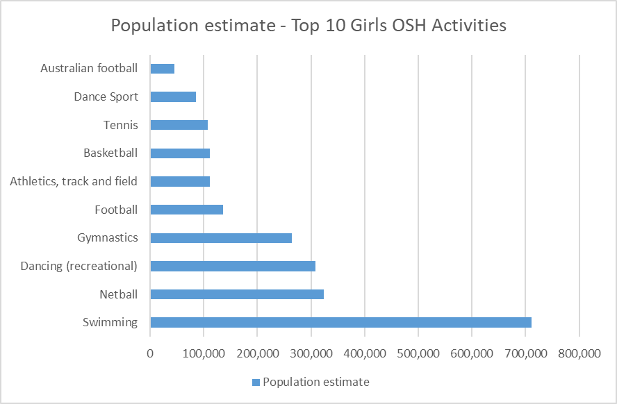
- The top ten out of school hours activities for boys ranks swimming as the most popular sport followed by football (soccer), Australian Rules Football and cricket.
Figure 9: Top 10 Boys OSH Activities
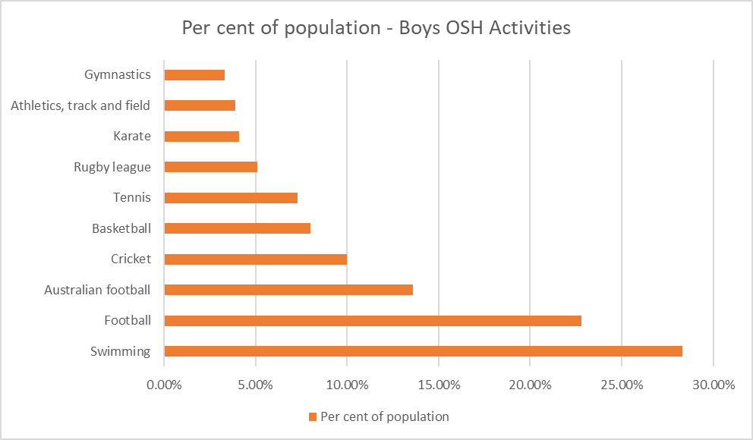
- The main barrier to young children’s participation in organised out of school hours sport or physical activity is their parents’ perception that they are too young to start playing.
- Women are more likely to participate in sport or physical activity, for physical and mental health reasons and to lose or maintain weight, than men.
Figure 10: Top 10 Activities for Adult Women
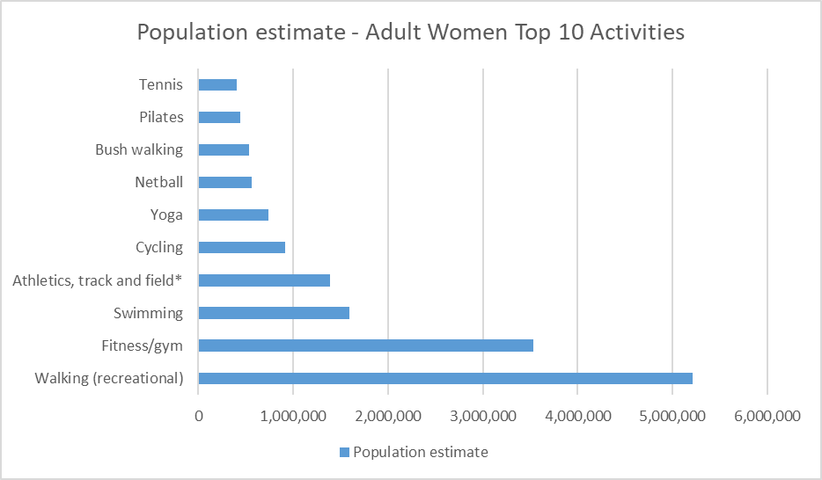
- For adults, up to middle-age, time pressure is by far the main barrier to participating in sport or physical activity. Poor health or injury then also becomes a main factor.
- Men are more motivated by fun/enjoyment and social reasons than women.
Figure 11: Top 10 Activities for Adult Men
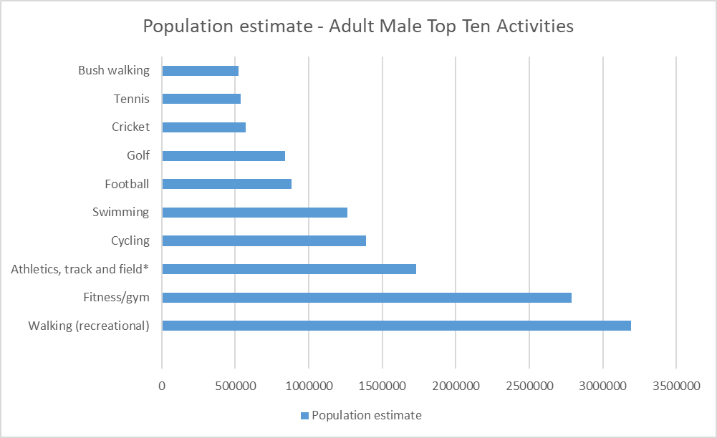
- Sport clubs are not the main choice for participation in sport or physical activity in Australia for adults aged 18 years and over.
- While sport clubs are the main avenue for both girls and boys, throughout childhood, boys (50%) are more likely to be active through club sport than girls (33%).
- The use of technology for sport or physical activity is popular with 39% of the Australian adult ‘playing’ population. Its popularity is highest amongst younger adults, particularly younger women.
- Recreational walking is the most popular physical activity for Australians overall followed by fitness/gym activities.
Figure 12: Top 20 Adult Activities
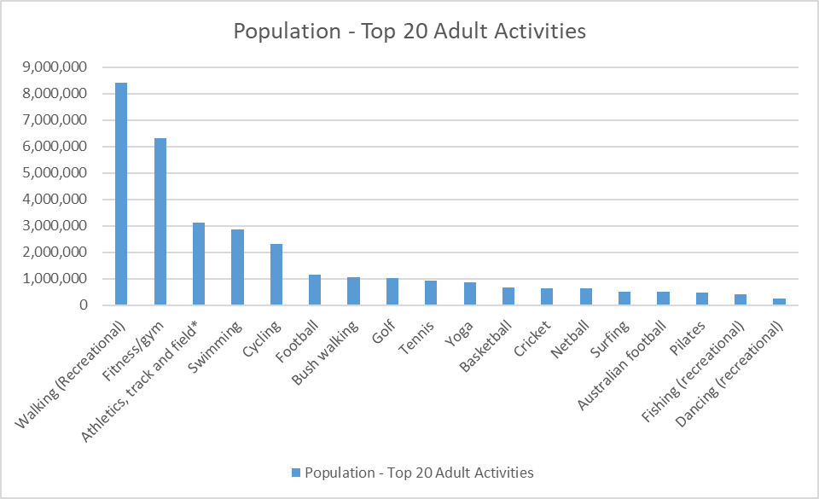
Figure 13: Percentage of Population Taking Part in the Top 10 Adult Activities
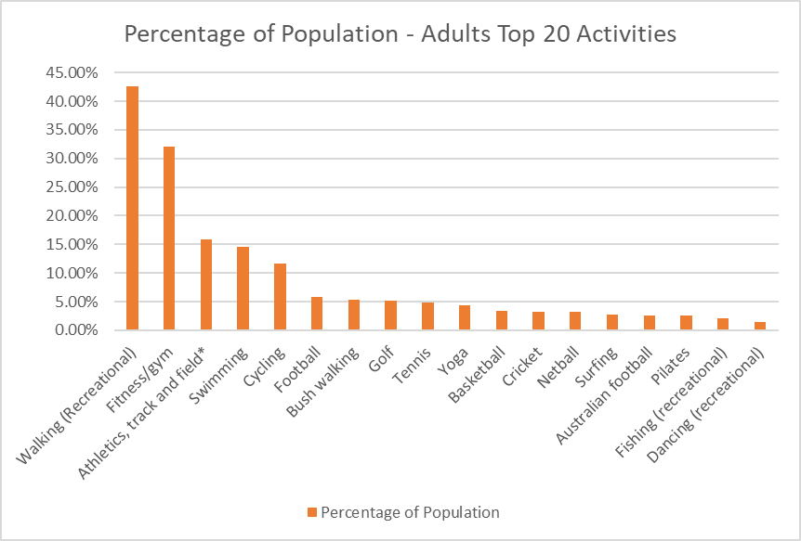
- Overall when combining male and female children’s participation together, swimming is the activity of choice for a large proportion of Australian children, ahead of Australian Rules Football in second.
Figure 14: Top 20 Out of School Hour Activities for Children
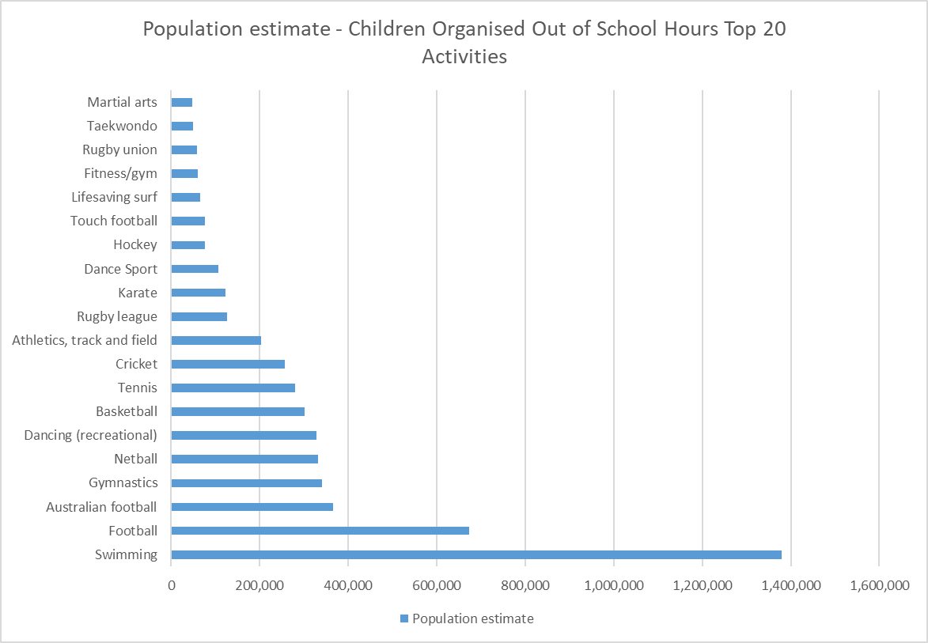
Subsequently state and territory data was provided in January 2017 which highlighted a variety of participation trends within each sport and recreational pursuits.
The data for Western Australia provides additional specific detail in respect of the propensity to take part in sport and physical activity in the state. The following conclusions are relevant to the Lords Review:
- The key venue/organisation based activities for adults are fitness/gym and swimming. Participation by females in both of these activities is significantly higher than male participation (figure 21 refers).
- For children participating in organised activities, swimming ranks as the highest participation amongst both males and females. The most dominant sport for boys is football (soccer), whilst the most dominant sport for girls is dancing, followed by Netball and gymnastics (figure 22 refers).
- In respect of sport related activities, the research found that the core participation age cohorts for adults indicated a higher propensity for females to take part in non-sports based activities whilst males under the age of 44 generally focused on sports based participation. As people age, there is a propensity to move away from sport to non-sports based activities (walking, gym, fitness and non-contact recreational activities).
Figure 15: Organisation/Venue Based Use by Activity for WA Adults (source: Ausplay)
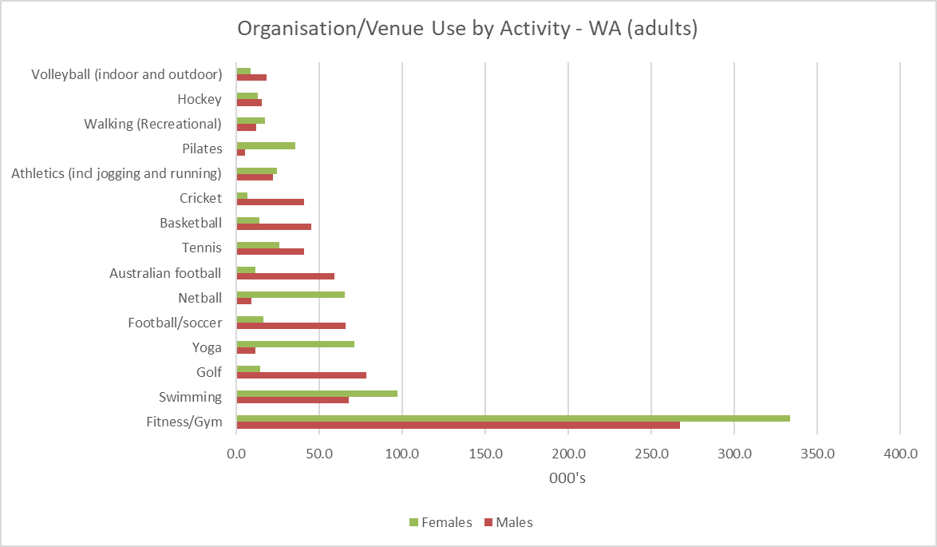
Figure 16: Participation in organised activities for Children (source: Ausplay)
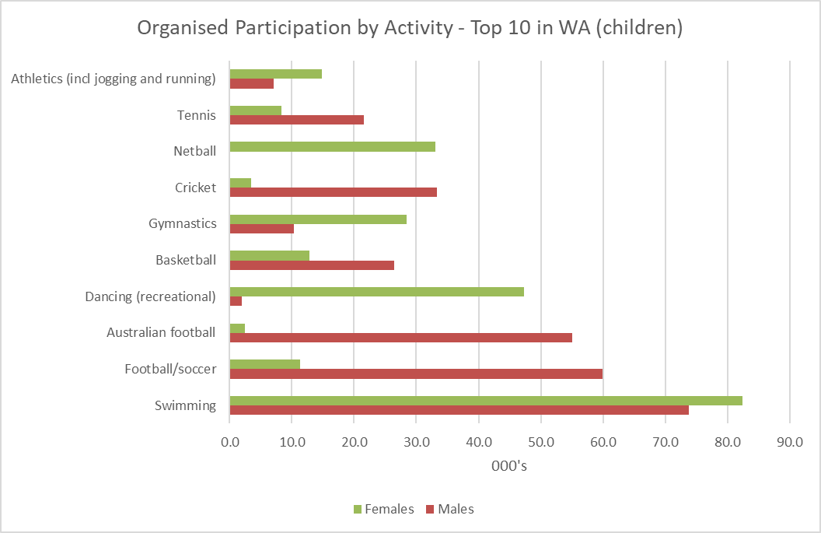
Figure 17: WA Male Adult Participation Rates (Source: Ausplay)
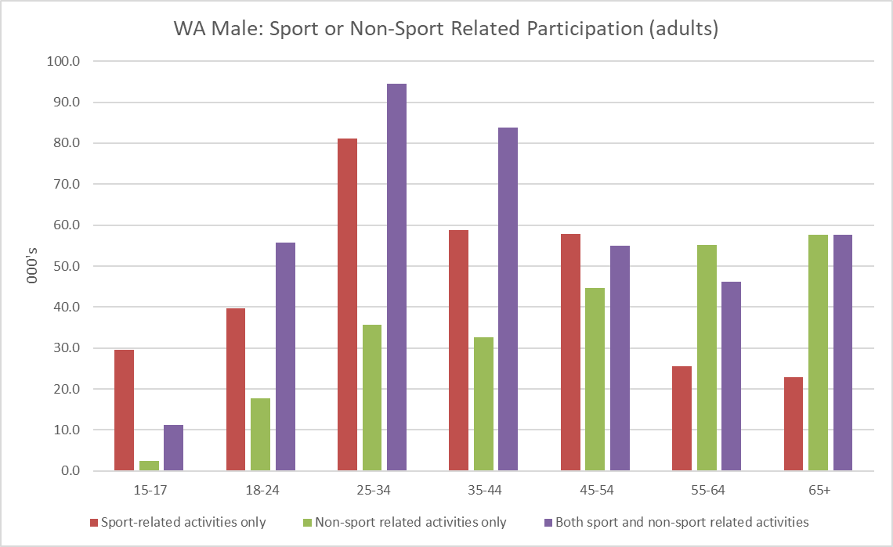
Figure 18: WA Female Participation Rates (Source: Ausplay)
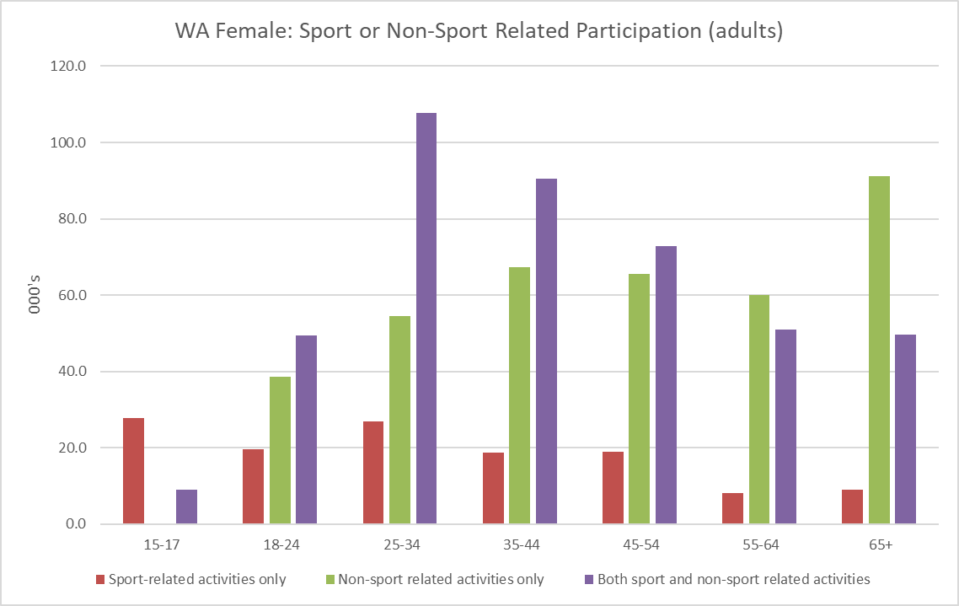
Figure 19: Top Motivation for Participation – Male and Female (Source: Ausplay)
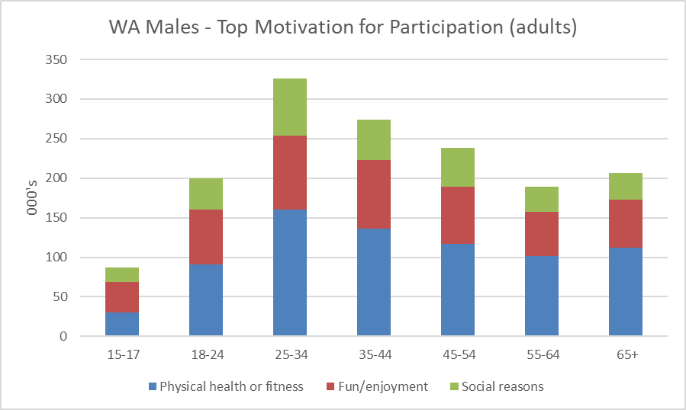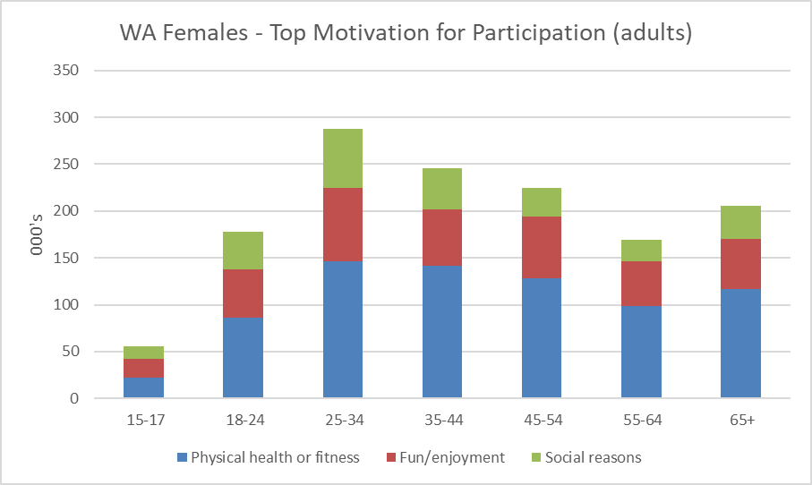
- In respect of motivation, physical health or fitness is the main motivation for men or women to participate in sport and recreational activities.
- In respect of recreational activities, walking is the most popular adult activity followed by fitness/gym, running, swimming, cycling, golf and yoga. It is to be noted that all of these activities can be undertaken in isolation and are non-contact in nature.
Figure 20: Adult Participation by Activity in WA (Source: Ausplay)
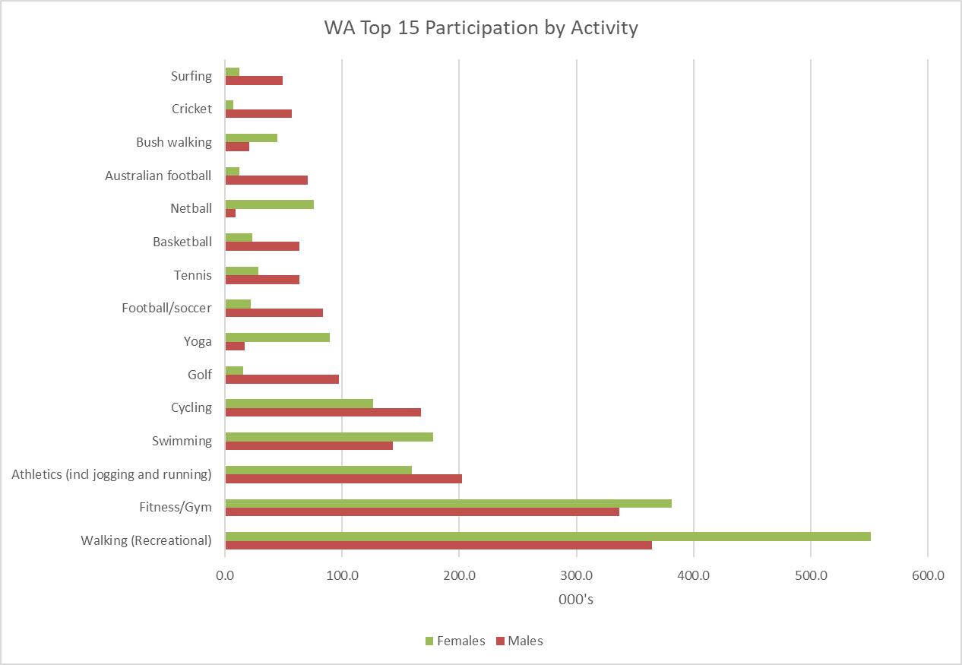

Appendix E: Industry Trends
Emerging Selected Sports Trends
The following information was supplied by the SSAs in respect of current participation and potential future growth of the sport. There is a lack of consistency in the way this information is obtained and collated across the sports. Nevertheless, it provides useful benchmarking against which the needs assessment may be measured:
Cycling and Bike Sports:
Cyclewest have recently developed the Western Australian Strategic Cycling Facilities Review to establish a high-level understanding of current provision and need for road, track and BMX facilities. Demographic data for CycleSport WA (road and track) and BMX Sports WA, including member numbers from 2011 to 2015 highlighted a number of key dynamics. Data collated by Cyclewest in respect of 2015 member participation indicated a significant shift in demographic profiling between disciplines with:
- BMX being dominated by the 5-15 age range.
- Bicycle membership/participation peaks from 45 through to 79 years of age.
- The male female split is 80% male and 20% female.
Figure 21: Demographic Nuances in Cycle Sport
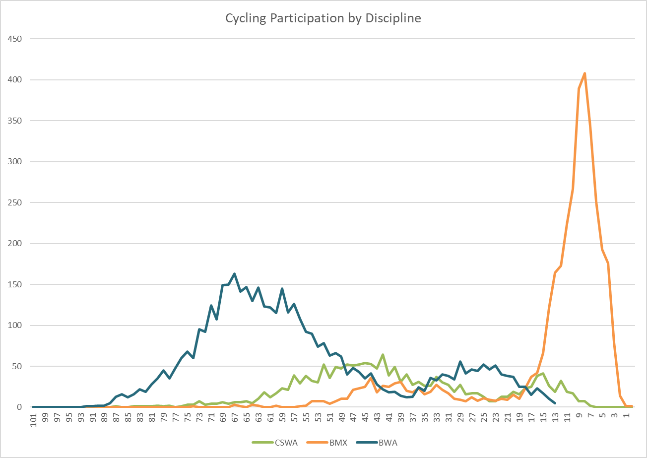
CycleWest advocate the importance of ensuring that activity nodes are accessible, connected and convenient for active transport modes (walking, cycling) to encourage all users to travel to a node by bike. This includes people using sport and recreation facilities other than the cycling facilities. Separated paths, bike parking and other end-of-trip facilities should also be provided at destination points.
Figure 22: Male Female Member Participation in Cycling
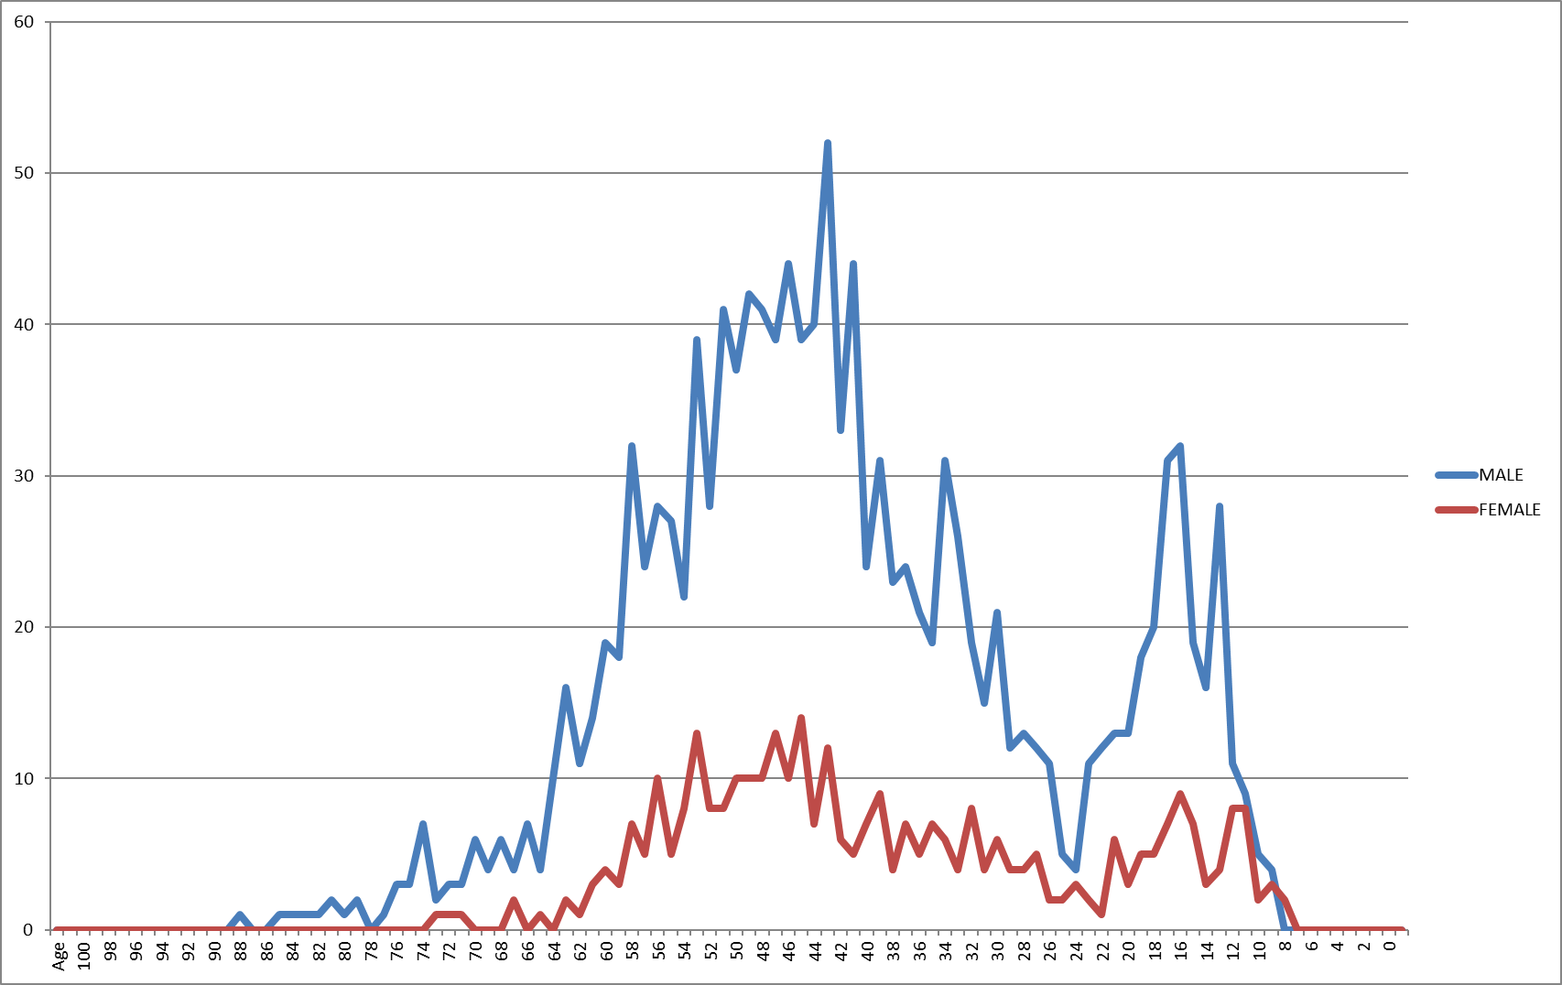
Cycling participation data in WA suggested that 720,000 cyclists aged 5+ participated in a form of cycling activity in 1993 and 432,512 cyclists aged 14+ in 2015, a reduction of 287,488. There were 261,413 West Australians aged 5 to 13 in 2015 and if all of them cycled it wouldn't make up the shortfall of 287,488. This decline in cycling is partly attributed to compulsory requirement to wear a helmet and in part to the greater dominance of the car and road safety issues. All road and telephone survey data above suggest a decline in WA cycling participation which is ongoing till 2015 on a per capita basis. This however does not take into account the trends associated with formalised cycle sports which is showing a gradual upwards trend from 2011, where BMX is showing an almost 3-fold growth in participation.
Figure 23: 2011-2015 Cycle Sport and BMX Participation Trends
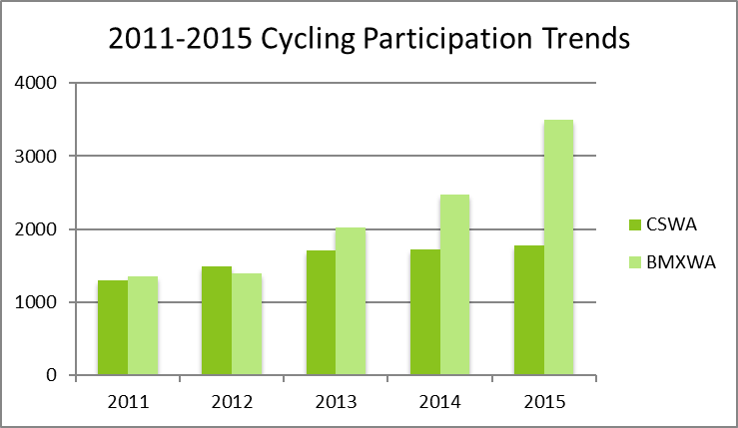
Tennis:
Tennis Australia has published a range of strategic and facility plans over the past 5 years focused on 2 key foundations of facilities and facility management. The sport advocates for quality venues as being vital to the continued growth of the sport. The guiding principles include professional management with community oversight and strong levels of governance, commercial and community responsibility. Management models identify minimum operating standards and a range of programs and services which ought to be provided. Tennis West is currently undertaking its facility strategy for Western Australia and strongly advocates the provision of consolidation of infrastructure and development of hard courts in preference to grass court infrastructure (to minimise maintenance expenditure and maximise capacity for use). Facilities within the City of Albany and surrounding area have been identified as having the potential to be rationalised and co-located at one centralised venue.
Football (WAFC):
A new strategic plan for youth football (2017-2020) identifies a number of initiatives which are to be put in place to expand the developmental base of the sport. Of the 12 recommendations, these include:
- Undertaking a trial of night football for youth participants over a four-week block during the regular season.
- Develop a plan for the inclusion of an additional phase to the junior football pathway via the implementation of a 15 a side competition for Years 7 to 9.
- Develop a suitable competition format to deliver Year 12 football in order to drive transition from Youth to Senior.
- WAFC High Performance (in conjunction with Community Football) establishes a regional talent pathway that will provide consistency, direction and quality training to players in regional areas.
- The development of a Long-Term Athlete Development approach of youth players to guide the direction and decision making for this segment of the game.
- Develop a Youth Football Calendar to better align School, Community, WAFL and State Academy programs that further supports the welfare of the player and the existing stakeholder relationships.
These initiatives are intended to drive up participation and build the foundation for increased senior level game development.
In addition to the response received to the consultation process the WAFC identified the level and quality of active football club facilities within the Great Southern. The ratings are only to be used as a guide to identify a potential facility review or development. The summary is provided in the table below:
Table 9: WAFC Assessment of Football Grounds in the Great Southern (Source: WAFC)
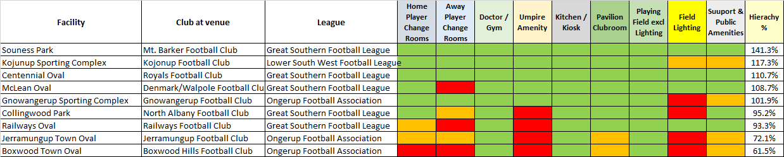
Key
 | In line with minimum standards
 | Mid-Long term improvement required
 | Not in line with minimum standards and should be a priority in any facility development
Hierarchy % | An overall facility rating (100% being a perfect facility for what is required)
NOTE: A facility can be over 100% if it has over and above what is required

It is to be noted that the facilities in need of further investment (i.e. falling below the 100% hierarchy assessment) are:
- Collingwood Park (which is identified as a priority for future investment by the City of Albany).
- Railways Oval (which is part of the Centennial Park redevelopment program).
- Jerramungup Town Oval (which has been identified by the Shire of Jerramungup for future investment).
- Boxwood Town Oval (which has been identified by the Shire of Jerramungup for future investment).
Golf Western Australia
The concern with golf clubs within the Great Southern and broader regional area relates to accessibility and the relative strength of the volunteer management. They generally operate independently of LG and are self-sustaining, relying on the membership base to manage and maintain the course and greens. Figure 30 identifies current golf clubs and membership across the Great Southern.
The most notable fact associated with golfing infrastructure is the strength of membership within the main population centre of the City of Albany and the Shire of Denmark. All other golf courses have a membership of less than 100, with the majority of small rural area golf courses surviving with membership levels of less than 40.
Figure 24: Great Southern Golf Club Membership (Source: Golf WA)
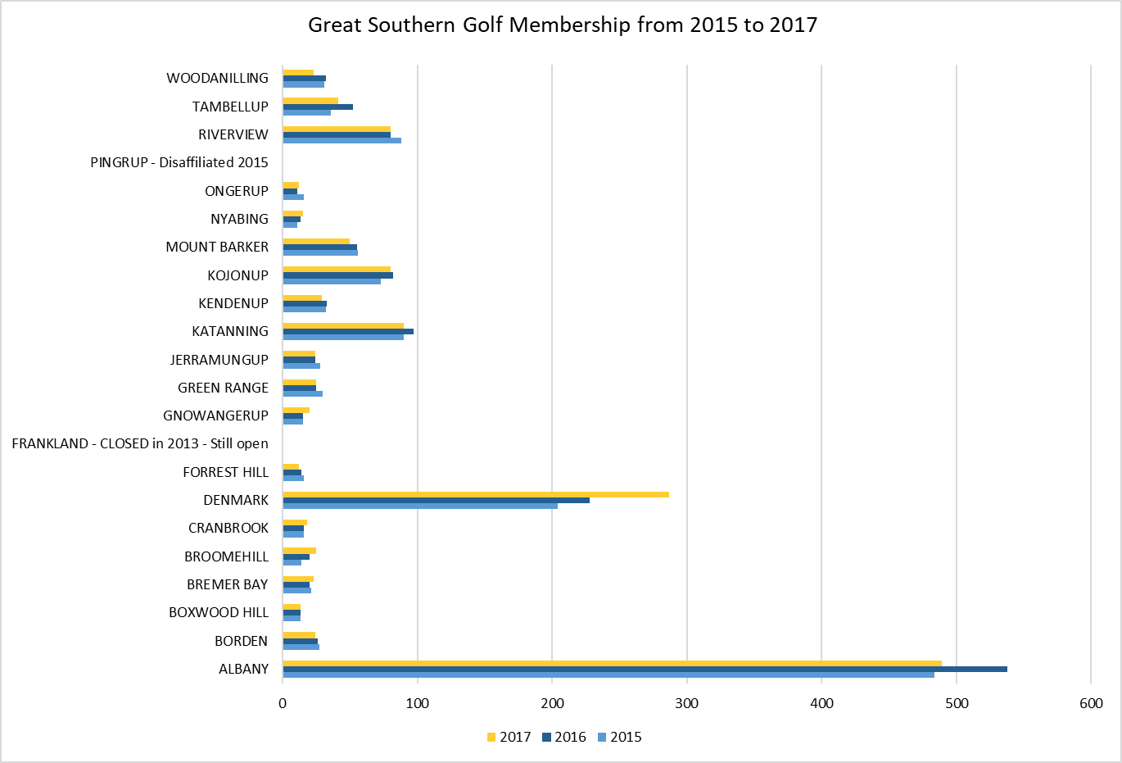
Basketball:
Basketball membership growth across the state has seen substantial increase from 2012 to 2016 with junior participation over the period highlighting a 24% growth and senior participation a 9% growth (figure 31 refers).
Figure 25: Basketball Membership 2012-2016
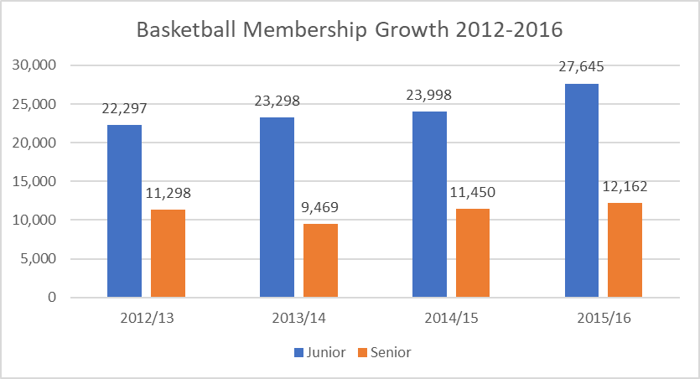

Sport and Recreation Facility Design and Provision Trends
The following trends are likely to impact on the provision of sport and recreation facilities within regional areas in the future:
Financial Viability:
- There is now a more acute focus on financial viability of all sport and recreation infrastructure and rationalisation of provision. This has been referenced within SD6 as a key issue for the industry.
- The importance of fully costing out asset management plans and future proofing expenditure (including lifecycle costing) is becoming more critical.
- There is an increasing expectation that local communities will develop sustainable solutions to sport and recreation provision that will minimise ongoing funding support. Providing facilities where activities can be provided at minimal cost and deliver a financial return is becoming more important.
- There is a predominance of ageing infrastructure without a sufficient asset management and maintenance process established and prioritised within resource constraints.
- The cost of building new facilities is increasing which creates challenges for delivering affordable sport and recreation infrastructure.
The Design and Range of Facility Provision:
- The intention of the majority of LG’s is to provide a range of sport and recreation opportunities for their community that promote physical activity, balanced with a mixture of sporting and recreational pursuits which are directly relevant to the community they serve.
- An increasing focus on disabled access, risk management and occupational health and safety. Increasingly stringent regulations and more rigorous monitoring of compliance may call for increasing resourcing, maintenance and associated costs.
- New and emerging design guidelines for sport and recreation facilities highlight the need to accommodate the capacity for the growth in women’s sport and greater flexibility of use.
- There are increasing demands and opportunities to use Information Technology to facilitate more effective use of sport and recreation infrastructure.
- Newly constructed pavilions tend to include multi-use community spaces and provide meeting rooms for local clubs and community groups needing a home (consolidating storage, change, clubroom, public toilet and social meeting facilities in a minimum number of built structures).
- The layout and mix of facilities should be flexible in design. The notion of multi-use facilities needs to be explored but the sharing of facilities should not compromise needs. It is important to optimise use for the benefit of all current and future users.
- The focus on the development of sport and recreation spaces is developing to secure greater integration with existing paths, tracks and accessways which are distributed and located to provide high levels of accessibility.
Sporting Hubs, Co-location and Shared Use:
- Integrated co-location and sharing brings a range of different uses and users together at one integrated site and enables significant cost savings to be achieved whilst also allowing a more professional approach to management, maintenance and programming. It assists in attracting a wider user base and as a result has the potential to increase financial and operational viability.
- The elimination of single, stand-alone club and group facilities. An integrated and consolidated facility provides an opportunity to cost share and avoids duplication of services and back of house activities.
- Recent trends in facility planning is through the development of sports hubs and complexes where the opportunity to share resources is potentially maximised. The rationale for this has stemmed from a number of reasons including:
  - Ageing infrastructure in need of replacement and the need for modern facilities to meet statutory building and health and safety requirements.
  - The increasing demands on open space provision and it’s use/function, particularly in a more urbanised setting where space is limited.
  - The need for LG’s to be responsible and accountable in asset management and provision.
  - Pressures facing local sporting and recreation groups with declining volunteers.
  - Increased competition resulting from alternative leisure opportunities and the need for clubs to be well managed and customer focused.
  - An acknowledgement that centralised administration and facilities can benefit clubs whilst reducing costs to the public purse.
  - Providing good integrated traffic and pedestrian movement both into and through a facility complex which provides safe access and clear signposting of uses/activities.
- The opportunity to realise good partnerships through school use of proposed sports facilities, and community use of existing school facilities is emphasised as being an important focus for LG’s , particularly where resources are constrained. In practice however, the delivery of effective shared use agreements is mixed.
- Built facilities such as pavilions in rural/regional areas are generally required to support sporting uses and other community activities.
Demographic Considerations:
- The need to provide flexible sport and recreation infrastructure is becoming increasingly important due to factors such as demographic shifts and changing sport and recreation preferences. The ageing demographic is necessitating greater consideration of non-contact sport and recreational activities with a higher level of casual social interaction.
- Where low incomes remain higher than the state average, it is important to provide sport and recreation facilities at an affordable price with equitable access to the community.
- In providing for Young People, there are a number of considerations which need to be taken into account:
  - A change in delivery is required just to maintain levels of interest in sport amongst each new generation. Sporting activities need to reflect technology as an integral part of young people’s lives.
  - There is a need to focus on changing behaviours not attitudes. Sport and physical activity needs to be more visible and accessible, with stronger reminders of their positive associations. Promoting the benefits, the youth are looking for is more effective.
  - Sport has to compete or connect to other interests and priorities (particularly with passive recreational opportunities.
  - Young people with negative associations based on previous experiences and a perceived lack of competence, are more likely to reject traditional, competitive activities. New or unusual sports or different positioning can encourage greater use.
  - Young people seek meaningful experiences to make sport a habit which benefits them as an individual, reinforces their place in their social group or helps them develop themselves.
  - The supply of sport to the youth tends to reach those who are already engaged. There is a need for a broader offer which meets more diverse needs to break the norms of sport participation.
Environmental Consideration and Sustainability:
- The declining trend in rainfall and increasing extractions of groundwater has led to falling groundwater levels. Alternative water options are now being considered. This has also resulted in the gradual integration of flood and storm water management practices into open space provision.
- Facilities are being designed and built to maximise access, safety and environmental sustainability. This has potential to increase capital costs and decrease operational costs.
General Participatory Trends:
- There is a trend to move away from formalised club based sports in adulthood.
- Motivations change as young people grow up, with health, fitness and looking and feeling good becoming more important. The shift towards fitness-related activities is occurring at an earlier age than previously.
- Changing sport and recreation expectations and needs will require changes to the type, amenity and level of services required to meet emerging sport and recreation demands.
- The decrease in volunteering and associated succession planning compromises the ability to attract and retain members to sustain and develop clubs.
Economic and Social Value Trends:
- Sporting infrastructure within regional areas provide more than just a place to engage in sport and recreational activities, they also build volunteer capacity and the opportunity to train and develop individuals in leadership and management capabilities.
- Sport and recreation infrastructure provide the opportunity for social interaction and have, in some regional areas become a focus for addressing physical and mental health issues. Clubs have also been targeted to provide a mechanism to educate and provide mentoring support for members of the community who have/are experiencing issues relating to drug and alcohol abuse.

Appendix F: Development Principles
Multi-functional Sports Facility Infrastructure – Design Principles:
The following identifies the development principles which are to be adopted during the consideration of any new development:
- The massing and design of any building and associated infrastructure should respond to the principle purpose. For a multi-functional sporting facility the design will incorporate:
  - Multi-functional ablutions which can be split and managed for club and public use
  - Accessible toilets for players and public
  - Umpires/Official Room
  - Medical/First aid
  - Kitchen and kiosk
  - Kitchen storeroom
  - An indoor social/function area
  - Administration/Office
  - Outdoor social area with a spectator view over the playing areas
  - Internal storage
  - External storage
  - Cleaners store
  - Utilities/Plant room
  - Maintenance/curators shed
  - Storage and activity space for existing and potential new community user groups
- The focus of any new building and associated infrastructure will be to minimise visual intrusion and negate noise/disturbance.
- The extent of clubhouse and changing room infrastructure will adhere to guidance published by the relevant peak bodies to ensure the standard meets current and future needs and comply with Australian Standards.
- The clubhouse/pavilion is to be multi-functional and multi-purpose in its design with a view to serving the needs of all sport and recreation groups.
- Any fencing associated with the development of sporting infrastructure (if necessary) should be low level and should not impact on the open nature and accessibility.
- Any extended use of the sports ground will be subject to controls in respect of times of use, noise attenuation and lighting control.
- Floodlighting within the sports ground will be limited to recreational and training levels unless an exceptional case is made. All floodlighting is to be of a high standard with directional cowls to minimise any potential light spill.

Community Use on School Sites – Guiding Principles:
The following identifies the main principles which need to be established as part of a shared use agreement on school sites:
- The Agreement should seek to ensure reasonable community access to sport and recreation facilities being provided having regard to the need for maintenance and viability. The structure supporting community use will vary according to the size and scale of facilities available/identified for use.
- Sports Facilities may include playing field/ovals, indoor sports hall, health and fitness suite, changing rooms, showers and toilets, games courts, café bar and car parking – all to be specified in the agreement.
- It should provide, where possible, the availability for any individual(s) or group to book the facilities for use on a pay-per-play or membership basis (i.e. as a “casual user” being any person not being a staff or student of the school).
- They should provide access for LG sports development initiatives (i.e. activities aimed at identifying, promoting and delivering co-ordinated opportunities for all people (particularly persons from the Under-Participating Groups) to participate in and reach their full potential in sport).
- LG in return will, provided that it is satisfied that the sports development initiative is for the benefit of the community, provide support for the development, implementation, marketing and management of all such initiatives.
To provide additional opportunities for local people and sports organisations to participate in sport and to develop their skills, particularly among low participant groups.

Australian Bureau of Statistics, 2016, QuickStats, ABS, Canberra. Viewed 4/09/17
Western Australian Planning Commission: WA Tomorrow. Medium Term Population Forecasts for Western Australia 2014 to 2026 and Sub-regions 2016 to 2026 (2015).

