LC 08/2019

Liquor Commission of Western Australia
(Liquor Control Act 1988)

Applicant: ALDI Foods Pty Limited
(represented by Ms Jessica Patterson of Lavan Lawyers)

Interveners: City of Mandurah

Chief Health Officer
(represented by Mr Francis Cardell-Oliver of State Solicitor’s Office)

Premises: ALDI Mandurah
2 Aldgate Street, Mandurah

Commission: Mr Edward Watling (Deputy Chairperson)
Mr Paul Shanahan (Member)
Mr Alex Zilkens (Member)

Matter: Application for review pursuant to section 25 of the Liquor Control Act 1988

Date of Order: 18 March 2019

Orders:

It is on 18 March 2019, ordered that:

- Leave be granted to withdraw proceedings.
- Proceedings are withdrawn
- No order as to costs.

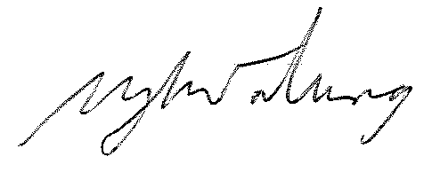

EDWARD WATLING
DEPUTY CHAIRPERSON

