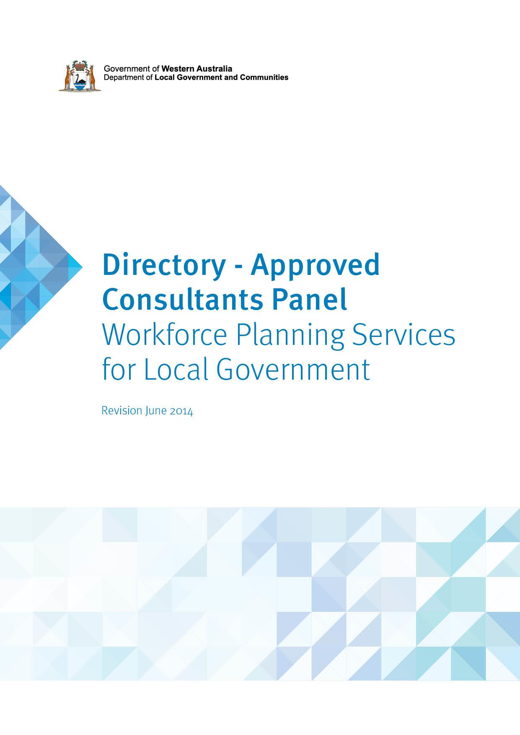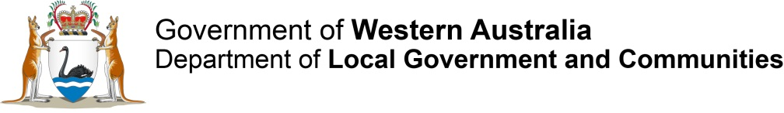Local Government Advisory Board (LGAB)

Assessment of the proposal to transfer   
Hamilton Hill and part of North Coogee from the City of Cockburn to the City of Fremantle

December 2016

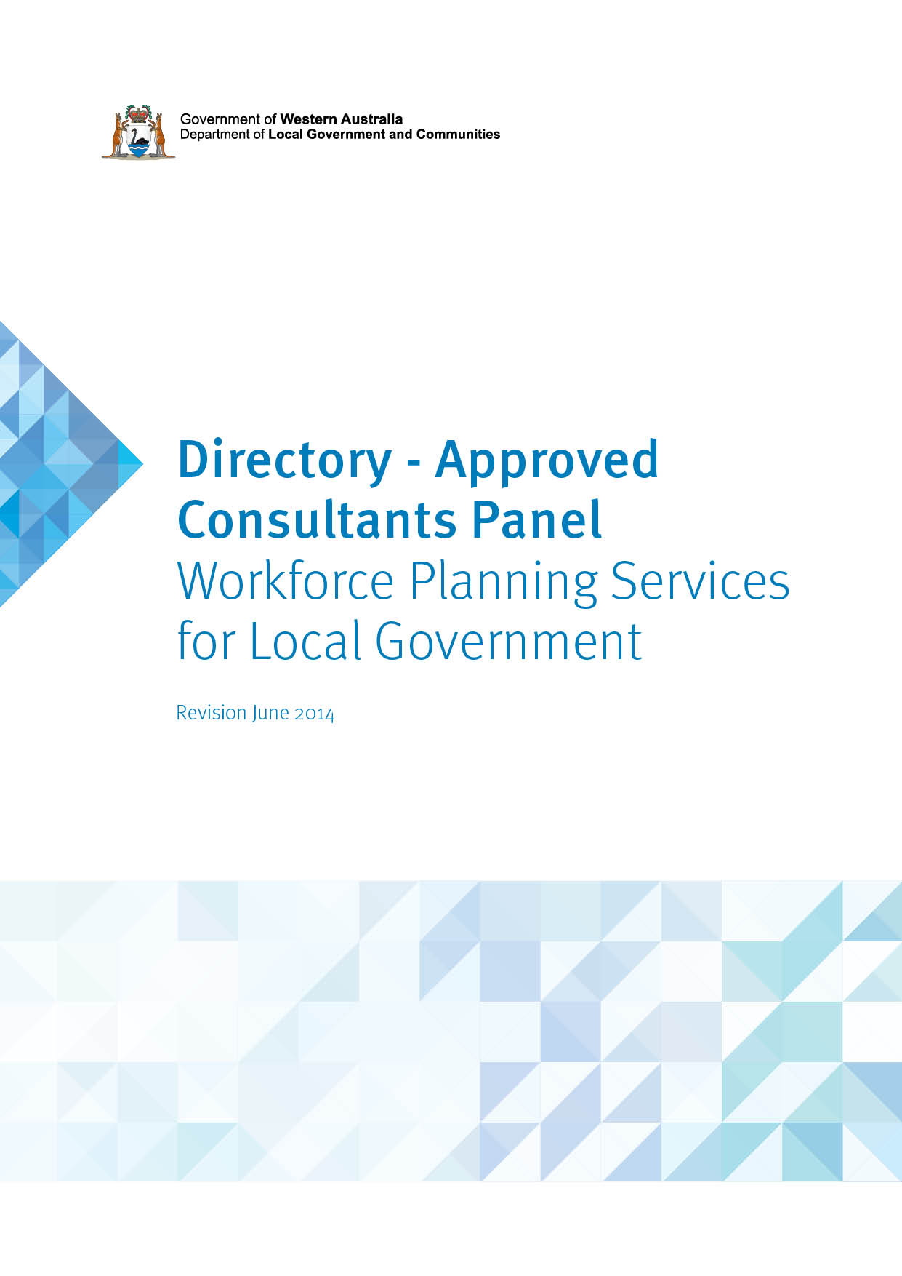

Contents

1. Introduction 4

1.1 The proposal 4

1.2 Key statistical data 5

2. Local Government Advisory Board 6

2.1 The proposal 6

2.2 Membership of the Board 7

3. Conducting the Inquiry 8

3.1 Making a proposal 8

3.1 Community of Interests 10

3.2 Physical and Topographic Features 11

3.3 Demographic Trends 11

3.4 Economic Factors 11

3.5 History of the Area 12

3.6 Transport and Communication 12

3.7 Matters Affecting the Viability of Local Governments 12

3.8 The Effective Delivery of Local Government Services 13

4. Consultation 14

4.1 Meetings with Affected Local Governments 14

4.2 Public Hearings 16

4.3 Analysis of Public Submissions 17

5. Assessment of the Proposal – Matters Considered by the Board 20

5.1 Community of Interests 20

Figure 1 – City of Cockburn - local community groups 21

5.2 Physical and Topographic Features 21

5.3 Demographic Trends 22

5.4 Economic Factors 25

5.5 History of the Area 27

5.6 Transport and Communications 29

5.7 Matters Affecting the Viability of Local Governments 30

5.8 The Effective Delivery of Local Government Services 33

5.9 Other Matters 34

6. Conclusion 35

7. Recommendation 36

Attachment 1 – Current boundaries for the Cities of Cockburn and Fremantle 37

# 1. Introduction

A group of Hamilton Hill and North Coogee residents submitted a proposal (the Greater Freo proposal) to the Local Government Advisory Board (the Board) on   
5 May 2016. The proposal was to amend the City of Cockburn’s district boundary   
to transfer Hamilton Hill and part of North Coogee from the City of Cockburn to the   
City of Fremantle.

Clause 2 (1) of Schedule 2.1 of the *Local Government Act 1995* (the Act) states a proposal may be made to the Advisory Board by -

(d) affected electors who –

i. are at least 250 in number; or

ii. are at least 10 per cent of the total number of affected electors.

According to Electoral Commission data, there are approximately 7,199 electors in the affected area (at 9 March 2015). A petition signed by 357 affected electors accompanied the proposal and 273 of those signatures (77 per cent) were able to be verified, thereby exceeding the 250 minimum requirement as specified by the Act.

A valid proposal also needs to meets the requirements of clause 2(2) of Schedule 2.1 of the Act which states:

“A proposal is to –

(a) set out clearly the nature of the proposal, the reasons for making the proposal and the effects of the proposal on local governments;

(b) be accompanied by a plan illustrating any proposed changes to the boundaries of a district; and

(c) comply with any regulations about proposals.”

The Board assessed the Greater Freo proposal as meeting all of the above requirements.

## 1.1 The proposal

A map illustrating the proposed boundary is included at Attachment 1 of this paper. The area is bounded by Stock Road on the east, Phoenix Road in the south, and then broadly following the northern and western boundary of Manning Park to the Indian Ocean at a point north of the Coogee Marina.

The proposal will see the City of Cockburn and City of Fremantle continue as local government entities, with the City of Cockburn population of 107,645 being reduced by more than 10,000 (9.5 per cent) and the City of Fremantle population increased by 33 per cent to approximately 41,157.

The Board met on 2 June 2016 and resolved to conduct a formal inquiry into the proposal.

## 1.2 Key statistical data

Under the Australian Classification of Local Governments, the City of Fremantle is classified as Urban Developed Small and the City of Cockburn is classified as Urban Fringe Large.

This proposal would see the City of Fremantle and City of Cockburn continue as local government entities; with the City of Fremantle population increased by 10,274 to approximately 41,157 (or by approximately 33 per cent) and the City of Cockburn population being reduced to 97,371 (or by approximately 9 per cent).

Table 1: Key Data

|  |  |  |  |
| --- | --- | --- | --- |
| Factor | City of Fremantle | | City of Cockburn |
| Area in square km | 19.03 | 170 | |
| Population 2011 | 30,883 | 107,645 | |
| Number of Electors | 17,738 | 62,706 | |
| Number of Councillors | 12 | 9 | |
| Number of Employees | 623 | 810 | |
| Number of Dwellings | 13,464 | 38,907 | |

Table 2: Impact of boundary proposal

|  |  |  |  |  |  |
| --- | --- | --- | --- | --- | --- |
| Factor | Proposal area | Existing City of Fremantle | City of Fremantle after adjustment | Existing City of Cockburn | City of Cockburn after adjustment |
| Area in square km | 8.34 | 19.03 | 27.37 | 170 | 161.66 |
| Population 2011 | 10,274 | 30,883 | 41,157 | 107,645 | 97,371 |
| Electors 2015 | 7,199 | 17,783 | 24,982 | 62,706 | 55,507 |

# 2. Local Government Advisory Board

## 2.1 The proposal

The Board is a statutory body established under section 2.44 of the Act. Its role is to provide advice to the Minister for Local Government on amalgamations, district and ward boundary amendments and councillor representation.

The Board’s major function is to assess proposals to change local government boundaries and their system of representation and make recommendations to the Minister about   
these proposals.

Clause 12 of Schedule 2.5 of the Act sets out the Board’s powers of inquiry and they are as follows:

### Powers of Inquiry

(1) For the purposes of carrying out an inquiry under this Act, the Advisory Board may:

(a) by summons signed on behalf of the Advisory Board by its executive officer, require –

(i) the attendance before the Advisory Board of any person;

(ii) the production before the Advisory Board of any document;

(b) Inspect any document produced before it, and retain it for such reasonable period as it thinks fit, and make copies of the document or any of its contents;

(c) require any person to swear to truly answer all questions relating to a matter being inquired into by the Advisory Board that are put by or before the Advisory Board (and for that purpose a member of the Advisory Board or its executive officer may administer any oath or affirmation);

(d) require any person appearing before the Advisory Board to answer any relevant question.

(2) A person is not excused from complying with a requirement under subclause (1) on the ground that the answer to a question or the production of a document might be incriminating or render the person liable to a penalty, but an answer given by a person that was required under subclause (1) to be given is not admissible in evidence against the person in any civil or criminal proceedings other than proceedings for perjury or for an offence against this Act arising out of the false or misleading nature of the answer.

## 2.2 Membership of the Board

Clause 2 of Schedule 2.5 of the Act makes provision for the membership of the Board and reads as follows:

### Membership of Advisory Board

The Advisory Board consists of five members appointed by the Governor of whom-

(a) one person is nominated by the Minister; and

(b) two persons are to be persons having experience as a member of a council appointed from a list submitted to the Minister by the WA Local Government Association (WALGA) under clause 4(1); and

(c) one person is to be a person having experience as the chief executive officer of a local government appointed from a list submitted to the Minister by the Local Government Managers Australia (LGMA) WA Division under   
clause 4(2); and

(d) one person is to be an officer of the department nominated by the Minister.

### Current Board Members

**Chair**

Mr Melvyn Congerton JP

**Members**

WALGA Nominees:

* Cr Karen Chappel (Member)
* Cr Russ Fishwick (Member)
* Mayor Gary Brennan (Deputy)
* Cr Chris Cornish (Deputy)

LGMA Nominees:

* Mr Anthony Vuleta (Member)
* Ms Francesca Lefante (Deputy)

Department of Local Government and Communities:

* Ms Mary Adam (Deputy Chair)
* Ms Jenni Law (Deputy)

# 3. Conducting the Inquiry

A proposal for amending local government district boundaries may be made by electors, local governments or the Minister.

Clause 2(2) of Schedule 2.1 of the Act sets out the requirements for proposals for amalgamations and boundary amendments and reads as follows:

## 3.1 Making a proposal

(1) A proposal may be made to the Advisory Board by —

(a) the Minister;

(b) an affected local government;

(c) two or more affected local governments, jointly; or

(d) affected electors who —

(i) are at least 250 in number; or

(ii) are at least 10 per cent of the total number of affected electors.

(2) A proposal is to —

(a) set out clearly the nature of the proposal, the reasons for making the proposal and the effects of the proposal on local governments;

(b) be accompanied by a plan illustrating any proposed changes to the boundaries of a district; and

(c) comply with any regulations about proposals.

Provisions for dealing with proposals are set out in clause 3 of Schedule 2.1 of the Act and reads as follows:

### Dealing with proposals

(1) The Advisory Board is to consider any proposal.

(2) The Advisory Board may, in a written report to the Minister, recommend* that the Minister reject a proposal if, in the Board’s opinion —

(a) the proposal is substantially similar in effect to a proposal on which the Board has made a recommendation to the Minister within the period of two years immediately before the proposal is made;

(aa) where the proposal was made by affected electors under clause 2(1)(d), that the majority of those electors no longer support the proposal; or

(b) the proposal is frivolous or otherwise not in the interests of good government.

* Absolute majority required.

(3) If, in the Advisory Board’s opinion, the proposal is —

(a) one of a minor nature; and

(b) not one about which public submissions need be invited, the Board may, in a written report to the Minister, recommend* that the Minister reject the proposal or that an order be made in accordance with the proposal.

* Absolute majority required.

(4) Unless it makes a recommendation under subclause (2) or (3), the Advisory Board is to formally inquire into the proposal.

At their meeting of 2 June 2016, the Board determined that the Greater Freo proposal should not be dealt with under the provisions of clause 2 and 3 above, and as such, the provisions of clause 4 would apply and the Board would therefore conduct a formal inquiry into the proposal. The Minister for Local Government and both local governments were informed of the Board’s decision on 7 June 2016.

When a formal inquiry is conducted, the Board is required to give notice to affected electors and affected local governments about the inquiry.

Clause 4 of Schedule 2.1 of the Act contains provisions relating to a Notice of Inquiry and reads as follows:

### Notice of inquiry

(1) Where a formal inquiry is required the Advisory Board is to give —

(a) notice to affected local governments, affected electors and the other electors of districts directly affected by the proposal; and

(b) a report to the Minister.

(2) The notice and report under subclause (1) are to —

(a) advise that there will be a formal inquiry into the proposal;

(b) set out details of the inquiry and its proposed scope; and

(c) advise that submissions may be made to the Board not later than six weeks after the date the notice is first given about —

(i) the proposal; or

(ii) the scope of the inquiry.

(3) If, after considering submissions made under subclause (2)(c), the Advisory Board decides* that the scope of the formal inquiry is to be significantly different from that set out in the notice and report under subclause (1), it is to give —

(a) another notice to affected local governments, affected electors and the other electors of districts directly affected by the proposal; and

(b) another report to the Minister.

(4) The notice and report under subclause (3) are to —

(a) set out the revised scope of the inquiry; and

(b) advise that further submissions about the proposal, or submissions about matters relevant to the revised scope of the inquiry, may be made to the Board within the time set out in the notice.

* Absolute majority required.

The Notice of Inquiry appeared in The Fremantle Cockburn Gazette on 30 August and   
6 September 2016. A copy of the Notice is included in Appendix 2.

A six week public submission period closed at 4pm on 13 October 2016. The Board met with both Councils on 5 October 2016 to discuss the proposal. The Board also held a public hearing in the evening of 5 October 2016 at the PCYC Progress Hall in Hilton.

More than 350 people attended the public hearing.

In carrying out a formal inquiry the Board is required to consider submissions made to it under clause 4(2)(c) of Schedule 2.1 of the Act and have regard, where applicable, to:

* Community of interests
* Physical and topographic features
* Demographic trends
* Economic factors
* The history of the area
* Transport and communication
* Matters affecting the viability of local governments
* The effective delivery of local government services.

The Board may also take into account any other matter it considers relevant as part of   
its inquiry.

The Board has developed the following guiding principles for each of the above factors.

## 3.1 Community of Interests

Community of interests includes part of a district that share common interests, values, characteristics and issues giving rise to a separate sense of identity or community.   
Factors contributing to a sense of identity or community include shared interests and shared use of community facilities. For example sporting, leisure, religious and library facilities create a focus for the community.

The use of shopping areas and the location of schools also act to draw people together with similar interests. This can also give indications about the direction that people travel to access services and facilities. The external boundaries of a local government need to reflect distinct communities of interest wherever possible.

Neighbourhoods, suburbs and towns are important units in the physical, historical and social infrastructure and often generate a feeling of community and belonging. The Board believes that wherever possible, it is inappropriate to divide these units between local governments.

## 3.2 Physical and Topographic Features

Physical and topographic features may be natural or manmade and will vary from area to area. They may include:

* Water features (such as rivers)
* Catchment boundaries
* Coastal plains and foothills
* Parks and reserves
* Manmade features (such as railway lines or freeways).

These features can form identifiable boundaries and can also act as barriers to movement between adjoining areas. In many cases physical and topographic features are appropriate district and ward boundaries. The Board supports local government structures and boundaries that facilitate the integration of human activity and land use.

## 3.3 Demographic Trends

Local governments should consider the following characteristics when determining the demographics within its locality:

* Population size
* Population trends
* Distribution by age
* Gender
* Occupation.

Current and projected population factors will be relevant as well as similarities and differences between areas within the local government.

## 3.4 Economic Factors

Economic factors can include any factor that reflects the character of economic activities and resources in the area including:

* Industries within the local area
* Distribution of community assets
* Infrastructure.

## 3.5 History of the Area

The history of an area can be a relevant consideration, although the Board believes that in the majority of cases this will not be a primary justification for changing or retaining local governments and local government boundaries. The nature of historical ties between communities is important to understand, irrespective of where the local government boundaries lie.

A community within a local government may have a strong historical identity; alternatively there may be strong historical links between two or more communities in adjacent local governments. It is important to note that historical identity is not lessened if an area does not have its own local government.

## 3.6 Transport and Communication

The transport and communication linkages between towns and other areas may be a significant barrier to movement and therefore an appropriate boundary between   
local governments.

Consideration of the following factors is important in any assessment of local government boundaries:

* port access
* neighbouring towns
* railways
* major roads.

## 3.7 Matters Affecting the Viability of Local Governments

Local governments should have a significant resource base:

* To be able to efficiently and effectively exercise its proper functions and delegated powers and operate facilities and services.
* To be flexible and responsive in the exercise of its functions and powers and operation of its facilities and services.
* To employ appropriate professional expertise and skills.
* To be capable of embracing micro-economic reform.

Each local government should have a diverse and sufficient rate base to ensure that general purpose grants do not represent the major revenue source.

## 3.8 The Effective Delivery of Local Government Services

A broad range of factors can be relevant to the effective delivery of local government services and these are often directly relevant to those that also affect the viability of local governments. They include:

* The size and geographical spread of the population.
* Management effectiveness and efficiency.
* The availability of staff expertise.
* Appropriate infrastructure and equipment.
* Customer satisfaction and feedback.

# 4. Consultation

## 4.1 Meetings with Affected Local Governments

### Meeting with the City of Cockburn

The Board met with councillors and staff of the City of Cockburn (Cockburn) on 5 October 2016, to discuss the inquiry process and Cockburn’s position on the proposal. The meeting also provided an opportunity for Cockburn to raise any concerns or issues about the boundary amendment proposal.

Cockburn resolved to strongly oppose the Greater Freo proposal and prepared a submission containing information extracted and updated from the Cockburn Community Steering Group’s submission made to the Board during the 2014 Metropolitan Local Government Reform process.

In a PowerPoint presentation to the Board, Cockburn’s chief executive officer outlined a number of key differences between the City of Cockburn and the City of Fremantle (Fremantle).

Cockburn noted that Fremantle’s population growth over the past four years has been an average of 1.6 per cent per annum. Should the boundary change go ahead, the population would grow by around 40 per cent.

Cockburn noted that it is concerned about the relatively small number of petition signatures required to submit a valid proposal to the Board – in this case, being 250 from an affected population of around 12,500, which represents just 2 per cent.

In response to the Greater Freo proposal, the City of Cockburn initiated a Reachtel telephone poll of 711 residents in North Coogee and Hamilton Hill and found that 64.2 per cent want to stay in Cockburn.

Cockburn links its urban revitalisation to community infrastructure and prides itself on being a growth council.

Cockburn notes that it operates a polycentric model – i.e. with a focus on residential precincts.

By contrast, Fremantle operates on a monocentric model – i.e. with a focus on tourism and CBD rejuvenation.

### Meeting with the City of Fremantle

The Board also met with councillors and staff of the City of Fremantle on 5 October 2016, to answer questions about the inquiry process and to give them the opportunity to raise any concerns or issues about the boundary amendment proposal.

Fremantle resolved to advise the Board that while the Greater Freo proposal is consistent with its long term vision, it does not see value in supporting the proposal at this time. Fremantle referred to the previous Minister for Local Government’s preference that all affected local governments should be in agreement on any proposal. As Cockburn have stated their position against the proposal, Fremantle has also chosen not to support the proposal as they don’t wish to jeopardise their relationship with Cockburn.

However, the City of Fremantle maintains that the community of interests for Hamilton Hill and North Coogee are strongly connected to Fremantle. For example, local landmarks on Rockingham Road call themselves ‘Fremantle’ and identify with Fremantle.

During Metropolitan Local Government Reform, the City of Fremantle committed significant resources to the process and have stated that they were accordingly disappointed when it was put on hold in early 2015.

Fremantle council believes that expanded boundaries will help the City of Fremantle to achieve its future goals. They consider the suggestions in the Greater Freo proposal a logical progression to do so. However, they don’t believe that this is the right time to do so.

Fremantle noted that Cockburn has launched a significant campaign against the Greater Freo proposal. It also noted that any resulting changes would be dealt with via a transitional process, and that all affected areas include both assets and liabilities. Therefore, no matter what the outcome, the residents living in the affected areas would continue to have regular provision of services.

Fremantle stated that any future boundary change would require ongoing negotiations and goodwill with Cockburn; noting that anticipating a challenge is not a reason to do nothing as any boundary change is by nature disruptive but not impossible.

## 4.2 Public Hearings

The Board conducted a public hearing in accordance with clause 5 of Schedule 2.1 of   
the Act.

The Act requires that any hearing for the purpose of an inquiry is to be conducted in a way that makes it as easy as possible for interested parties to participate fully in the process. The Board held a public hearing on 5 October 2016 at the PCYC Progress Hall in Hilton.

The venue and time for the public hearing was organised to ensure that affected   
residents were able to attend a hearing within close proximity to their place of residence. The hearing was also held in the evening to ensure maximum participation and minimal conflict with people’s work commitments.

The meeting was attended by approximately 350 people including the lead proponent, Adin Lang, plus the City of Cockburn mayor, councillors and staff. It appeared that there only were one or two representatives present from the City of Fremantle.

A total of 39 people spoke publicly at the hearing including the proponent, with the majority of speakers opposing the proposal.

Attendees commented that the City of Cockburn does an excellent job for all residents, including for residents in the area subject to the proposal. This includes provision of a recycling service, tip passes, senior’s services and centres, infant care and homecare services and local security services. One speaker noted that she had done some research to compare the services provided by the Cities of Cockburn and Fremantle and that there was little provided by Fremantle for seniors compared with the significant amount provided by Cockburn.

The City of Cockburn is planning approximately $32m worth of projects over the next   
10 years. In contrast, it was suggested that it would take the City of Fremantle 20-30 years to undertake the same projects.

It was suggested that should the boundary change go ahead, the City of Fremantle would be likely to inherit several million dollars’ worth of debt. It was suggested that would result in an increase in resident’s rates and corresponding reduction in their services.

A number of speakers conveyed that those who currently live within the City of Cockburn feel strongly about their choice to live within that particular council area. They stated that if they’d wanted to live in the City of Fremantle they would have chosen to do so.

A City of Cockburn councillor asked for a show of hands of those present at the public meeting (approximately 350 people) who supported the Greater Freo proposal. Six people indicated their support.

As the last person to speak at the hearing, Cockburn mayor Logan Howlett noted that the proponent Adin Lang had a passionate approach to his proposal. Mayor Howlett said that the inquiry represented democracy in action as the Local Government Act allowed a group of local electors to make a proposal to the Board. It provided the opportunity for an open community discussion to then take place.

## 4.3 Analysis of Public Submissions

The consultation period commenced on 1 September 2016 and concluded on 13 October 2016. The Board received 1,859 submissions in total. Of these, 57 (3 per cent) supported the proposal and 1,802 (97 per cent) opposed the proposal.

Table 3: Submission Results

|  |  |  |
| --- | --- | --- |
| Support | Oppose | Total |
| 57 | 1,802 | **1,859** |
| 3% | 97% | **100%** |

There were a number of common views which were expressed in the public submissions, including:

* The City of Cockburn is considered to be a more progressive, efficient and   
  well-managed council, with a strong focus on and support for, residents and community groups.
* Most residents use services exclusively within the City of Cockburn, such as sporting facilities, senior citizen’s facilities, recreational parks and reserves, roads, shopping centres, schools, public library and medical facilities.
* By contrast, many of the current City of Cockburn residents categorically stated that they would not use the equivalent City of Fremantle services because either a) they were not actually available or b) the City and its infrastructure were either run down or closed down.
* The City of Cockburn rates are cheaper than those of the City of Fremantle.
* The City of Cockburn runs a local security patrol, whereas this is not available in the City of Fremantle.
* Many residents indicated their preference for the three free rubbish tip passes provided by the City of Cockburn, as opposed to the annual verge pick-up offered by the City of Fremantle.
* There is a very strong community connection to the City of Cockburn and if   
  forced to move via boundary changes, residents may feel somewhat alienated   
  and disenfranchised.
* Reflecting the comment noted above, many affected residents indicated that they did not feel they were suited to be a part of the City of Fremantle. Instead, most feel that they are an integral and valued part of the City of Cockburn community.
* There are strong historical and family links to the City of Cockburn. For example, many submissions referred to three generations growing up in the area. While this is not necessarily a pragmatic reason to stay within the City of Cockburn, it was clear that the emotional and family ties are important to the local residents.
* Many of the residents who made submissions appear to have consistently high expectations of the City of Cockburn – which they state are always met.
* In contrast, some submissions noted that there is no particular evidence that the City of Fremantle has a strong focus on residents. Instead the council appears to concentrate more on the CBD area.
* Unusually, there was a relatively high number of submissions from local community groups that receive significant financial and other support from the City of Cockburn. There is no evidence that the City of Fremantle could continue to provide similar support for these groups.
* Also, there was a significant number of submissions from City of Cockburn staff, opposing the proposal. Some staff lived within the affected area and some didn’t. Their submissions indicated a very strong loyalty to, and affection for,   
  Cockburn and the services it provides to local residents.
* Some of the submissions indicated a concern that the Greater Freo proposal didn’t properly articulate the benefits of the proposed change, therefore there wasn’t any substantial evidence that it would be advantageous to do so.

For the relatively small number of submissions in support of the proposal, the main   
views included:

* Fremantle would gain a rates base of around $2million per year.
* Many people are concerned about the economic demise of Fremantle and a decision to alter the boundaries could provide an immediate and ongoing boost to its annual budget.
* There is community support within South Beach Estate to join Fremantle.
* Rates from those living at South Beach Estate should be directed to the amenity of South Beach and Fremantle, as this is the local beach and Fremantle is the   
  local city.
* The City of Fremantle CBD is closer to some than the City of Cockburn shopping/entertainment area.
* The closest cafes and restaurants are on South Terrace (South Fremantle).

Based on the large number of submissions received (1,859), and the fact that 97 per cent were against the proposal, it could be concluded that a majority of residents in the affected area oppose the transfer of Hamilton Hill and North Coogee from the City of Cockburn to the City of Fremantle. In any event, the submissions could be said to indicate a very low level of support for the proposal.

Additionally, the opinions expressed by the significantly large number of people who attended the public hearing also strongly indicates a preference for those in the affected area to remain within the City of Cockburn rather than transferring to the City of Fremantle.

The City of Cockburn has confirmed its opposition to the Greater Freo proposal, both in its meeting with the Local Government Advisory Board, and in its written submission.

The City of Fremantle, while generally in agreement with the overall idea of altering the boundaries with the City of Cockburn, does not support the current proposal as it does not believe that the current timing or environment is conducive to a positive outcome.

# 

# 5. Assessment of the Proposal – Matters Considered by the Board

## 5.1 Community of Interests

The Board notes that there is strong community engagement in the City of Cockburn, including community of interest linkages and this was in evidence throughout the submissions received by the Board and the comments made by speakers at the   
public hearing.

Submissions provided to the Board indicate that services provided by the City of Cockburn meet the expectations of the community and this was the prevailing sentiment of speakers at the public hearing.

The Greater Freo proposal noted that:

“Not only do all roads lead to Fremantle, people choose to live in Hamilton Hill and North Coogee due to the proximity to Fremantle, a community that they identify with.”

This comment was refuted by a number of speakers at the public hearing and in some cases, speakers advised that they chose to live in the City of Cockburn rather than the City of Fremantle. The City of Cockburn advised the Board that it has a large number of communities of interest within Hamilton Hill and North Coogee, many of which have their own regional connections. These include sporting, resident and cultural groups. These comments were strongly supported by submissions received by the Board.

The Board noted that the service delivery provided to the residents by the City of Cockburn appeared to be highly valued by its residents. The Board was unable to confirm that the same level of service would continue should the proposal be accepted as the City of Fremantle did not provide the Board with information about the community services they offer for consideration and assessment.

The City of Cockburn provided the map in Figure 1 to demonstrate the community groups and other groups which are located in the affected areas of Hamilton Hill and North Coogee (which receive funding from Cockburn).

## 

## Figure 1: City of Cockburn - local community groups

The following map[1] shows number and location of local community groups within the City of Cockburn which receive considerable funding from the Cockburn Community Fund. Green dots represent community groups. Orange dots represent cultural groups. Purple dots represent not-for-profit groups. Blue dots represent schools. The area proposed to be taken over by the Greater Fremantle proposal is within the red border on the map.

Map showing number and location of local community groups within the City of Cockburn

## 

## 5.2 Physical and Topographic Features

The proposal presented by the Greater Freo group states:

“Current boundaries that separate the City of Fremantle from the City of Cockburn do not offer any clear or logical delineation between the two councils, in both Hamilton Hill and North Coogee. The lack of clarity between the two council areas causes confusion for both the councils themselves and the community.”

The City of Cockburn, in their submission, state that there are several practical issues associated with the proposal and that two pieces of infrastructure would be split – the reinjection bore from Port Coogee and the Port Coogee sand bypassing facility.

Cockburn also noted that amongst other things, the proposal splits the Phoenix Revitalisation Redevelopment Area and in some cases it would be difficult to determine which local government had control and management over a number of parks (e.g. Manning Park).

The Board assessed the boundary proposed by the Greater Freo group as logical but noted that the current boundary is also clear and logical, and creates no real boundary anomalies or detrimental effect for service delivery.

## 

## 5.3 Demographic Trends

### Demographics

The City of Cockburn provided a table[2] as part of their submission to enable comparisons, and demonstrate the differences and similarities in demographics in the affected areas. The data is shown in the following pages as tables 4 – 6.

“The Greater Fremantle Proposal states that the demographics of Hamilton Hill and the City of Fremantle are similar.”

## Table 4: Demographic data comparisons submitted by the City of Cockburn - Population

|  |  |  |  |  |  |  |
| --- | --- | --- | --- | --- | --- | --- |
| Community of Interest | City of Cockburn | City of Fremantle | Hamilton Hill and Surrounds | North Coogee and Surrounds | Coolbellup - Northlake and Surrounds | Spearwood and Surrounds |
| **Community population** | 89,683 | 26,582 | 9,855 | 579 | 7,744 | 9,096 |
| **Median age** | 34 | 41 | 39 | 39 | 37 | 41 |
| **Median weekly household income** | $1,554 | $1,299 | $978 | $2,774 | $1,180 | $1,090 |
| **Median monthly mortgage repayments** | $2,015 | $2,167 | $1,733 | $4,333 | $1,1770 | $1,625 |
| **Percentage of Aboriginal and Torres Strait Islander People** | 1.8% | 1.6% | 3.0% | 0.0% | 2.8% | 1.8% |

## Table 5: Demographic data comparisons submitted by the City of Cockburn - Median weekly incomes

|  |  |  |  |  |  |  |
| --- | --- | --- | --- | --- | --- | --- |
| Community of Interest | City of Cockburn | City of Fremantle | Hamilton Hill and Surrounds | North Coogee and Surrounds | Coolbellup - Northlake and Surrounds | Spearwood and Surrounds |
| **Personal** | $691 | $680 | $532 | $1,182 | $605 | $527 |
| **Family** | $1,820 | $1,863 | $1,288 | $2,968 | $1,551 | $1,369 |
| **Household** | $1,554 | $1,299 | $978 | $2,774 | $1,180 | $1,090 |

## Table 6: Demographic data comparisons submitted by the City of Cockburn - Family composition

|  |  |  |  |  |  |  |
| --- | --- | --- | --- | --- | --- | --- |
| Community of Interest | City of Cockburn | City of Fremantle | Hamilton Hill and Surrounds | North Coogee and Surrounds | Coolbellup - Northlake and Surrounds | Spearwood and Surrounds |
| **Couple family without children** | 35.0% | 44.1% | 39.2% | 38.7% | 38.0% | 40.2% |
| **Couple family with children** | 48.3% | 36.6% | 35.3% | 54.6% | 40.5% | 40.9% |
| **One parent family** | 14.9% | 17.3% | 23.2% | 6.7% | 18.6% | 17.5% |
| **Other family** | 1.8% | 1.9% | 2.2% | 0.0% | 2.9% | 1.5% |

Cockburn advised the Board that they believe this information demonstrates that the Fremantle area has distinct differences in demographics to Cockburn, but that the Hamilton Hill demographic is more similar to Spearwood, Coolbellup, North Lake and surrounds than to Fremantle.

Cockburn also noted that North Coogee has a demographic that bears no relationship   
to Fremantle; the key ‘family composition’ characteristics are more closely aligned   
to Cockburn.

2014 Australian Bureau of Statistics data indicates that of the 106,540 population in Cockburn, 11,423 (or 10.8 per cent) are aged 65 or over. In Fremantle, there is a population of 30,883 where 5,122 (or 16.5 per cent) are aged over 65. Submissions made to the Board and comments at the public hearing noted the good level of services and amenities provided by Cockburn to people in the over 65 age bracket.

### Population

The proposal would see the City of Cockburn and the City of Fremantle continue as local government entities, with Cockburn’s population being reduced by more than 10,000 (9.5 per cent) and Fremantle’s population increased by 33 per cent to approximately 41,157.

Cockburn’s population forecasts[3] for the year 2026 is 149,900; which equates to an average annual growth rate in 2026 of 3.08 per cent. The Fremantle forecast for the year 2026 is 36,180; an average growth rate of 1.57 per cent.

## 5.4 Economic Factors

The City of Cockburn is a growing residential area with substantial rural-residential areas, significant industrial areas and some commercial areas. Much of the rural land is used for market gardening and hobby farming, with some ship building and limestone quarrying. Cockburn encompasses a total land area of around 170 square kilometres, including lakes, beaches and parkland.

The City of Fremantle encompasses a total land area of around 19 square kilometres, including significant river foreshore and coastline. Fremantle is an established predominantly residential area with substantial maritime and industrial areas, and some commercial and tourist land use.

Key employment sectors in Fremantle include manufacturing, health, retail, education and tourism. The main industrial areas are located in North Fremantle and O'Connor, with major maritime areas in the Port of Fremantle (Inner Harbour), Victoria Quay, Fishing Boat Harbour and Fremantle Harbour. The Port of Fremantle is Western Australia's major commercial port, handling the majority of the State's imports and exports. Fremantle features two major retail centres; the Fremantle CBD and the Fremantle Markets. Fremantle features two tertiary institutions, Challenger TAFE and University of Notre Dame Australia, and a number of private and public schools.

There are important economic factors to be considered in the context of this proposal.

As the potential transfer would involve around 10,000 residents, there would be an associated impact on both the City of Cockburn experiencing a significant rates and population loss, and conversely, the City of Fremantle experiencing a significant rates and population increase.

Additionally, the City of Cockburn has applied (April 2016) to the State Government to install underground power in Hamilton Hill (including Hamilton Hill West North, Hamilton Hill North East, Hamilton Hill South West and Hamilton Hill South).[4]

This represents a multi-million dollar total investment by State and Local Government of around $12,500 per property.

Under the State Underground Power Program funding arrangements, local governments contribute between 50 and 100 per cent of the project cost as specified in their project proposal.

The Cockburn’s Hamilton Hill Revitalisation Strategy was adopted in 2012 and council has progressively undertaken works to beautify streets and parks, and upgrade sporting facilities in the area.

Additionally, Cockburn has five further major projects planned for Hamilton Hill in   
2016-2017, totalling $900,000.

In recent times, Cockburn has also completed 11 major works in Hamilton Hill totalling more than $5 million.

The [City of Fremantle has developed its Economic Development Strategy 2015-20](http://www.fremantle.wa.gov.au/sites/default/files/sharepointdocs/Economic%20development%20strategy%202015-20-C-000451.pdf)[5], which is aimed at improving Fremantle's economic prosperity through an increase in the number of people living in, working in and visiting Fremantle.

The Strategy indicates that Fremantle has more than $1.3billion of investment currently in the pipeline.

The Strategy focuses on the bigger picture for Fremantle’s development and highlights projects and plans for the CBD, such as the Esplanade, the West End, Fishing Boat Harbour, High Street, Queen Street, Kings Square and Cantonment Hill. In contrast, the City of Cockburn’s developments concentrate more on residential areas.

The following table compares a number of economic indicators between the City of Cockburn and the City of Fremantle. The data is from the .idcommunity website’s [City of Cockburn Economic Profile](http://economy.id.com.au/cockburn/home) and [City of Fremantle Economic Profile](http://economy.id.com.au/fremantle/home).

Table 5: Economic indicators

|  |  |  |
| --- | --- | --- |
| Economic Indicator | City of Cockburn | City of Fremantle |
| Gross Regional Product | $7.11 billion | $4.43 billion |
| Population | 107,645 | 31,046 |
| Population density (persons per hectare) | 6.41 | 16.32 |
| Local jobs | 49,001 | 32,612 |
| Largest industry | Manufacturing | Health care and social assistance |
| Number of local businesses | 7,168 | 4,515 |
| Number of employed residents | 56,975 | 15,847 |

In their Housing Affordability and Diversity Strategy[6], the City of Cockburn estimates a population growth of around 48 per cent in Hamilton Hill from 10,514 to 15,610 for the period 2014 to 2031 and a significant growth of 263 per cent from 6,259 to 22,756 for Coogee/North Coogee over the same period. Such growth would clearly impact on both the gaining and losing councils.

By contrast, the residential population of the whole of the City of Fremantle has remained steady at an average of 1.75 per cent per annum over the past 10 years[7].

## 5.5 History of the Area

In the City of Cockburn, European settlement dates from 1829, although population was minimal until the 1870s. Gradual residential and industrial growth took place from the late 1800s into the early 1900s, especially in the north-western suburbs. Several small rural communities were established, with land used mainly for market gardening, dairy farming and orcharding.

Significant residential development occurred after the war, with growth particularly in Coolbellup, Hamilton Hill, Spearwood and Yangebup. The population of the Cockburn increased from around 3,000 in 1947 to around 29,000 in 1976. Rapid growth took place from the 1980s, especially in the southern suburbs, with the extension of the Kwinana Freeway, further growth in areas such as Spearwood and Yangebup, and the development of Coogee and Bibra Lake. In the 1990s, areas such as Atwell and Beeliar commenced development and, more recently, Success and Aubin Grove. The population increased to around 88,000 in 2011. Population growth is expected to continue, especially in Aubin Grove, Hammond Park, Coogee, North Coogee, Success and Beeliar.

In the City of Fremantle, European settlement dates from 1829 when the port was established for the Swan River Colony, with the township established soon after. The main industries were shipping, fishing and farming. Gradual growth took place during the   
mid 1800s. More rapid growth took place during the 1890s and early 1900s, with the opening of the railway line from Perth in 1881, the opening of the Inner Harbour in 1897, and the gold rush. Fremantle had a population of around 19,000 in 1911, growing to around 31,000 in 1954. Significant development occurred from the 1950s into the early 1970s, particularly in the southern and eastern suburbs. The population declined during the late 1970s and early 1980s. The population of Fremantle increased marginally, rising from nearly 24,000 in 1991 to around 25,000 in 2006. Growth continued from 2006 with the population rising to around 27,000 in 2011.

The local government boundary between Cockburn and Fremantle has undergone some changes in the past 60 years since the establishment of the Cockburn Road District. [8]

Key historical events in the two local governments since their establishment are outlined below.

**City of Fremantle:**

* Originally established as the Fremantle Road District on 24 January 1871 and Fremantle Municipal District from 21 February 1871.
* Fremantle Municipal District declared as City of Fremantle Municipal District from   
  3 June 1929.
* Fremantle Road District name changed to Cockburn Road District on   
  21 January 1955.
* Transfer from Cockburn Road District on 22 August 1958.
* Name changed to City of Fremantle on 23 June 1961.
* Union with Town of North Fremantle on 3 November 1961.
* Transfer of territory from City of Cockburn on 24 December 1993.

**City of Cockburn:**

* Fremantle Road District name changed to Cockburn Road District on   
  21 January 1955.
* Transfer to City of Fremantle on 3 August 1958.
* Name changed to Shire of Cockburn 1 July 1961.
* Name changed to Town of Cockburn 24 December 1970.
* Name changed to City of Cockburn 26 October 1979.
* Transfer of territory from Cockburn to Fremantle on 24 December 1993.

During the course of the inquiry, a large number of submissions indicated the strong historical and family links to the City of Cockburn. Many submissions referred to three generations growing up in the area. While this may not be considered as a pragmatic reason for maintaining the status quo, it is evident that the community and family ties are very important to the local residents.

## 5.6 Transport and Communications

The Board noted that the City of Fremantle have a long-term integrated plan for   
transport that extends to North Coogee. The plan includes CAT bus services and   
cycling infrastructure.

Cockburn advised the Board that it has a road development plan up to 2030. The plan shows improvements to roads that stretch from the coastal precinct through to other arterial roads. Cockburn asserts that removing one and a half suburbs significantly compromises the plan.

While both local governments have transport plans into the future, this factor is not considered to provide any useful determinant to the Board about the validity of the proposal itself.

## 5.7 Matters Affecting the Viability of Local Governments

As can be seen from the following tables, both provided by the City of Cockburn, the total net yearly rates for the area in question is $8,988,767. Table 7 provides a financial comparison between Cockburn and Fremantle.

Table 6: Rating income analysis for all categories of rates 2016-17

Impacted Area: Hamilton Hill and North Coogee without Port Coogee.

| **Hamilton Hill / North Coogee** | **Property No.** | **Valuation**  **$** | **Non-Minimum Rates**  **$** | **Minimum Rates**  **$** | **Rates Total**  **$** | **Improved Residential Concession**  **$** | | **Net Rates Total**  **$** |
| --- | --- | --- | --- | --- | --- | --- | --- | --- |
| Improved Commercial | 107 | 5,475,832 | 411,304 | 2,232 | 413,536 | 0 | 413,536 | |
| Improved Industrial | 99 | 5,833,440 | 432,136 | 10,416 | 442,552 | 0 | 442,552 | |
| Improved Residential | 5,139 | 100,134,664 | 4,159,805 | 3,655,974 | 7,815,779 | 206,753 | 7,609,026 | |
| Vacant Commercial | 9 | 912,650 | 84,519 | 2,976 | 87,495 | 0 | 87,495 | |
| Vacant Industrial | 17 | 1,694,000 | 159,084 | 0 | 159,084 | 0 | 159,084 | |
| Vacant Residential | 213 | 2,658,421 | **198,954** | **78,120** | **277,074** | **0** | **277,074** | |
| **Total** | **5,584** | **116,709,007** | **5,445,802** | **3,749,718** | **9,195,520** | **206,753** | **8,988,767** | |

Table 7: Cockburn and Fremantle finance comparisons

|  |  |  |
| --- | --- | --- |
| Cockburn and Fremantle finance comparisons | Cockburn | Fremantle |
| 2014-2015 Average Residential Rate (Adjusted to include refuse charge) | $1,323.14 | $1,569.33 |
| Average Gross Rental Value | 1,114,862,480/41,529 = $26,845 | 554,129,489/15,027 = $36,875 |
| Residential Improved Rate in the dollar | 0.04303 | 0.060709 |
| Residential Improved minimum rate | 683 | 1,164 |
| Commercial Rate in the dollar | 0.06994 | 0.071641 (General) |
| Commercial minimum rate | 683 | 1,164 |
| Residential Rates as a percentage of total rates (vacant and improved) | 35,514,434/61,512,033 = 57.73% | 20,397,220/37,844,996 = 53.90% |
| Commercial rates as a percentage of total rates (all vacant and improved, includes industrial) | 25,225,679/61,512,033 = 41.01% | 17,447,776/37,844,996 = 46.10 |
| Alternative revenue sources |  |  |
| Rates as a percentage of operating revenue | 50.82% | 53.05% |
| Total Operating Revenue | $128,588,280 | $71,770,673 |
| Total Operating Expenditure | $116,277,932 | $70,517,511 |
| Property Plant and Equipment per capita | $2,421.80 | $8,174.57 |
| Infrastructure per capita | $6,663.26 | $7,406.48 |
| Rates | $65,356,648 | $38,076,535 |
| Fees and User Charges | $40,311,919 | $25,384,773 |
| Other Income | $26,637 | $736,233 |
| Population – ABS as at 31 March 2016 | 107,645 | 31,046 |

Based on the information provided, the Board is of the view that both local governments are viable and will remain sustainable into the future if the proposal were to proceed.

It appears that the proposal would improve the City of Fremantle’s income as there would be an increase in rates collected and, in the long term, the reduction in rates would not be detrimental to the sustainability of the City of Cockburn.

The Greater Freo proposal notes that:

“As part of its function, Fremantle must provide facilities and services well beyond what any other local council must provide, perhaps with the exception of Perth City Council. The point of difference is that it must provide these functions and services off a tiny suburban rate base.

For Fremantle to flourish to its full potential and effectively deliver the services and functions for all those who visit from around Western Australia, and the world, the rate base must be increased.”

While the City of Cockburn provided extensive financial data in its submission, it also noted that the Greater Freo proposal did not include financial data to support its claim that gaining extra ratepayers will make the City of Fremantle more viable. The City of Fremantle did not provide any evidence to the Board which would support the Greater Freo proposal in this matter.

## 5.8 The Effective Delivery of Local Government Services

In light of the information submitted, the Board concluded that the City of Cockburn has the capacity to value add to the district economy via its developer contribution schemes and to deliver a number of varied services to the community,

The Greater Freo Group stated:

“The Greater Freo proposal will allow both Fremantle and Cockburn Councils to deliver services more effectively and efficiently as the existing boundary alignment is illogical and hard to identify. There are also areas within the City of Cockburn that Fremantle Council would be more experienced and skilled at managing” (such as the South Fremantle Power Station Precinct).”

The City of Cockburn noted that the Greater Freo proposal made no reference to, or analysis of, the impact a boundary adjustment would have on the delivery of services it offers its residents such as: frail aged and disability services, Aboriginal community services, waste services, security patrols and seniors centres.

Based on submissions made to the Board, the different service offerings of the City of Cockburn, particularly in relation to the availability of tip passes and services for seniors,   
is a major motivation for Hamilton Hill and North Coogee residents to be attached to the City of Cockburn.

## 5.9 Other Matters

### Capacity to undertake major capital projects

In their submission, the City of Cockburn provided information about Developer Contribution Plans (DCP’s) which are underway. Two DCP’s deal with the provision of infrastructure within the areas of Coogee and Hamilton Hill. It is unclear if the projects would continue if the affected areas were no longer in Cockburn. The City of Fremantle advised that it is possible for transitional arrangements to be worked out, but did not have any detailed knowledge of the projects.

The City of Cockburn website indicates that Cockburn applied to the State Government in April 2016 to have the areas of Hamilton Hill - Hamilton Hill West North, Hamilton Hill North East, Hamilton Hill South West and Hamilton Hill South included in their planning for underground power. In 2012, Cockburn adopted the Hamilton Hill Revitalisation Strategy. Cockburn have earmarked $890,000 for this project in 2016-2017.

A search of Fremantle’s website indicated that major capital projects are mainly focussed on the Fremantle CBD.

# 6. Conclusion

After conducting this inquiry, the Board finds that the proposal to amend the City of Cockburn’s district boundary to transfer Hamilton Hill and part of North Coogee from the City of Cockburn to the City of Fremantle is not warranted.

There is strong support for the proposal to be rejected from the affected electors who live in the area, evidenced by the significant number of submissions received during the   
inquiry (1,859) and the fact that only 57 submissions (or 3 per cent) supported the Greater Freo proposal. In addition, of the approximate 350 people who attended the public hearing, only six people indicated that they supported the proposal.

Further to strong community support against the proposal, neither local government has resolved to fully support the proposal made by the Greater Freo group.

While the community expectations for the services to be delivered by the City of Cockburn are high, the Board considers Cockburn as having a strong capacity to deliver services that are greatly valued by its community. This point was very apparent in the submissions received by the Board, and there is a benefit to the community for the boundary to   
remain unchanged.

Conversely, the evidence put to the Board in favour of a boundary change does not outweigh the evidence in favour of the current boundary remaining.

On the basis of the above, the Board considers there is a strong case to reject the proposal and recommends accordingly.

# 

# 7. Recommendation

**Recommendation:**

That in accordance with the clause 6(1)(a) of Schedule 2.1 of the *Local Government* *Act 1995,* the Minister for Local Government rejects the proposal submitted by the Greater Freo community group to amend the City of Fremantle's district boundary to include the suburb of Hamilton Hill and a portion of the suburb of North Coogee, currently located in the City of Cockburn.

# Attachment 1 – Current boundaries for the Cities of Cockburn and Fremantle

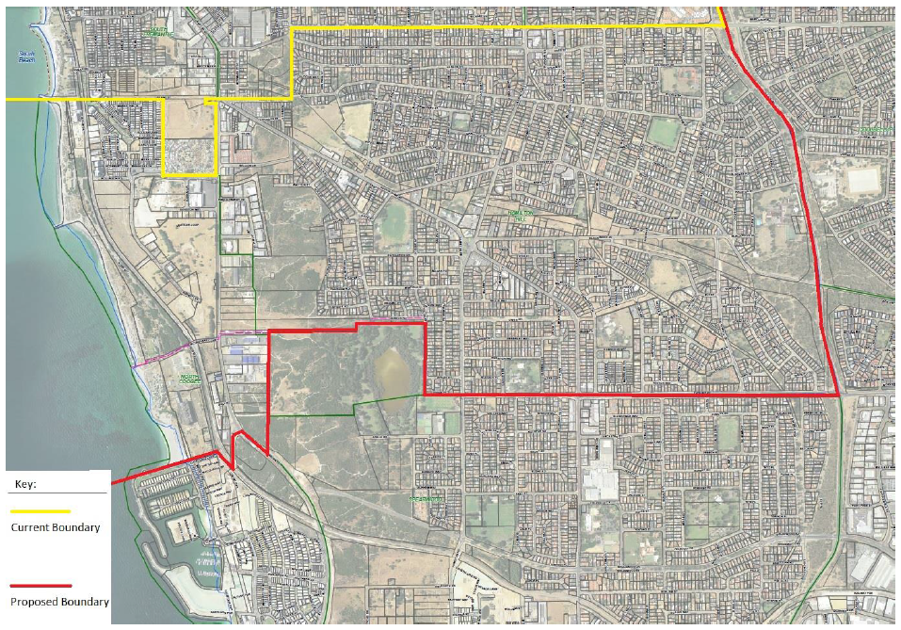

# For more information, please contact:

Local Government Advisory Board

Gordon Stephenson House, 140 William Street, Perth WA 6000

GPO Box R1250, Perth WA 6844

Telephone: (08) 6552 1500 Fax: (08) 6552 1555

Freecall: 1800 620 511 (Country callers only)

Email: [advisoryboard@dlgc.wa.gov.au](mailto:advisoryboard@dlgc.wa.gov.au)   
Website: [www.dlgc.wa.gov.au](http://www.dlgc.wa.gov.au)//AboutUs/Pages/LGAB.aspx

Translating and Interpreting Service (TIS) – Telephone: 13 14 50

All or part of this document may be copied. Due recognition of the source would be appreciated.

1. Response to the proposal to transfer the suburb of Hamilton Hill and a portion of the suburb of North Coogee to the City of Fremantle – City of Cockburn presentation October 2016
2. Response to the proposal to transfer the suburb of Hamilton Hill and a portion of the suburb of North Coogee to the City of Fremantle – City of Cockburn presentation October 2016

   Source of data – ABS 2011 Census Data
3. Department of Planning Western Australia Tomorrow <http://www.planning.wa.gov.au/publications/6194.asp>
4. City of Cockburn Planning and Development Projects <http://www.cockburn.wa.gov.au/News/major_projects/>
5. Fremantle’s Economic Development Strategy 2015-2020 http://www.fremantle.wa.gov.au/sites/default/files/sharepointdocs/Economic%20development%20strategy%202015-20-C-000451.pdf
6. City of Cockburn Housing Affordability and Diversity Strategy October 2014 <http://www.cockburn.wa.gov.au/Your_Council/Corporate_Strategic_Plans/3684-housing-affordability-and-diversity-strategy.pdf>
7. Profile.id <http://profile.id.com.au/fremantle/population-estimate>
8. Profile.id <http://economy.id.com.au/cockburn/about> <http://economy.id.com.au/fremantle>